MPS-100 Parking Sensor Power Consumption Test Report

(V1.0)

Prepared by: 2026 Year 10 Month 20 Day
Reviewed by: 2026 Year 10 Month 28 Day
Approved by: 2026 Year 10 Month 29 Day

Hunan HKT Technology Co., Ltd.

Revision History
Version | Description | Author | Reviewer | Approver | Date
V1.0 | Initial release | Li Jie | Wu Zhiyong | OuYan Wei | October 27, 2026

1. Test Objects
MPS-100 parking sensors: 3 units, surface-mount installation;
Device EUIs: 00956906000AF026, 00956906000AF03E, 00956906000B06CD;
Hardware version: DC-10_V1.0 2024.07.11;
Software version: MPS100_EU868_V11.28_26.8.5_S.O.A;
LoRaWAN antenna: 868MHz PCB patch antenna;
Battery: EVE ES-261520/W 3.6V & 8.5Ah × 2

2. Test Objective
By simulating real user scenarios, this test measures the actual power consumption of the sensor's key operations. Using the test data together with the battery parameters, the device's battery service life in days and years is calculated, verifying whether the battery life of the MPS-100 parking sensor meets the product documentation requirements.
Reference document: "HKT_MPS100 LoRaWAN Surface-Mount Parking Sensor User Manual V1.0.docx"

3. Test Environment

3.1 Test Instruments and Tools
- One Nissan Teana sedan
- One laptop computer
- One gateway: ND65-L04EU-868M-EA
- Power consumption analysis software and constant power supply: BLU Power Monitor 939; measurement range 100nA~6A, resolution 80nA, sampling rate 100kHz, output supply voltage: 3.6V.

3.2 Test Information
Tester: Li Jie
Test period: October 21 to October 26, 2026
Test environment: air temperature 18-26°C, overcast/rainy and sunny days

3.3 Network Setup
This test was conducted in a real parking-lot environment and can be divided into two environments by network conditions:
- The gateway and the three MPS-100 parking sensors were about 15 meters apart; the BLU 939 constant power supply was connected in series for the test.
- The gateway and the three MPS-100 parking sensors were about 500 meters apart with obstacles blocking the line of sight; the BLU 939 constant power supply was likewise connected in series for the test.

4. Test Scenarios and Methods

4.1 Test Overview
This test used the BLU939 series power analyzer to perform full-scenario power consumption testing on three MPS-100 prototypes (AF026, AF03E, B06CD). The test covered all operating states: idle noise floor, radar pulses, magnetometer detection, vehicle arrival, vehicle departure, periodic reporting, etc.

4.2 Test Description
The BLU 939 software recorded the periodic reporting power, vehicle entry/exit power, and baseline power of the MPS-100 parking sensors, including each phase's maximum current, minimum current, average current, power consumption, and duration. Results are presented as screenshots: 3 screenshots were captured per phase and averaged for analysis.
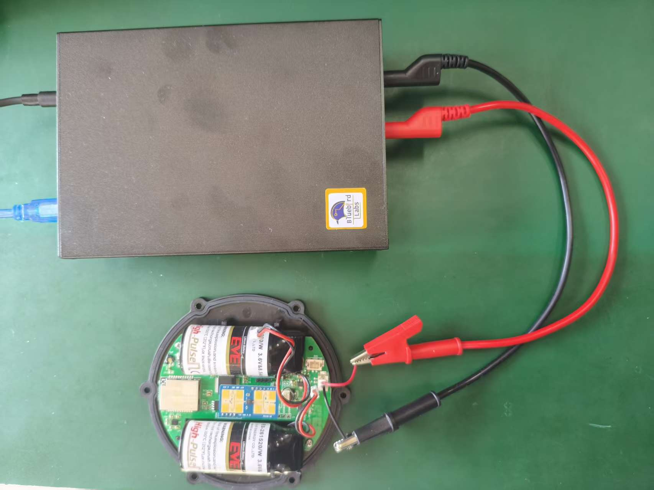
Figure 1 On-site test photo

4.3 Test Scenarios
A total of 5 test scenarios were defined, with power consumption metered separately:
- The three MPS-100 parking sensors in the idle state after calibration: idle noise floor, routine radar operating power, magnetometer periodic detection, and long-period detection power were measured;
- A vehicle arrives and parks: arrival and reporting power, and the power consumed while the vehicle remains parked, were measured;
- A vehicle departs: departure and reporting power were measured;
- Idle power after the vehicle departs;
- Periodic data reporting power.

4.4 Battery System Description and Lifetime Calculation Model
The devices under test are equipped with the EVE ES-261520/W hybrid power module, which consists of two ER26500 lithium thionyl chloride (Li-SOCl₂) cells (nominal 3.6V/8,500mAh × 2) in parallel with an SPC1520 super pulse capacitor, for a nominal total capacity of 17,000 mAh. This chemistry has extremely high energy density, but exhibits accelerated self-discharge at high temperature and sharply increased internal resistance at low temperature.
- Annual self-discharge rate: EVE Energy officially specifies that the annual self-discharge rate of the ER26500 + SPC1520 solution is below 2%.
- Pulse discharge capability: the SPC1520 super pulse capacitor has a maximum pulse current of 2,000 mA (2A). The device's LoRa transmission peak is about 120~189 mA (see Figure 30), far below the capacitor's 2A pulse limit, so the super capacitor provides sufficient buffering for transmission current spikes. At -20°C, the risk of the voltage dropping to the cut-off voltage during transmission is significantly reduced by the SPC1520; the hardware protection mechanism is effective.
3. Nominal capacity definition: the 8,500 mAh of a single ER26500 is the figure measured by EVE Energy under 2 mA discharge, +20°C, and a 2.0V cut-off voltage. The device's actual operating current (about 130µA~134 µA on average, calculated from daily consumption) is far below 2 mA, so the discharge rate is even lower and the theoretically deliverable capacity proportion is no less than under nominal conditions.
4. Operating temperature range: EVE Energy specifies an operating temperature of -30°C ~ +70°C for the hybrid power solution, within which the SPC1520 super pulse capacitor can deliver pulse discharge normally.

Battery year-by-year iteration formula: remaining capacity of the current year = remaining capacity of the previous year - consumption of the current year - (remaining capacity of the previous year × 2%).

Calculation basis: all lifetime values in this report are calculated with the year-by-year iteration model above — the room-temperature baseline (Chapter 5 and Section 6.2) uses an initial effective capacity of 17,000 mAh, and the extreme-climate derating estimate (Section 6.3) uses an initial effective capacity of 14,450 mAh (85% of nominal capacity).

5. Test Data Statistics
This chapter presents the power consumption tests of the three MPS-100 parking sensors; details are shown in the figures and the detailed power consumption metric tables.

5.1 Overall Power Consumption Overview
As shown in Figure 2, the power consumption of each phase of the MPS-100 parking sensor is marked on the diagram. The actual power is the same before a vehicle arrives (idle) and after it parks (occupied), so the report consistently breaks consumption down into baseline power, composed of noise-floor power + radar operating baseline power (one pulse per second) + magnetometer detection power (one pulse every 8 seconds).
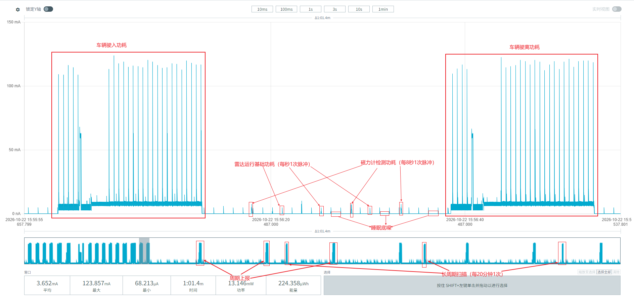
Figure 2 Overall power consumption segmentation diagram

5.2 Device Power Consumption Data under Good Communication Conditions

5.2.1 Device 00956906000AF026
The three waveforms in Figure 3 show no pulses at all — pure sleep noise floor. We can see:
Average current: (76.724 + 76.802 + 76.662) / 3 ≈ 76.729 µA
Duration: (990.6 + 989.2 + 985.2) / 3 ≈ 988.33 ms
Average energy: (76.003 + 75.980 + 75.530) / 3 ≈ 75.838 nWh
The sleep noise-floor power can be calculated:
Per day: 76.729 µA × 24h = 1,841.496 µAh = 1.841 mAh/day
Per year: 1.841 × 365 = 671.965 mAh/year
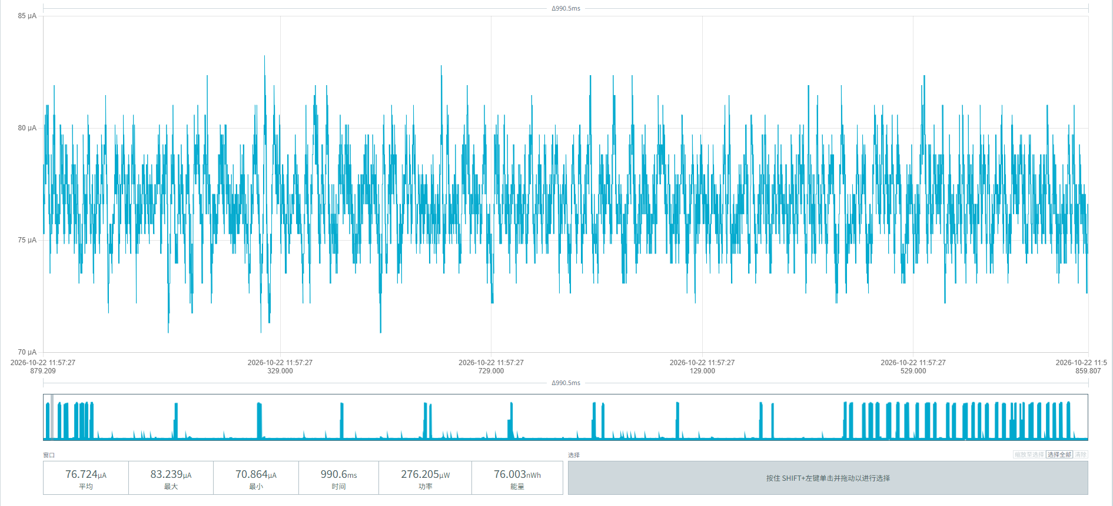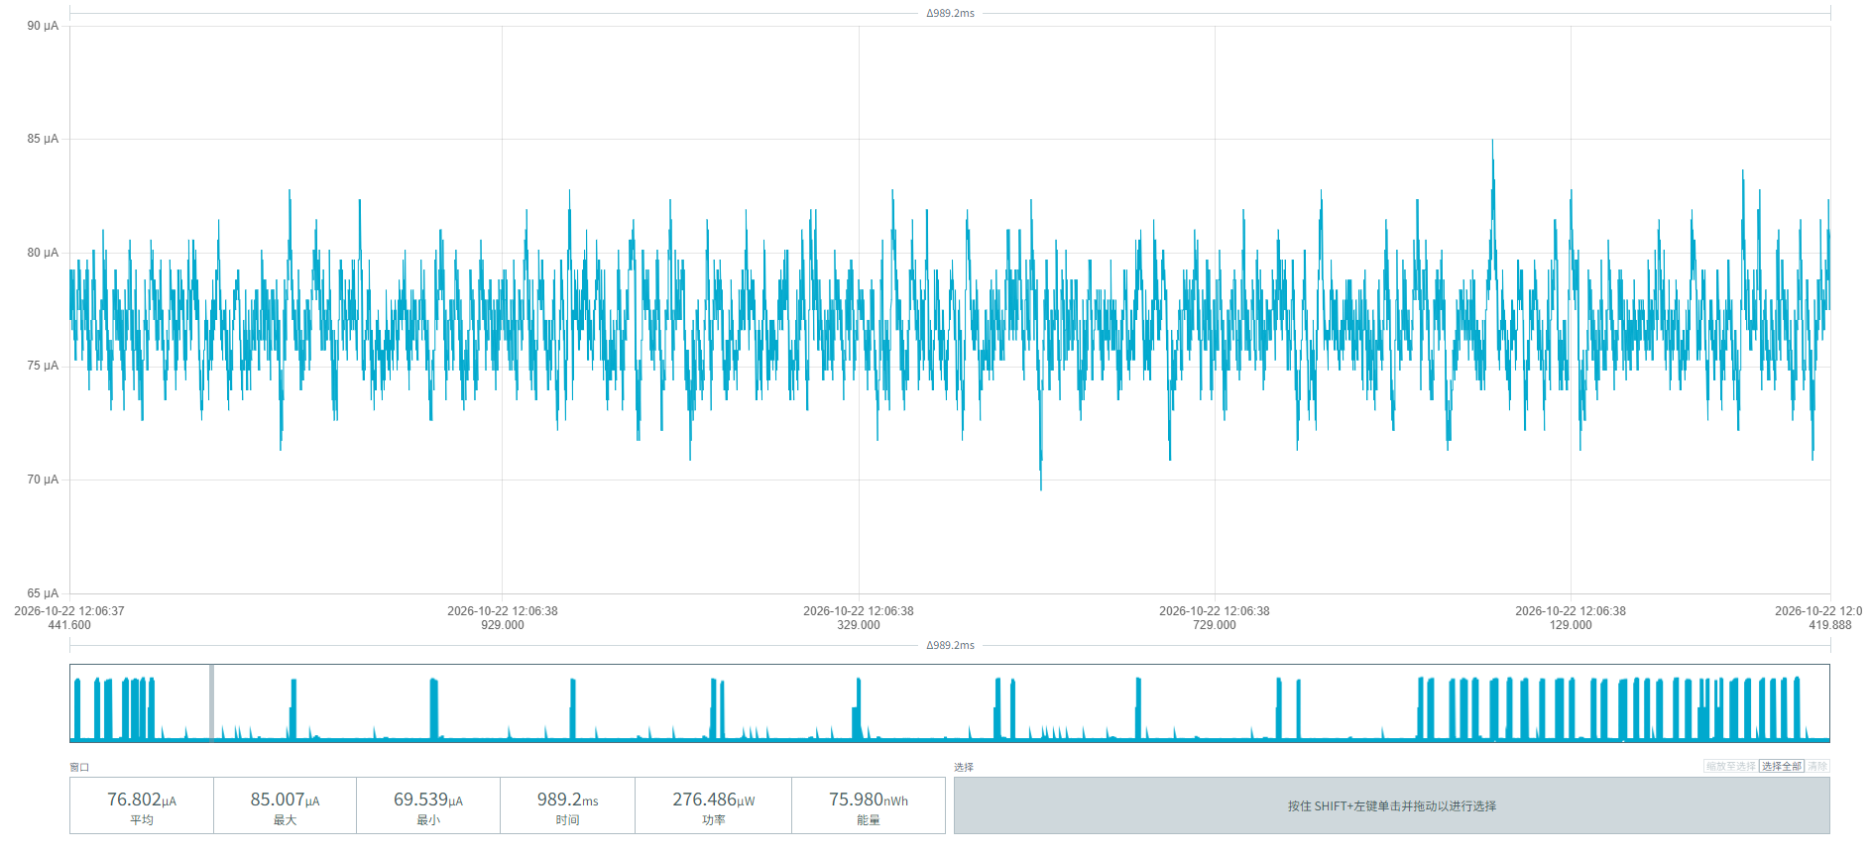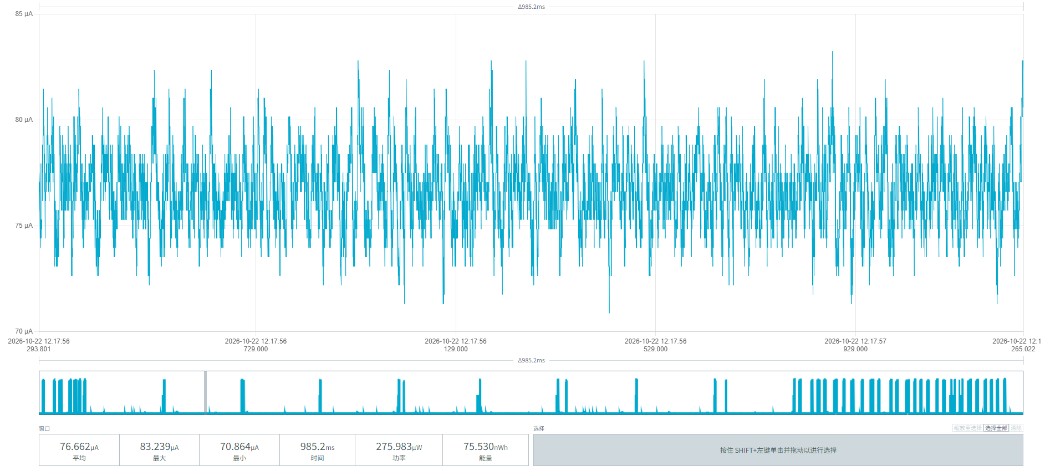
Figure 3 Noise-floor power consumption

After power-on, the radar module of the MPS-100 parking sensor runs automatically with one pulse per second. The three screenshots in Figure 4 show the radar module's baseline operating power:
Average current: (883.519 + 881.010 + 891.225) / 3 = 885.251 µA
Average duration: (15.52 + 15.07 + 15.42) / 3 = 15.337 ms
Average energy: (13.720 + 13.285 + 13.747) / 3 = 13.584 nWh
Average energy per radar pulse: 13.584 nWh / 3.6V = 3.7733 nAh = 0.0037733 µAh
Daily consumption: 0.0037733 µAh × 86,400 = 326.01312 µAh/day = 0.326 mAh/day
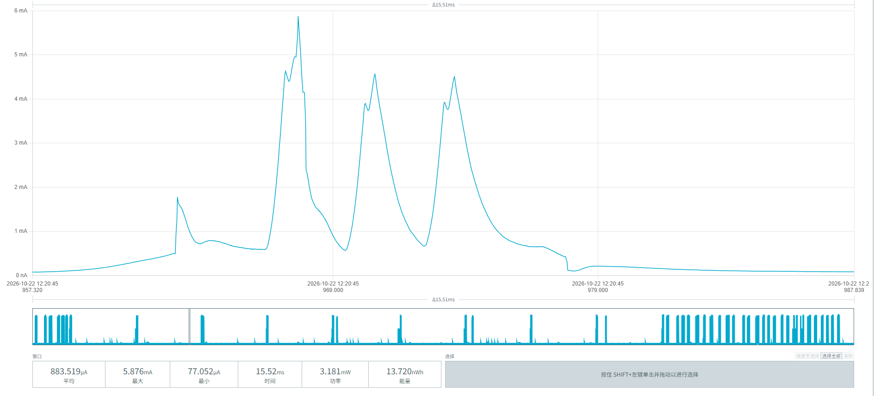
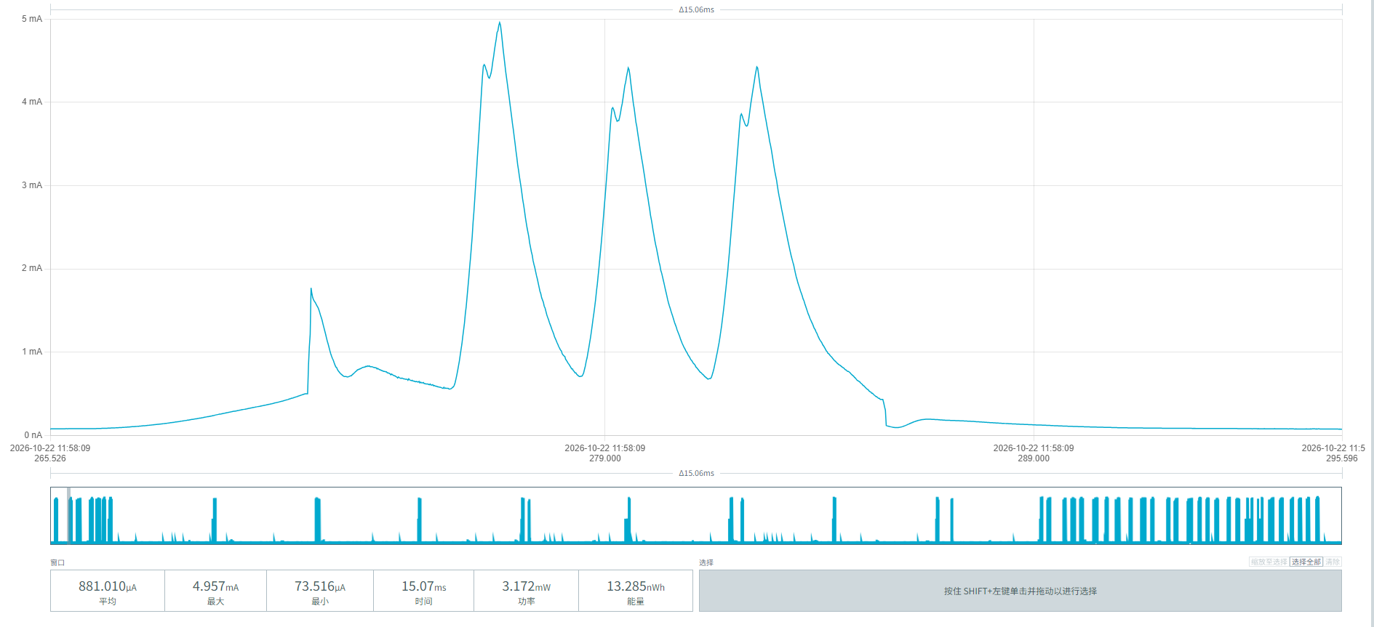
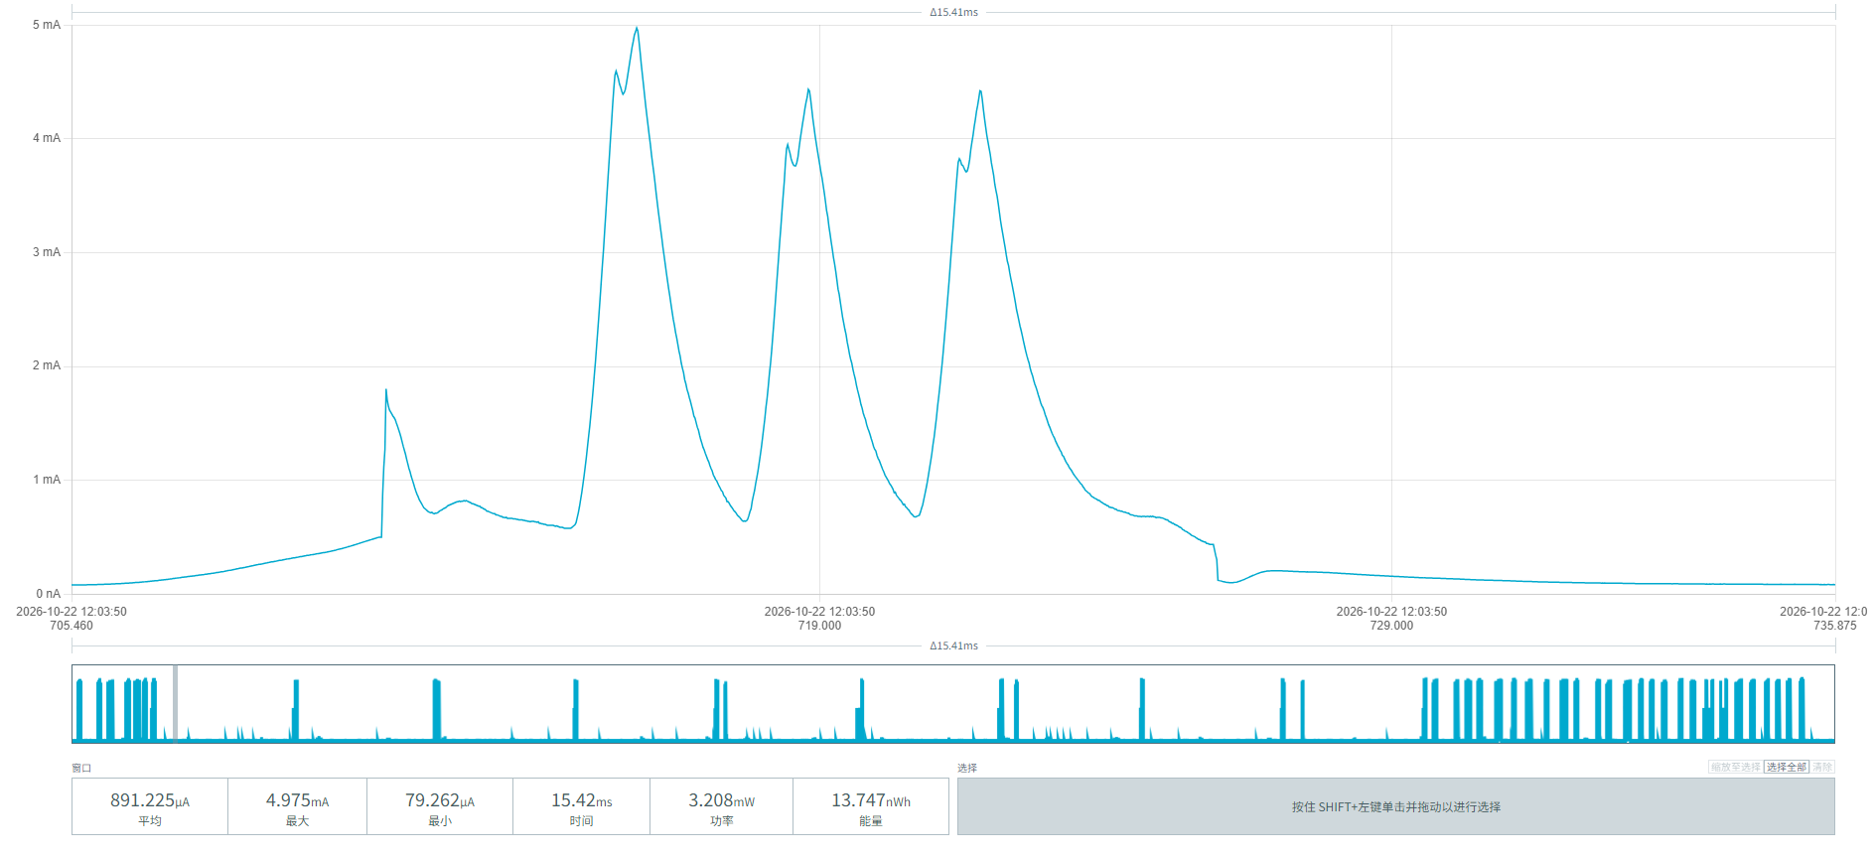
Figure 4 Radar module baseline operating power

After power-on, the MPS-100 parking sensor initiates one magnetometer detection every 8 seconds. The three screenshots in Figure 5 show the power consumption of the magnetometer detection process.
Average current: (3.328 + 3.275 + 3.322) / 3 = 3.3083 mA
Average duration: (59.02 + 59.75 + 59.06) / 3 = 59.276 ms
Average energy: (0.196 + 0.196 + 0.196) / 3 = 0.196 µWh
Consumption per event: 0.196 µWh / 3.6V = 0.05444 µAh
Frequency: once every 8 seconds → 86400 / 8 = 10,800 times per day
Daily consumption: 0.05444 µAh × 10800 = 587.95 µAh = 0.588 mAh/day
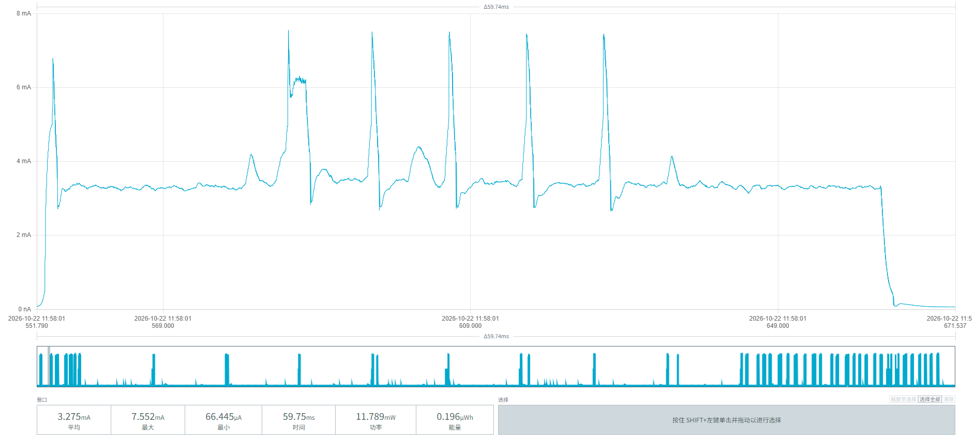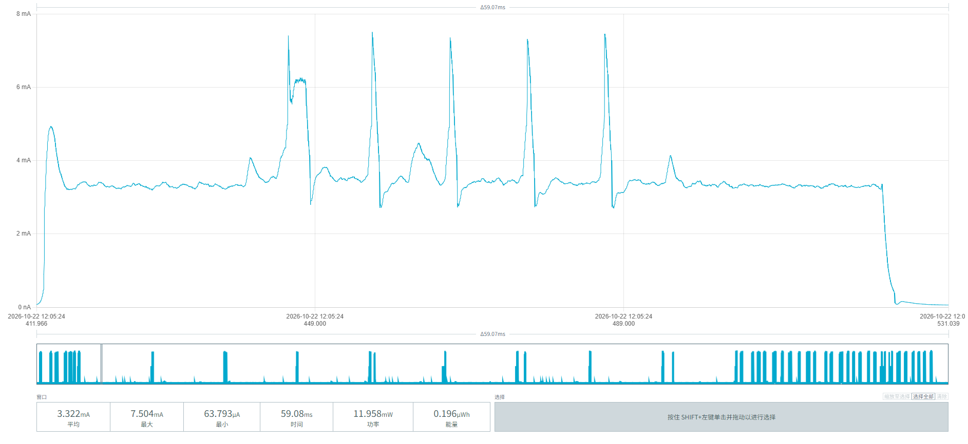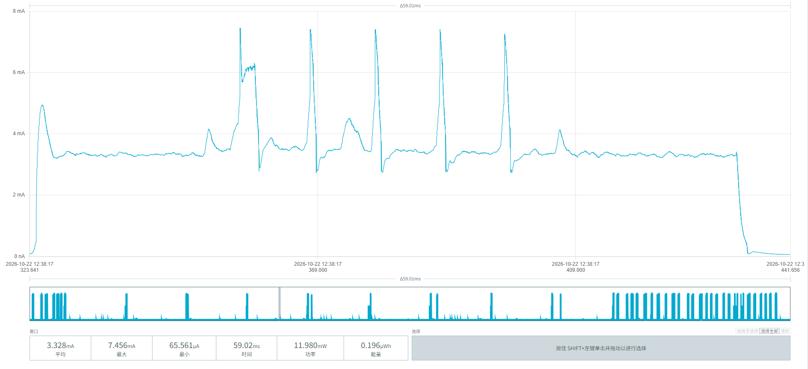
Figure 5 Power consumption of magnetometer detection initiated once every 8 seconds

The MPS-100 parking sensor periodically wakes up to poll the radar module once every 20 minutes. The three screenshots in Figure 6 show the power consumption of this process:
Average current: (4.855 + 4.881 + 4.909) / 3 ≈ 4.882 mA
Average duration: (4.494 + 4.824 + 4.659) / 3 ≈ 4.659 s
Average energy: (21.823 + 23.550 + 22.870) / 3 ≈ 22.748 µWh
Average consumption per event: 22.748 µWh / 3.6 V ≈ 6.319 µAh/event
Events per day = 24 h × 60 min / 20 min = 72 times/day
Daily consumption: 6.319 µAh × 72 = 0.455 mAh/day
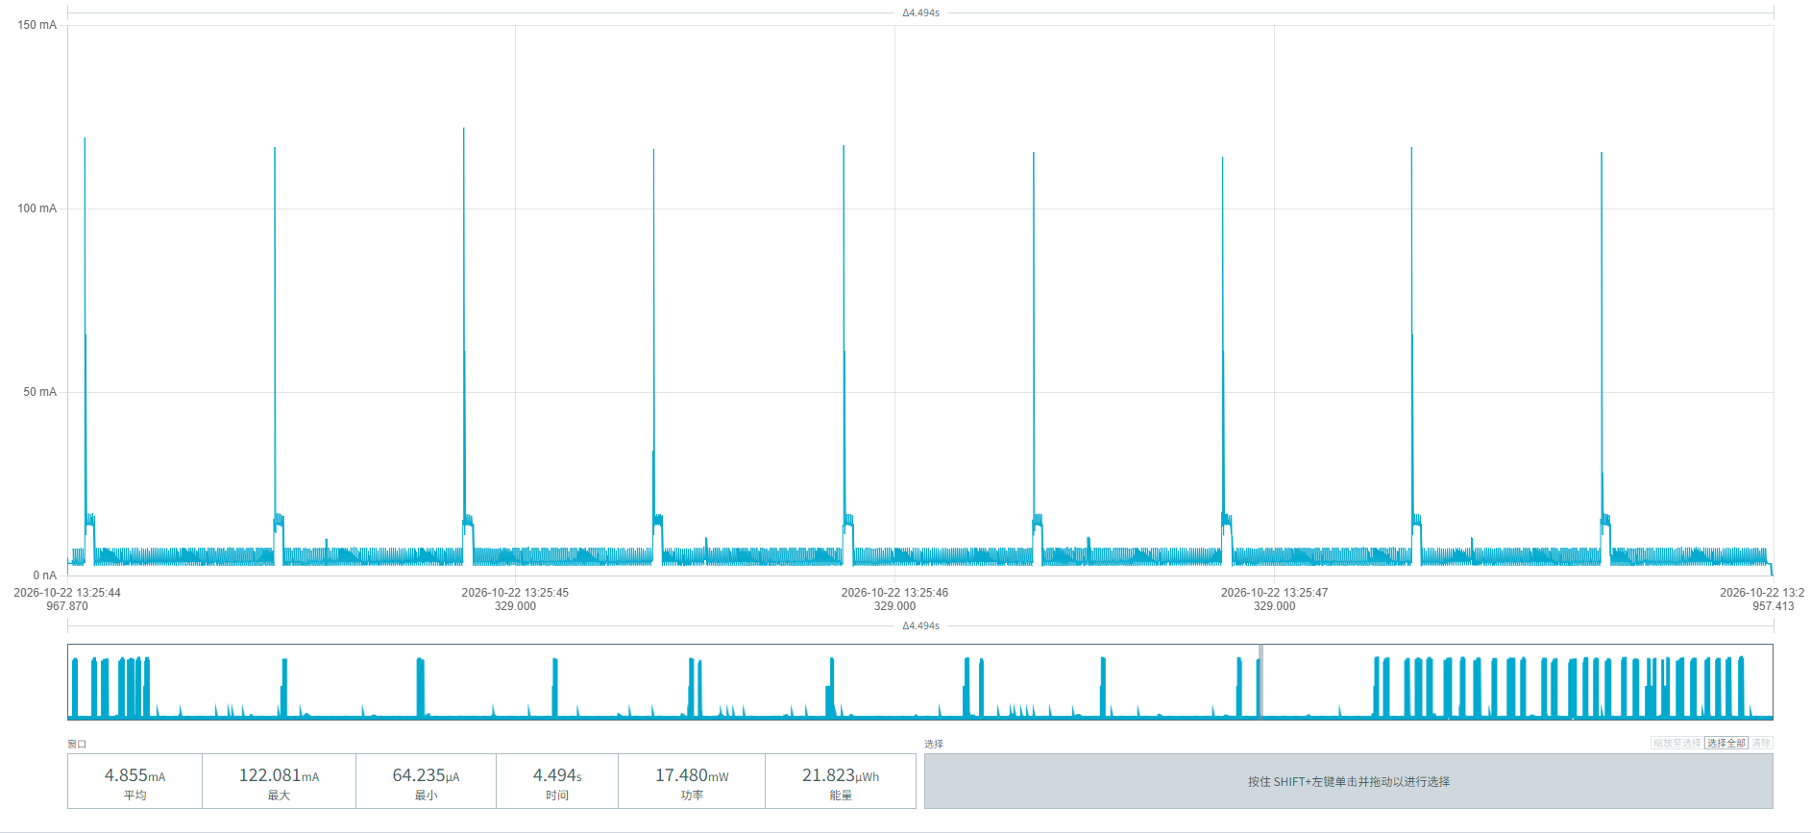
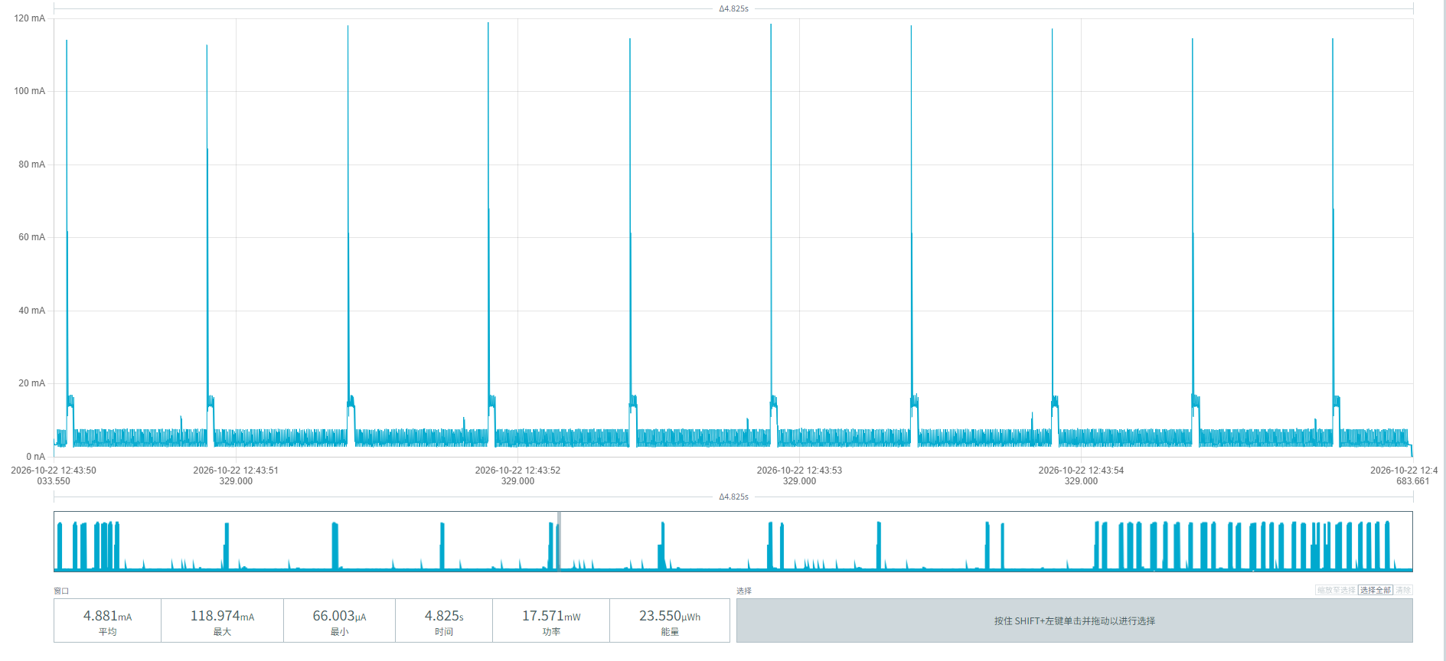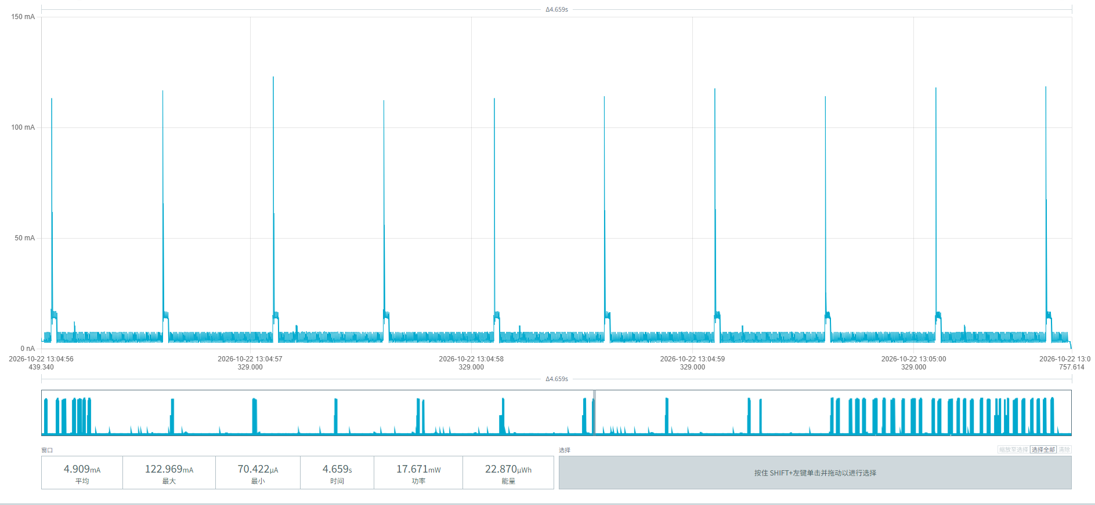
Figure 6 Power consumption of scanning initiated once every 20 minutes

After a vehicle parks above the MPS-100 parking sensor, detection and reporting are triggered. The three screenshots in Figure 7 show the power parameters of the vehicle-arrival process:
Average current: (7.209 + 7.448 + 7.963) / 3 = 7.54 mA
Average duration: (14.96 + 14.65 + 14.44) / 3 ≈ 14.68 s
Average energy: (107.169 + 110.661 + 113.551) / 3 = 110.460 µWh
Average consumption per event = 110.460 / 3.6 = 30.683 µAh
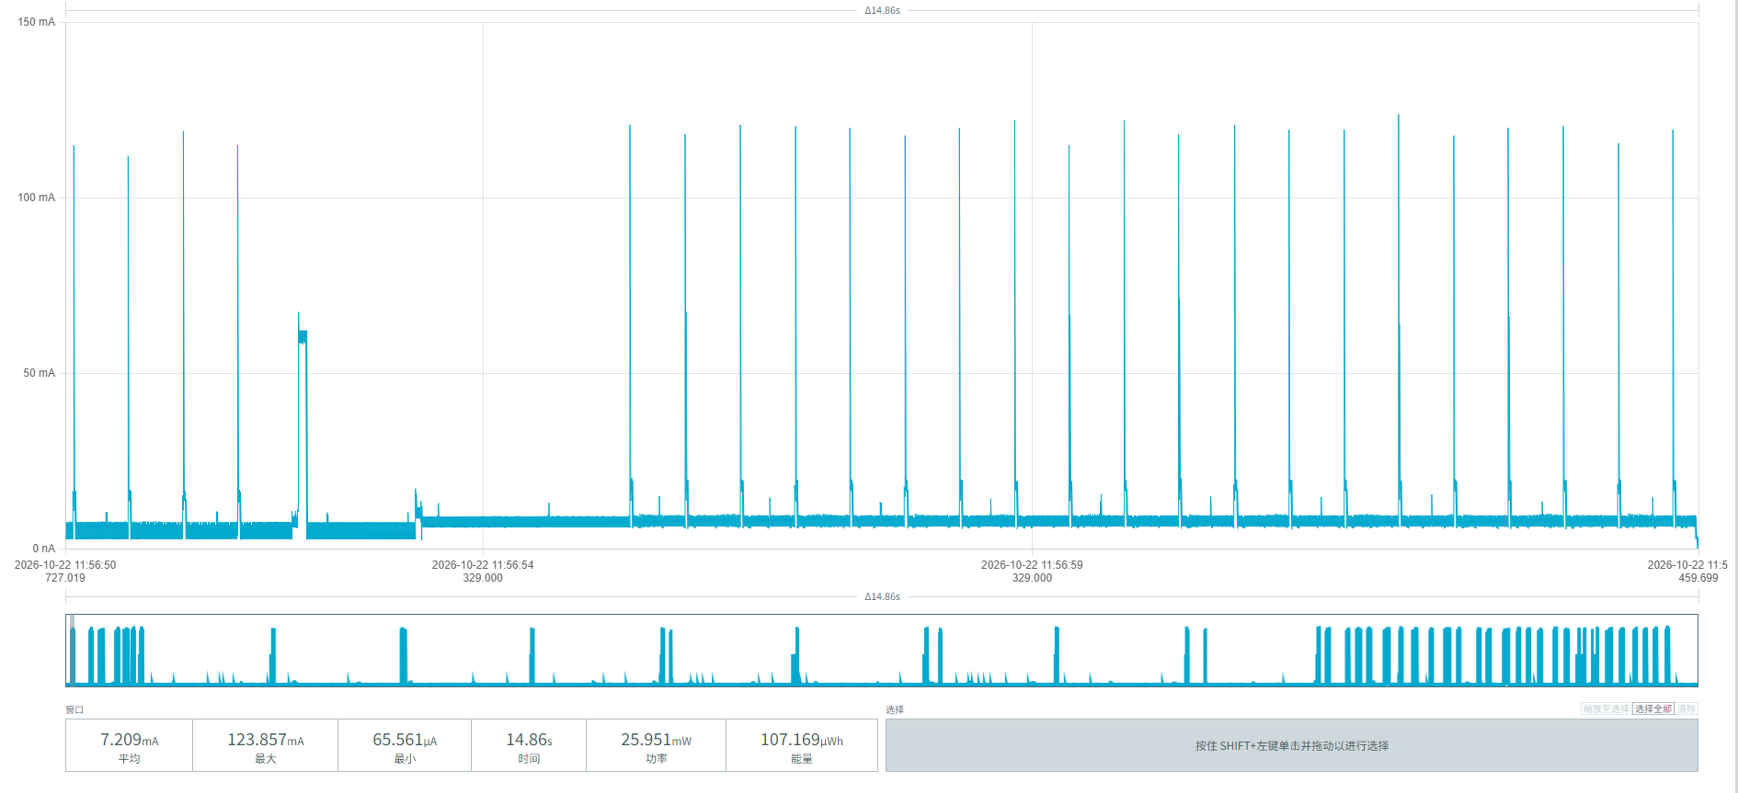
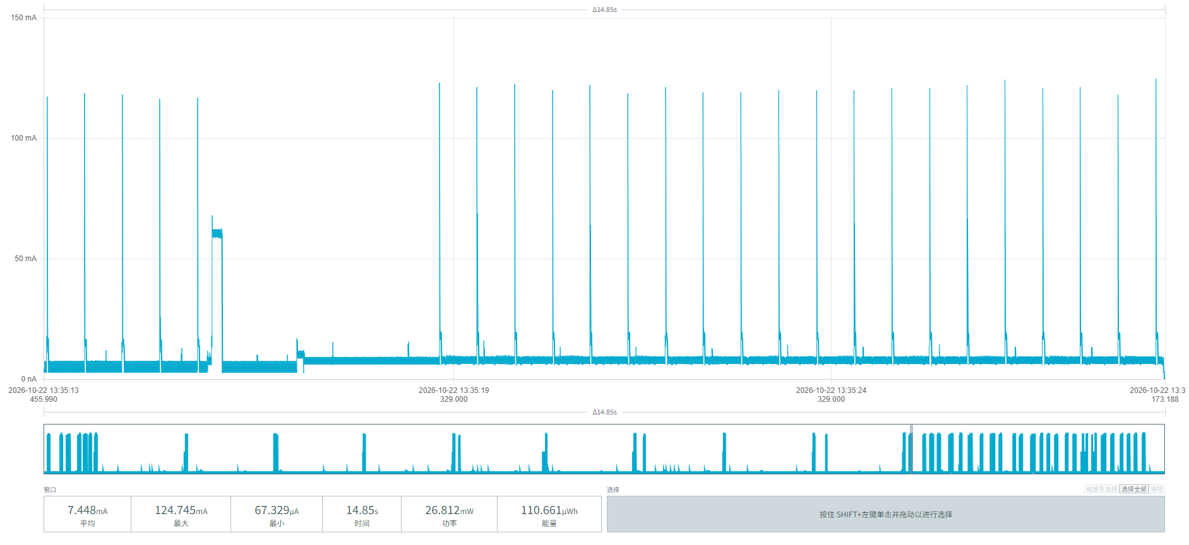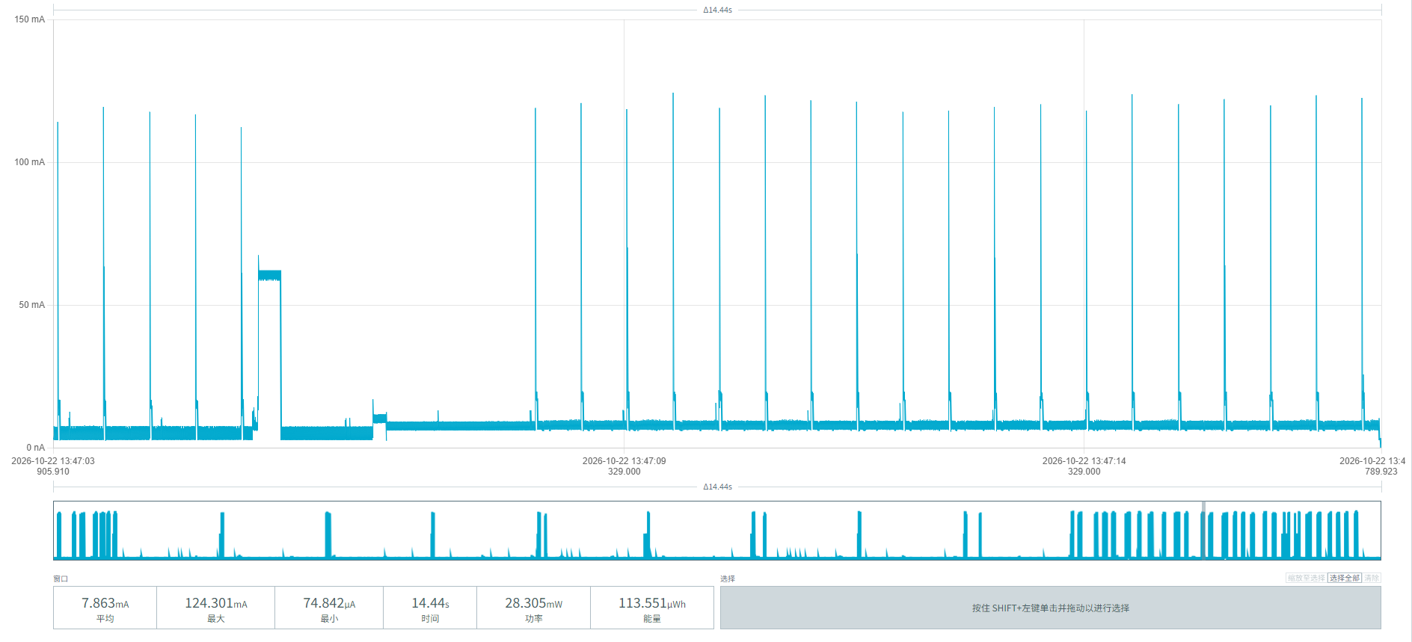
Figure 7 Vehicle arrival power screenshots
When the vehicle leaves the area above the MPS-100 parking sensor, detection and reporting are triggered. The three screenshots in Figure 8 show the power parameters of the vehicle-departure process:
Average current: (7.201 + 7.430 + 7.961) / 3 ≈ 7.5307 mA
Average duration: (14.53 + 14.45 + 14.61) / 3 = 14.53 s
Average energy per event: (104.706 + 107.382 + 116.436) / 3 = 328.524 / 3 = 109.508 µWh
Average consumption per event = 109.508 µWh / 3.6V ≈ 30.42 µAh
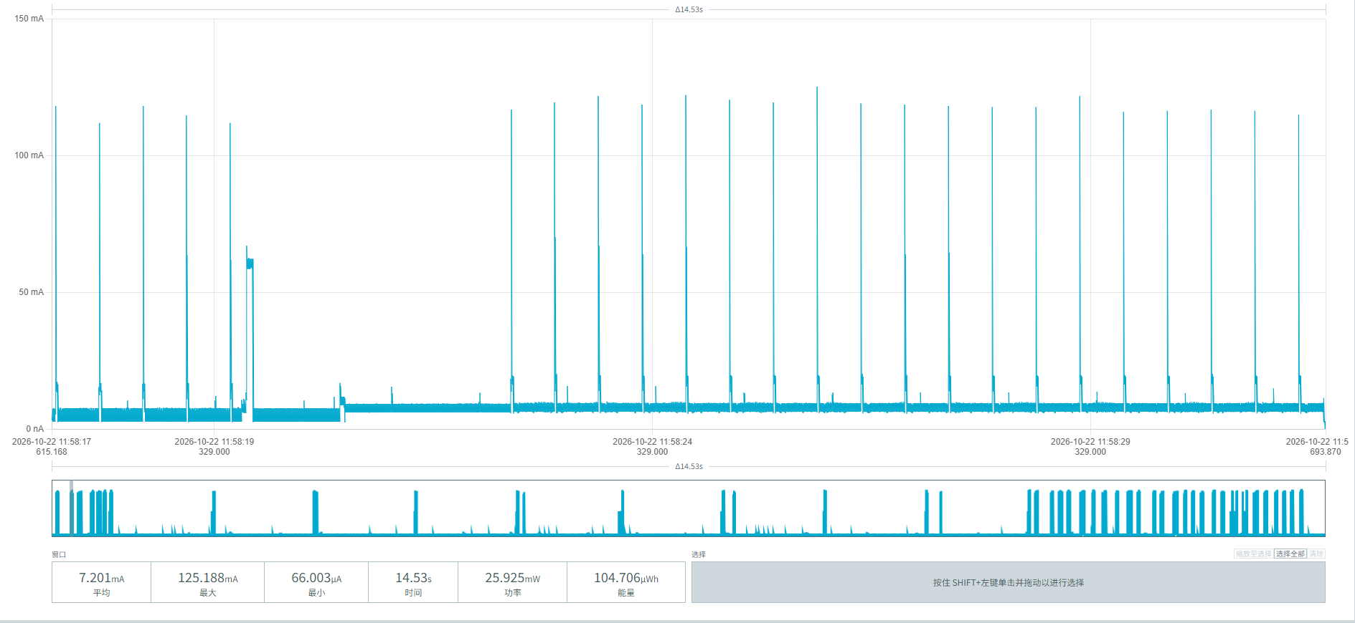
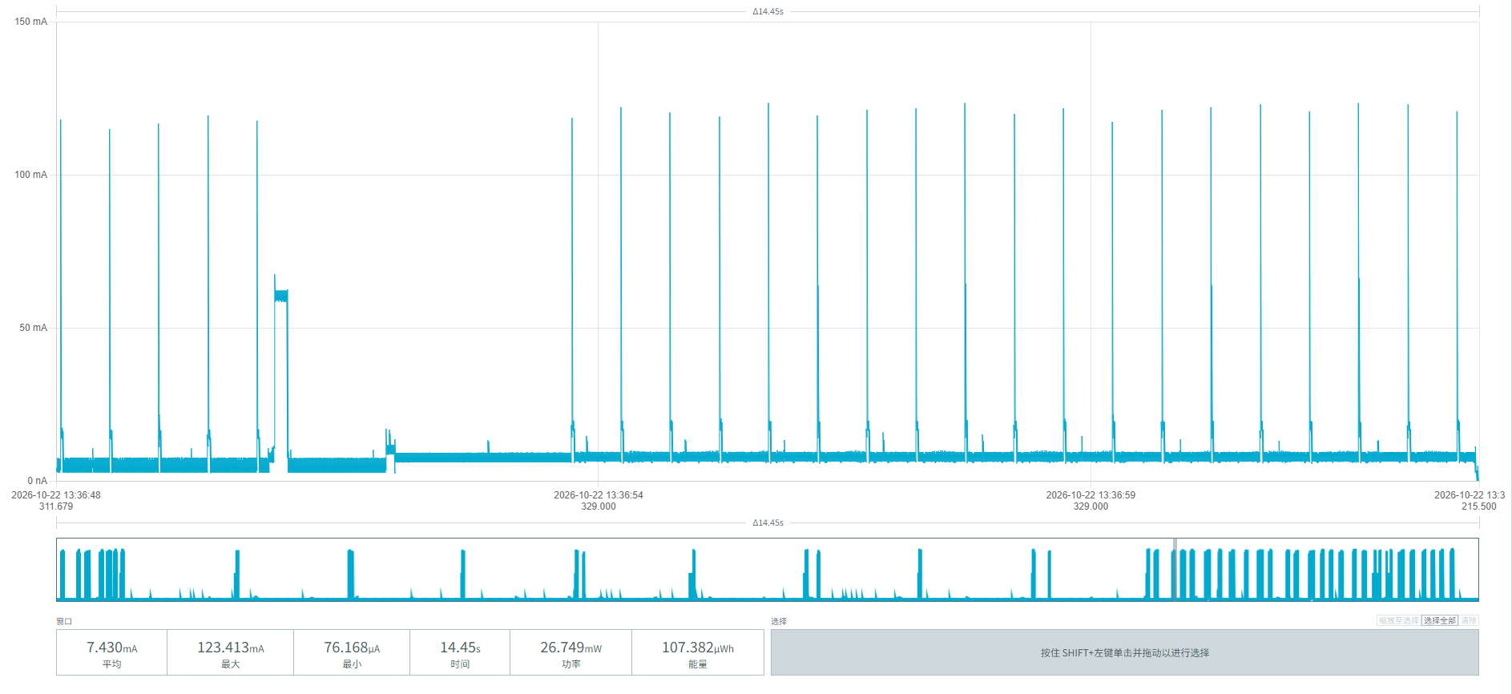
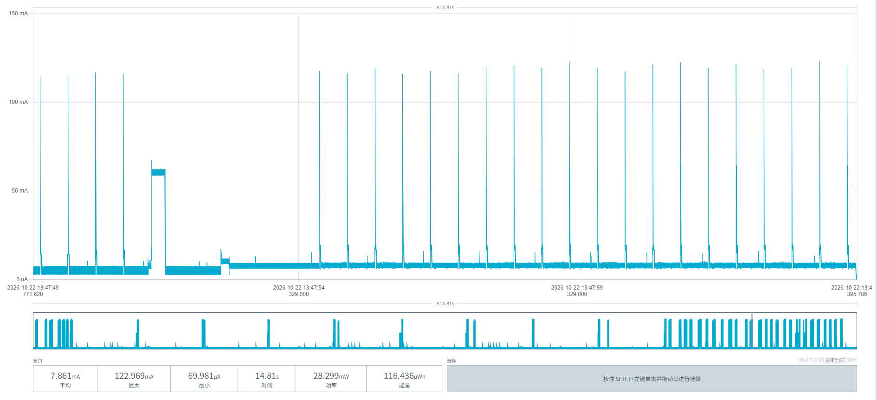
Figure 8 Vehicle departure power screenshots

Figure 9 shows the power parameters of a single periodic report of the MPS-100 parking sensor:
Average current: (7.589 + 7.583 + 7.576) / 3 ≈ 7.583 mA
Duration: (12.87 + 12.96 + 13.02) / 3 ≈ 12.95 s
Total energy per event: (97.673 + 98.312 + 98.653) / 3 ≈ 98.213 µWh
Average consumption per event = 98.213 / 3.6 = 27.28 µAh
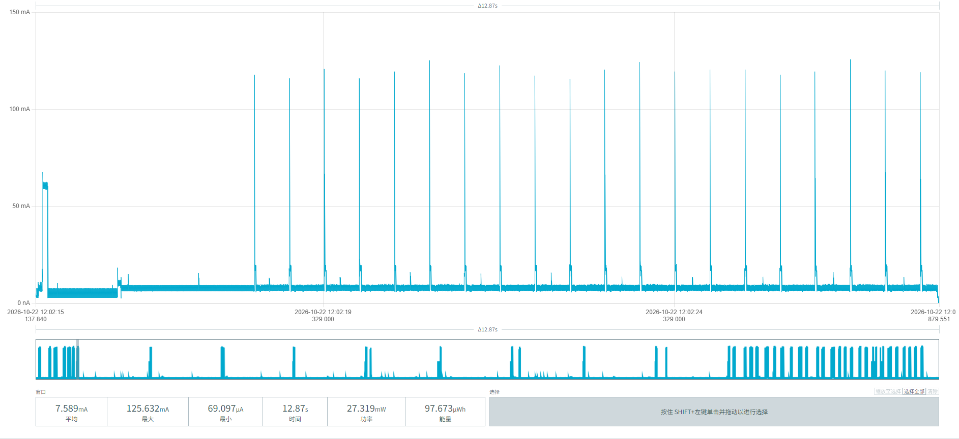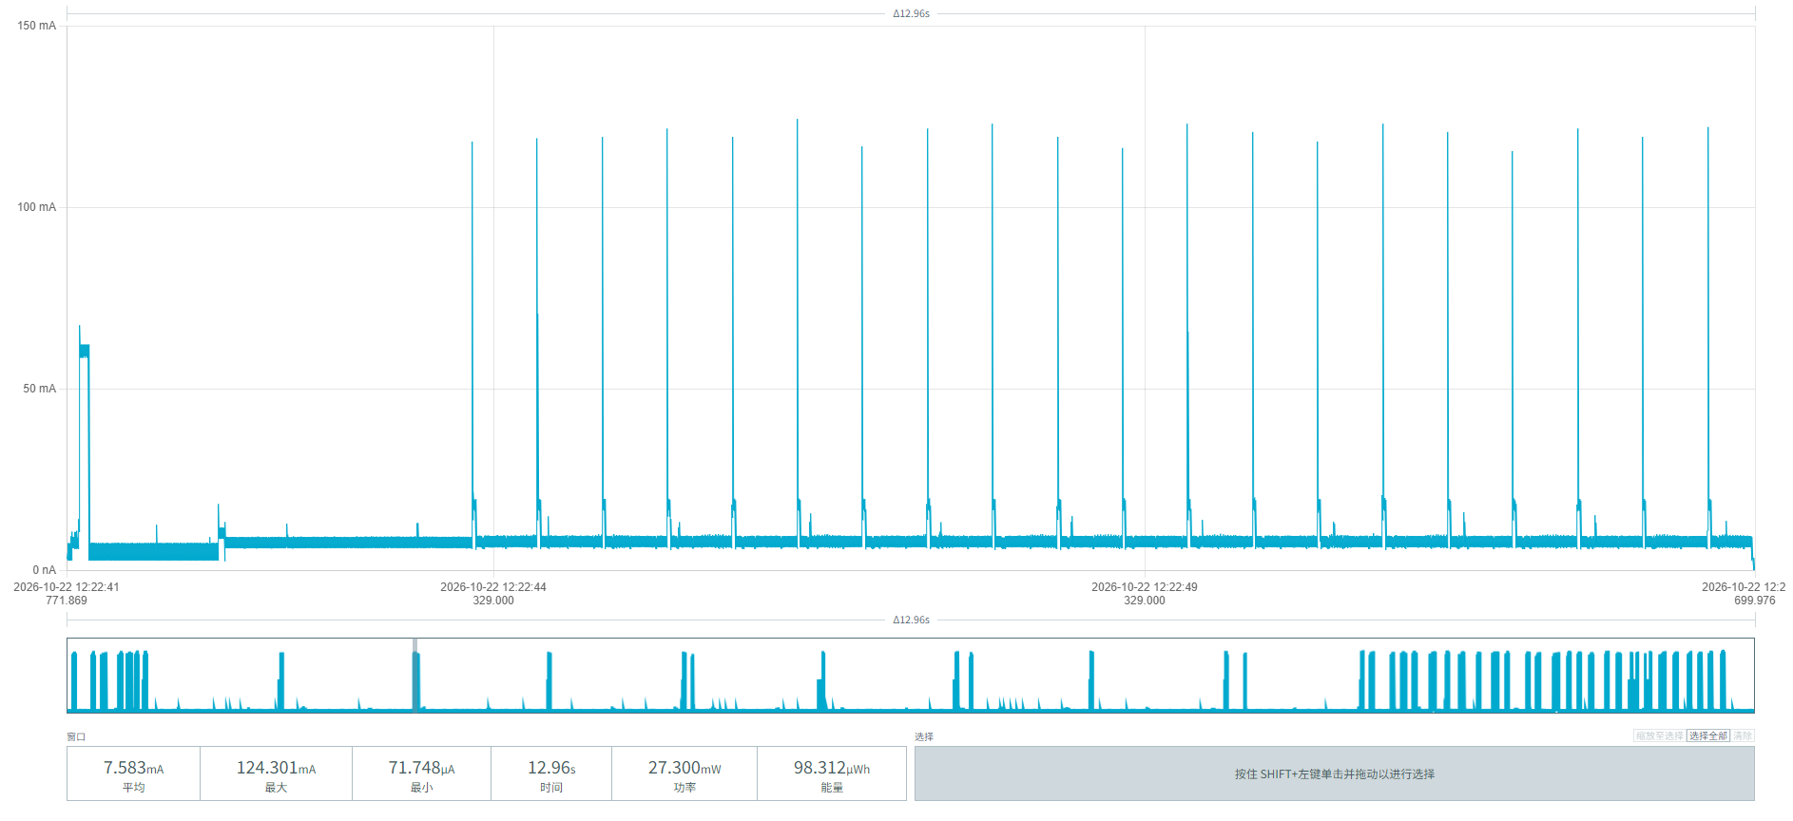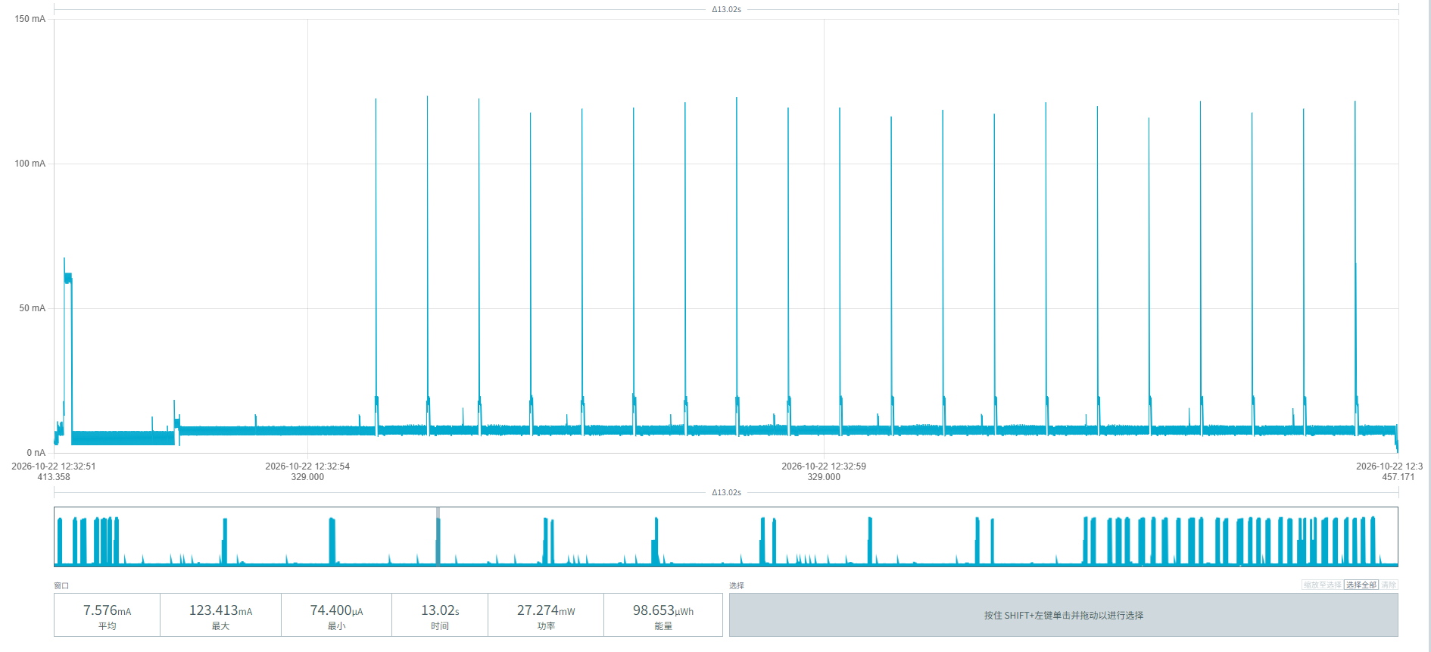
Figure 9 Periodic reporting power waveform
From the segmented power consumption data of device 00956906000AF026 in this chapter, the battery service life under different demand scenarios with an unobstructed network can be calculated:
Baseline parameters:
Initial effective battery capacity: 17000mAh
Idle baseline consumption: 3.21 mAh/day (noise floor 1.841 + radar 0.326 + magnetometer 0.588 + 20-minute watchdog wake-up 0.455)
Single complete parking event (incl. 20% margin): 73.32 µAh (arrival 30.68 + departure 30.42, incl. 20% margin)
Single periodic report: 27.28 µAh

Parking frequency | Reporting interval | Daily / Annual consumption (mAh) | Estimated lifetime (iterative)
10 times/day | 1 per hour | 4.599 / 1,678.6 | 9.14 years
 | 1 per 4 hours | 4.108 / 1,499.4 | 10.28 years
 | 1 per 24 hours | 3.971 / 1,449.4 | 10.65 years
30 times/day | 1 per hour | 6.066 / 2,214.1 | 6.78 years
 | 1 per 4 hours | 5.575 / 2,034.9 | 7.43 years
 | 1 per 24 hours | 5.438 / 1,984.9 | 7.63 years

5.2.2 Device 00956906000AF03E
The waveforms in Figure 10 show no pulses — pure sleep noise-floor power. We can see:
Average duration: (983.9 + 985.8 + 988.9) / 3 = 986.2 ms
Average current: (76.771 + 76.728 + 76.699) / 3 = 76.7327 µA
Average energy per event: (75.545 + 75.641 + 75.849) / 3 = 75.6783 nWh
The sleep noise-floor power can be calculated:
Per day: 76.733 µA × 24h = 1.8416 mAh/day
Per year: 1.8416 × 365 = 672.184 mAh/year
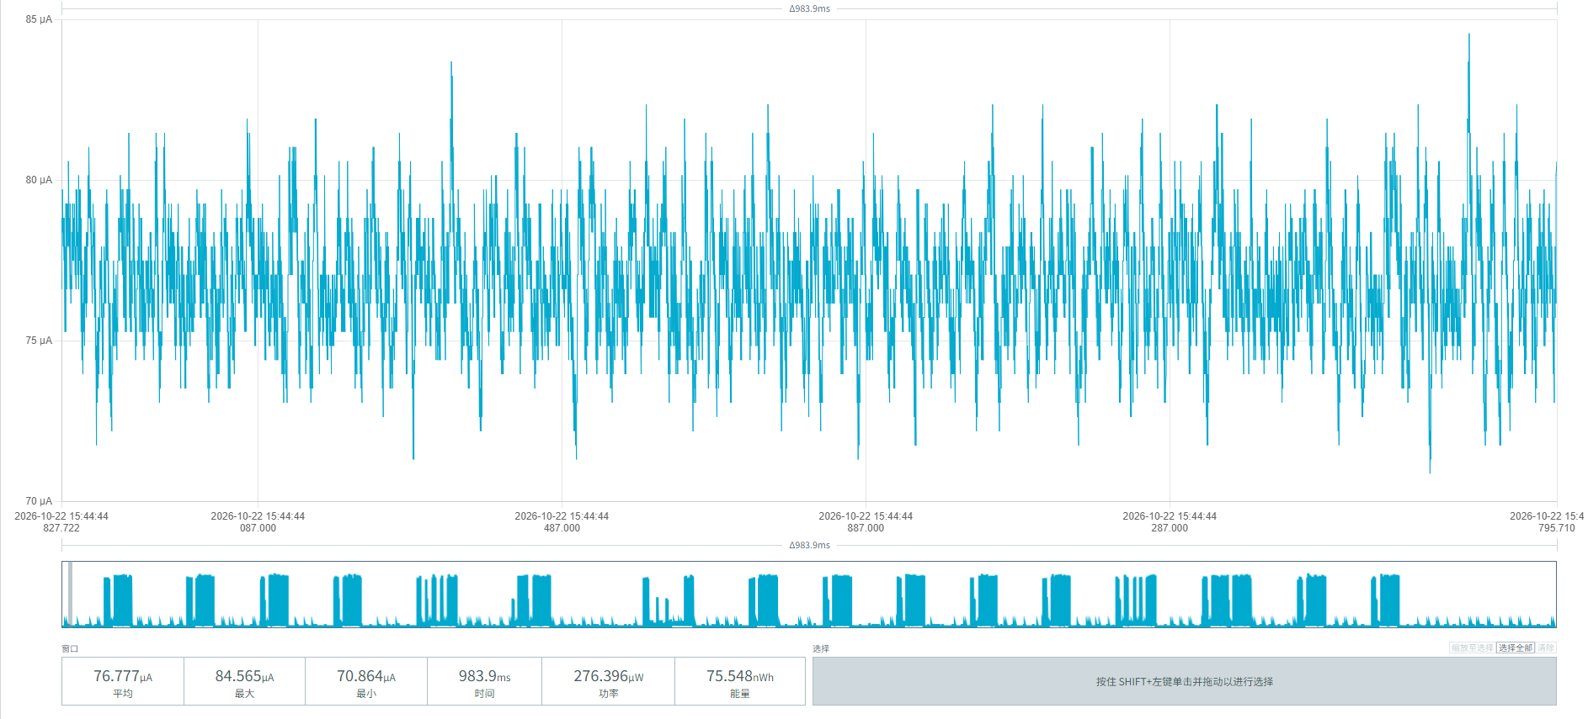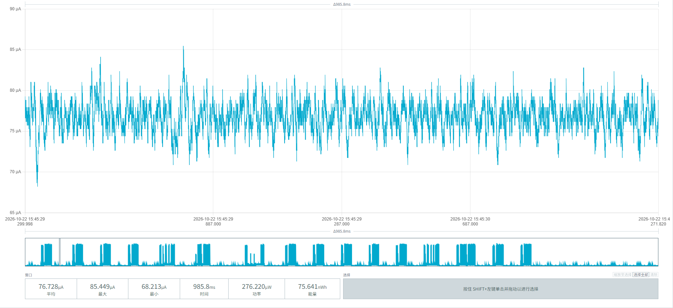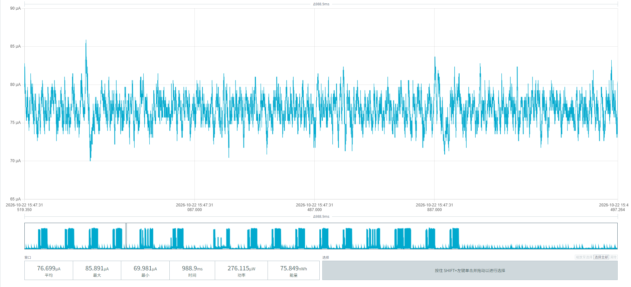
Figure 10 Power noise floor

After power-on, the radar module of the MPS-100 parking sensor runs automatically with one pulse per second. Figure 11 shows the radar module's baseline operating power:
Average duration: (16.74 + 16.16 + 16.73) / 3 ≈ 16.54 ms
Average current: (818.128 + 816.095 + 790.920) / 3 ≈ 808.381 µA
Average energy per event: (13.697 + 13.191 + 13.237) / 3 = 13.375 nWh
Converted consumption per pulse: 13.375 / 3.6 / 1000 ≈ 0.003715 µAh/pulse

The radar baseline operating power can be calculated:
At a frequency of 1 pulse/second, one day has 24 h × 3600 s = 86,400 s, so the number of pulses per day = 86,400
Daily radar baseline operating power: 0.003715 µAh × 86,400 ≈ 320.99 µAh = 0.321 mAh/day
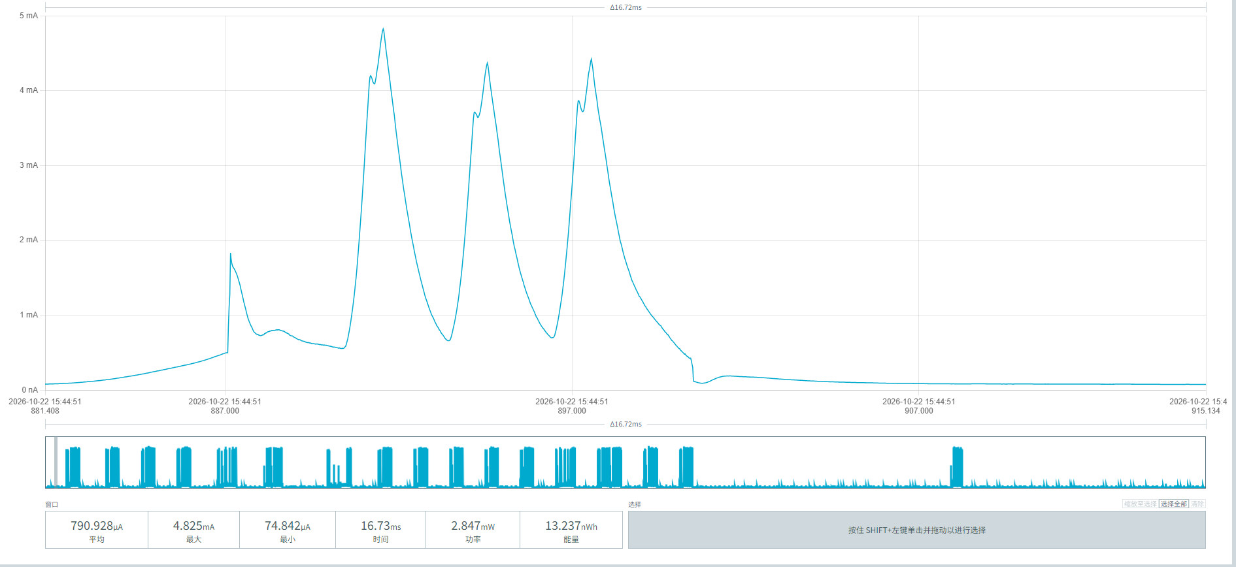
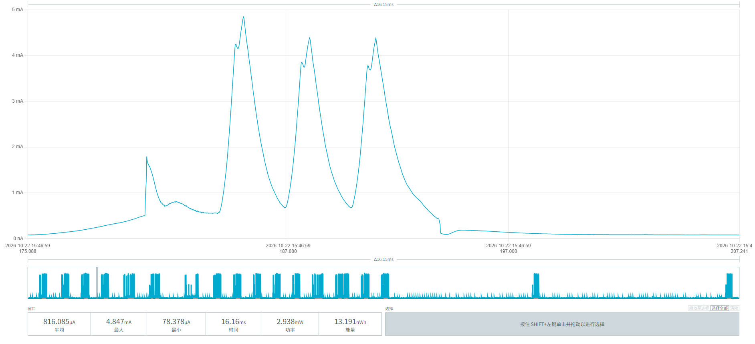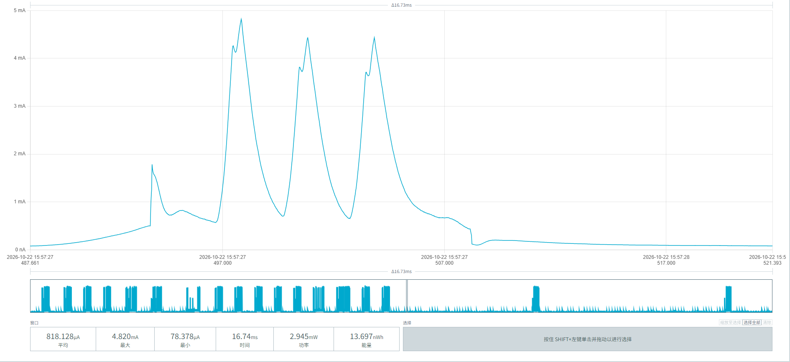
Figure 11 Radar module baseline operating power

After power-on, the MPS-100 parking sensor initiates one magnetometer detection every 8 seconds; Figure 12 shows the magnetometer detection power:
Average duration: (59.20 + 59.26 + 58.98) / 3 = 59.147 ms
Average current: (3.317 + 3.296 + 3.323) / 3 = 3.312 mA
Average energy per event: (0.196 + 0.195 + 0.195) / 3 = 0.19533 µWh
Converted consumption per event: 0.19533 µWh / 3.6V ≈ 0.054258 µAh/event
Daily consumption: 0.054258 × 10800 ≈ 585.99 µAh = 0.586 mAh/day
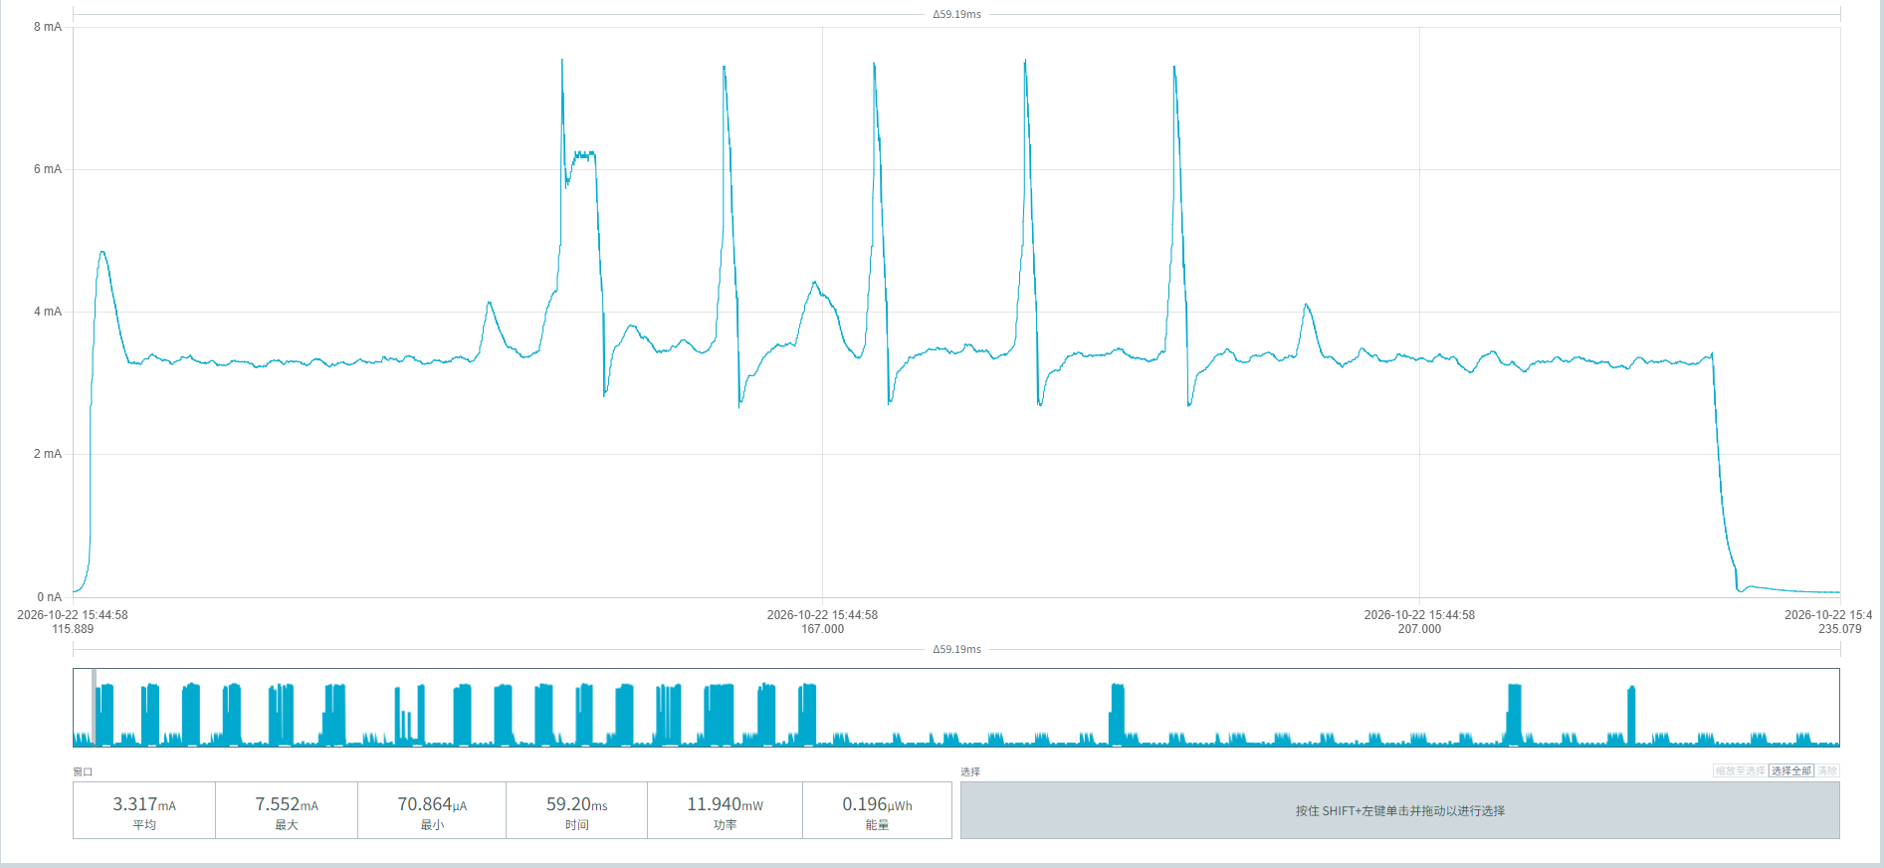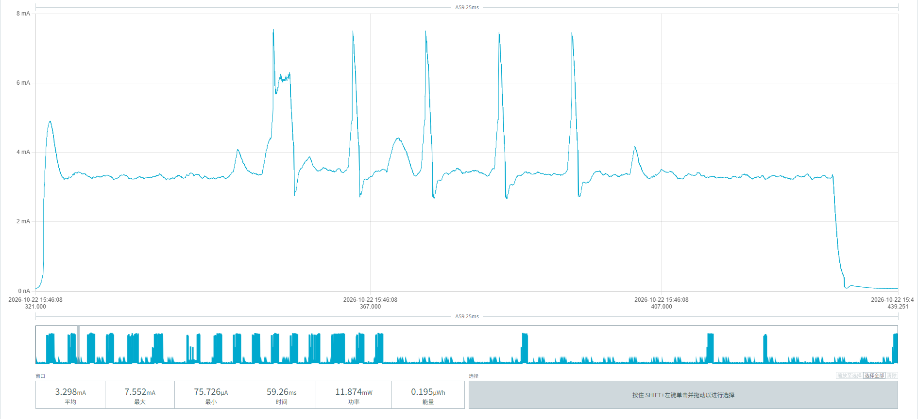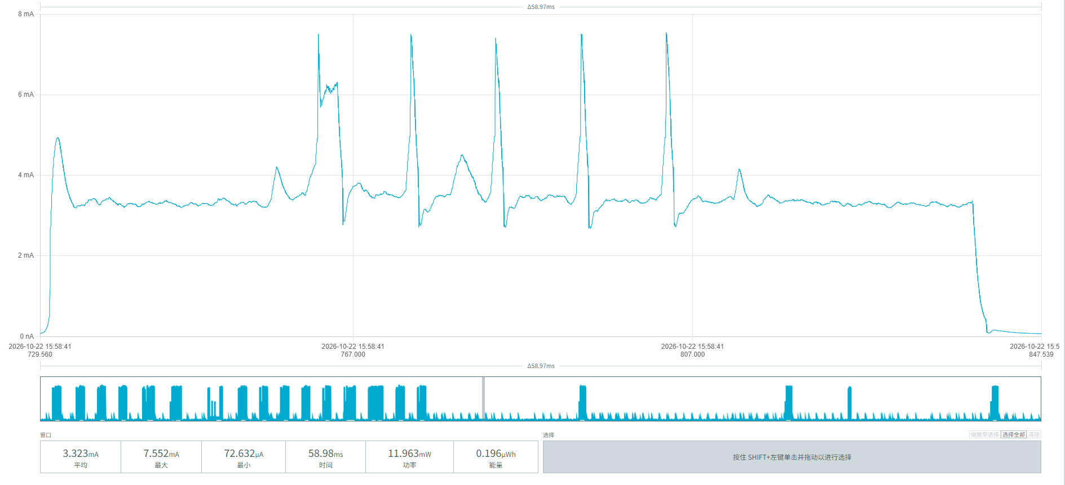
Figure 12 Power consumption of magnetometer detection initiated once every 8 seconds

The MPS-100 parking sensor periodically wakes up to poll the radar module once every 20 minutes. The three screenshots in Figure 13 show the power consumption of this process:
Average current: (4.882 + 4.873 + 4.910) / 3 = 4.888 mA
Average duration: (4.343 + 4.894 + 4.653) / 3 = 4.630 s
Average energy: (21.204 + 23.853 + 22.850) / 3 = 22.636 µWh
Average consumption per event: 22.636 µWh / 3.6V ≈ 6.288 µAh
Events per day = 24 h × 60 min / 20 min = 72 times/day
Daily consumption: 6.288 µAh × 72 ≈ 452.7 µAh = 0.453 mAh/day
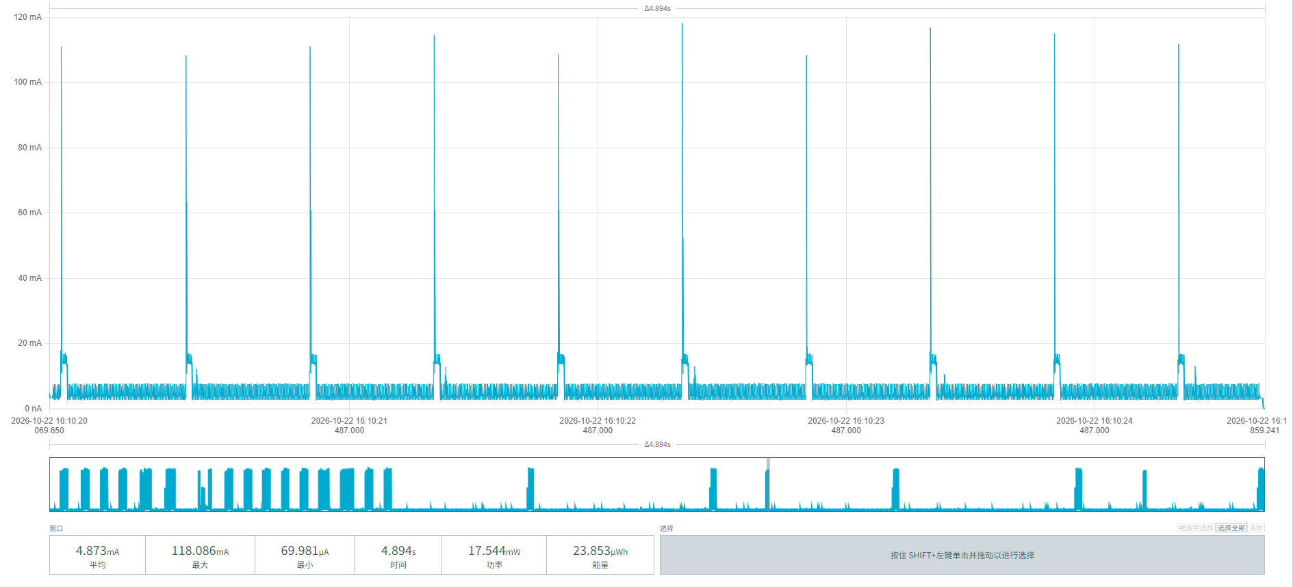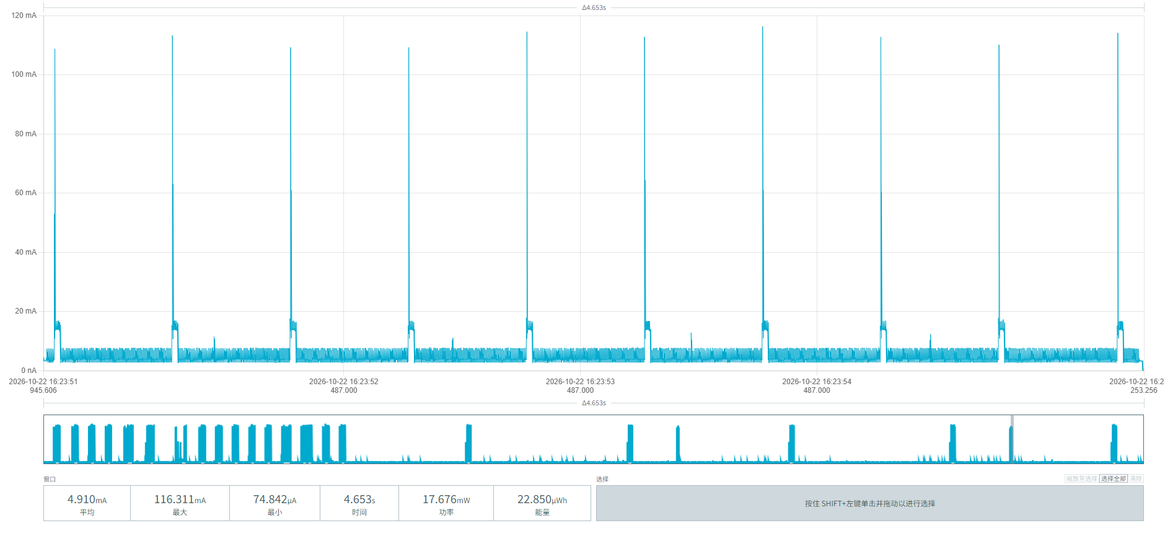
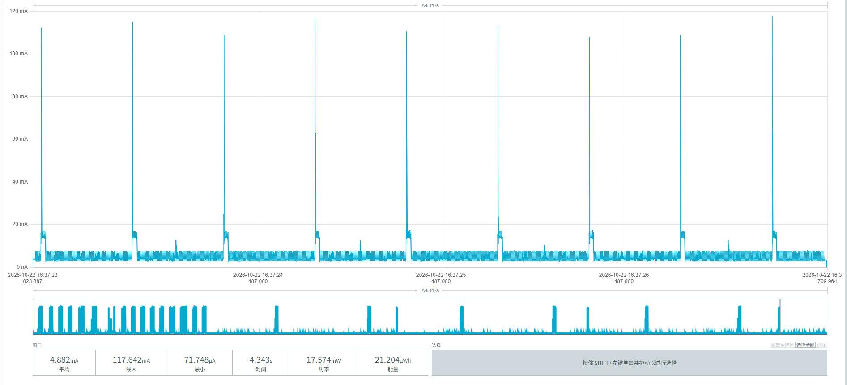
Figure 13 Power consumption of scanning initiated once every 20 minutes

After a vehicle parks above the MPS-100 parking sensor, detection and reporting are triggered. The three screenshots in Figure 14 show the power parameters of the vehicle-arrival process:
Average duration: (14.43 + 14.76 + 14.76) / 3 = 14.65 s
Average current: (7.219 + 7.300 + 7.462) / 3 = 7.327 mA
Average energy: (104.208 + 107.794 + 110.168) / 3 = 107.390 µWh
Converted consumption: 107.390 µWh / 3.6V ≈ 29.83 µAh
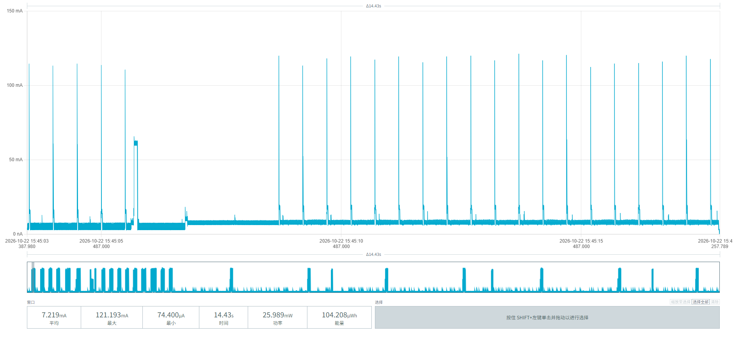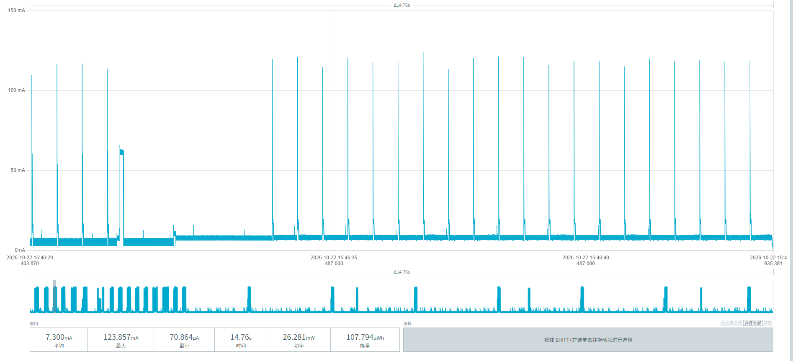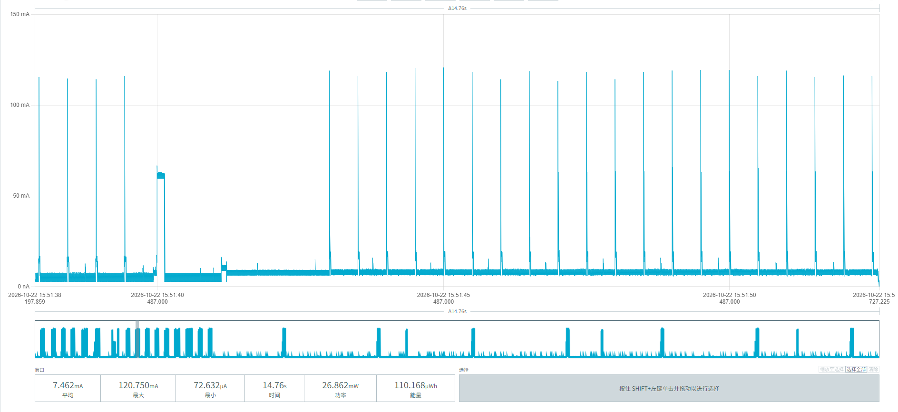
Figure 14 Vehicle arrival power waveform

When the vehicle leaves the area above the MPS-100 parking sensor, detection and reporting are triggered. The three screenshots in Figure 15 show the power parameters of the vehicle-departure process:
Average duration: (14.71 + 14.76 + 14.76) / 3 = 14.743 s
Average current: (7.213 + 7.206 + 7.460) / 3 = 7.293 mA
Average energy: (106.117 + 106.401 + 110.122) / 3 = 107.547 µWh
Converted consumption: 107.547 µWh ÷ 3.6V ≈ 29.874 µAh/event
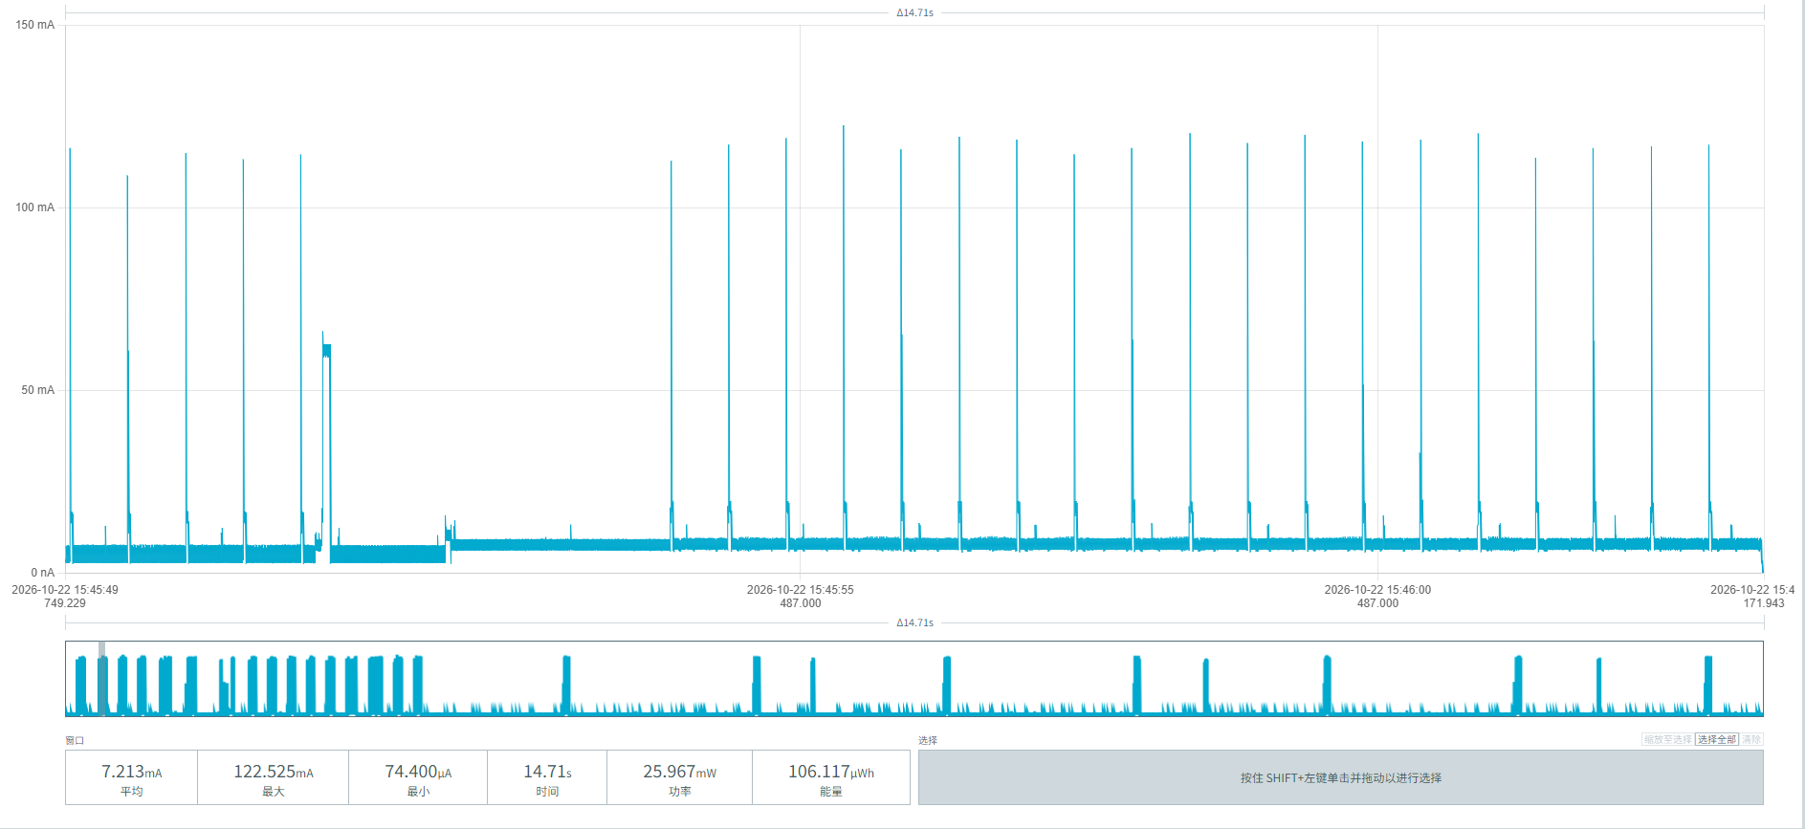
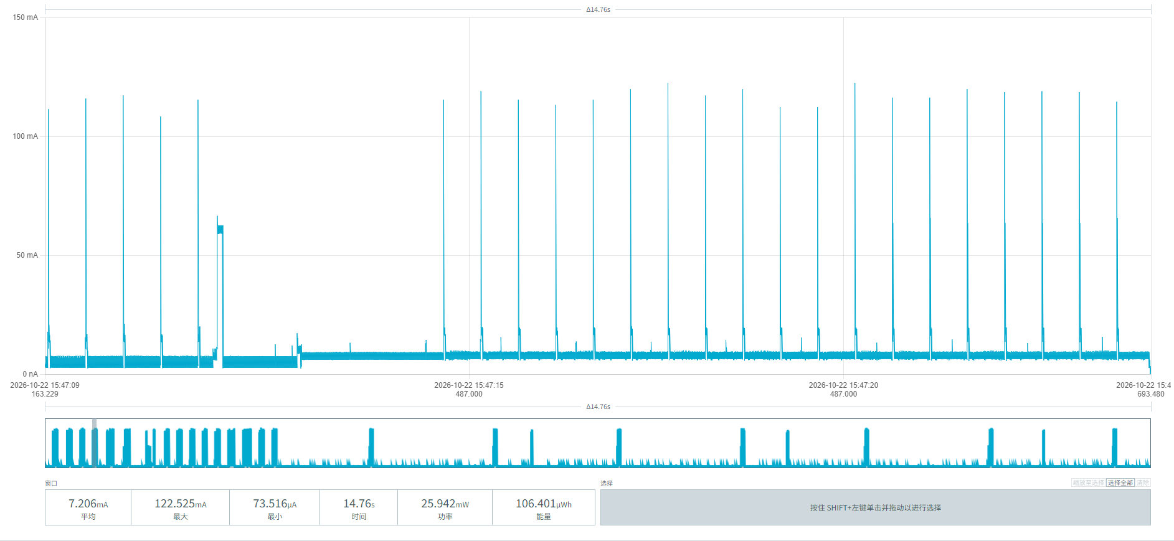
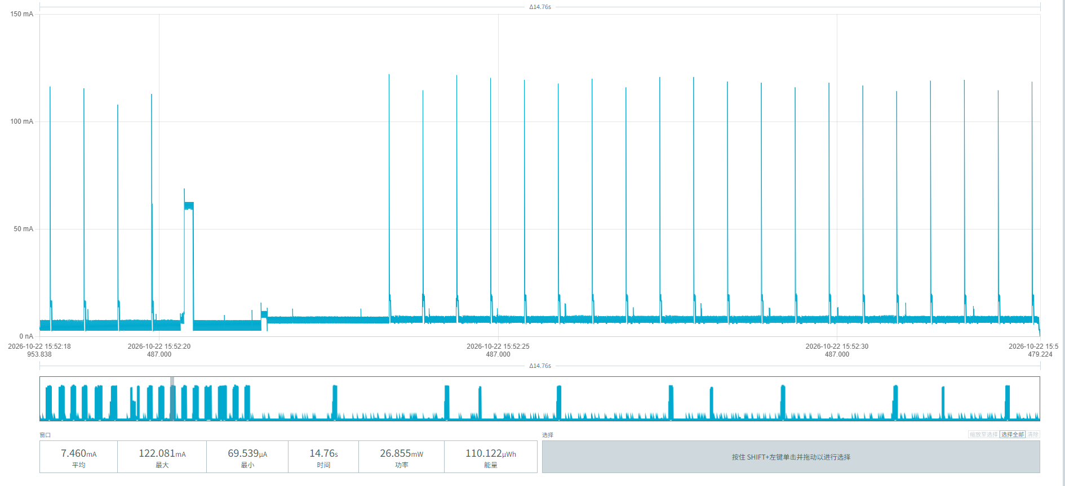
Figure 15 Vehicle departure power waveform

Figure 16 below shows the power parameters of a single periodic report of the MPS-100 parking sensor:
Average duration: (12.81 + 12.96 + 12.22) / 3 = 12.66 s
Average current: (7.873 + 7.851 + 7.890) / 3 = 7.871 mA
Average energy: (100.919 + 101.792 + 96.437) / 3 = 99.716 µWh
Converted consumption: 99.716 µWh ÷ 3.6V = 27.70 µAh/event
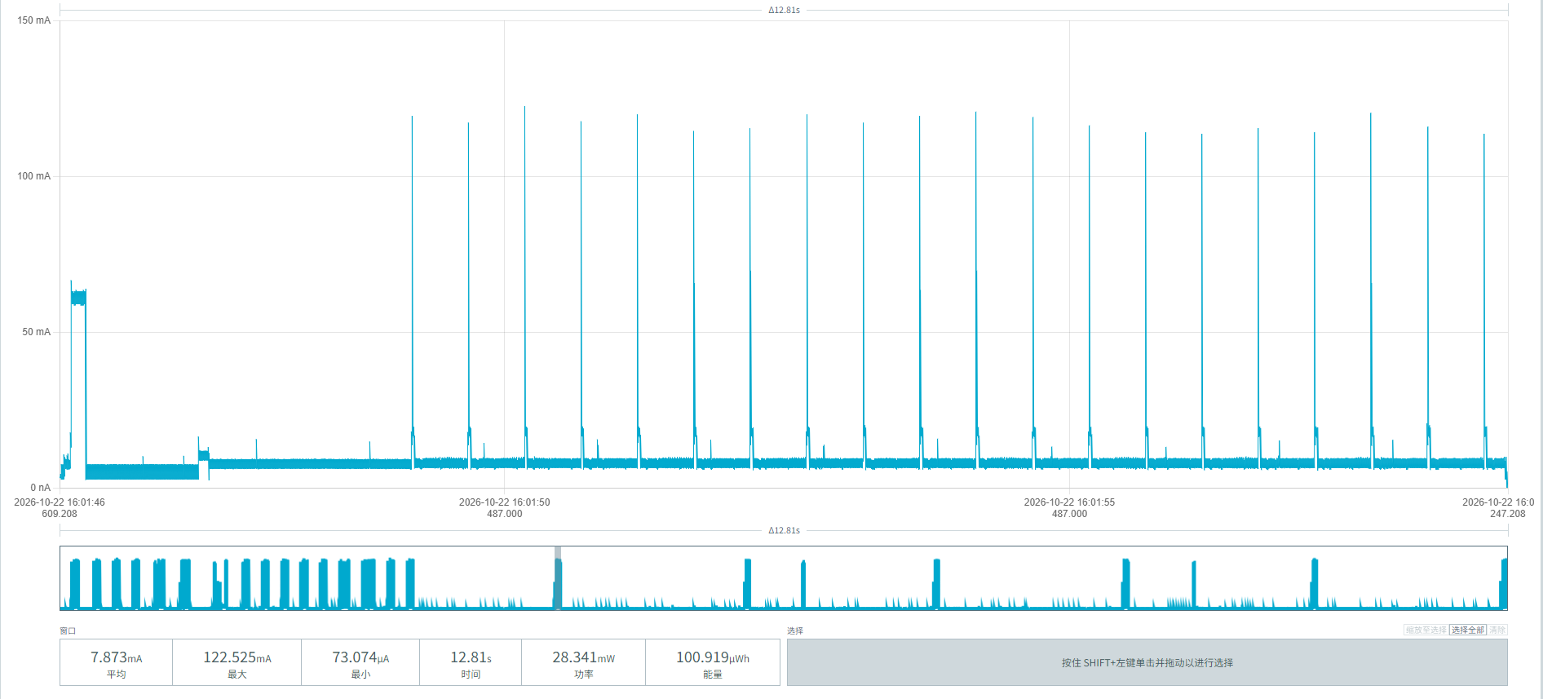
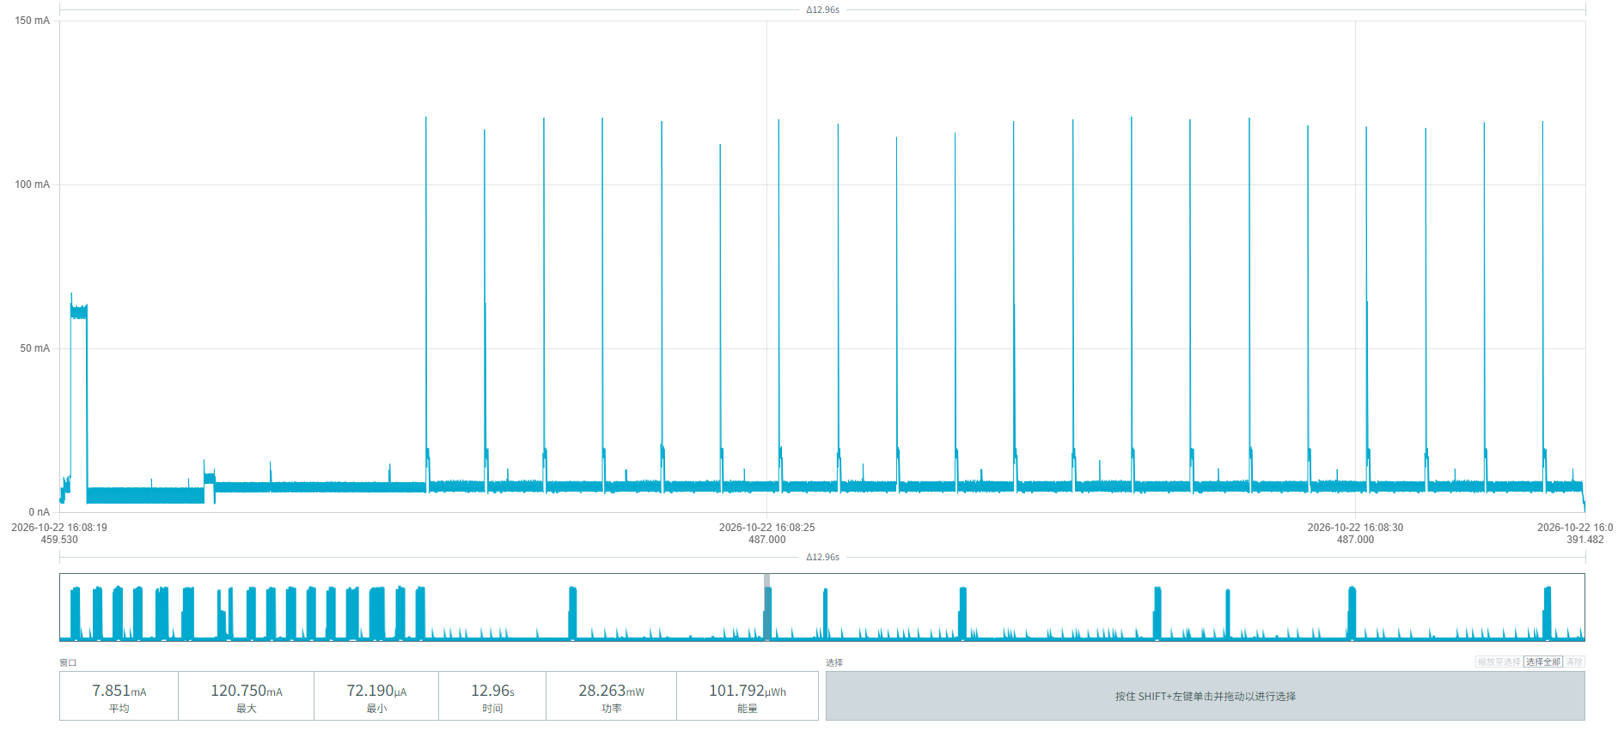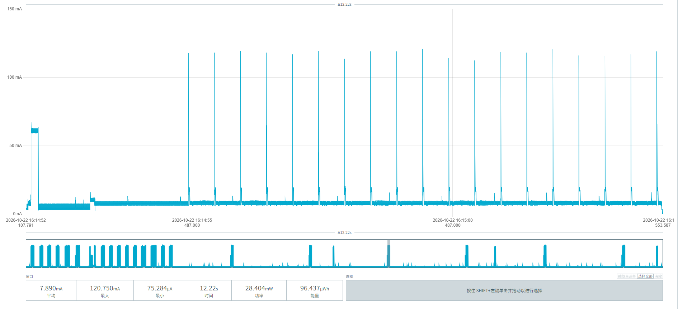
Figure 16 Periodic reporting power waveform

From the segmented power consumption data of device 00956906000AF03E in this chapter, the battery service life under different demand scenarios with an unobstructed network can be calculated:
Baseline parameters:
Initial effective battery capacity: 17000mAh
Idle baseline consumption: 3.2016 mAh/day (noise floor 1.8416 + radar 0.321 + magnetometer 0.586 + 20-minute watchdog wake-up 0.453)
Single complete parking event (incl. 20% margin): 71.64 µAh (latest measurements: arrival 29.83 + departure 29.87, incl. 20% margin)
Single periodic report: 27.70 µAh

Parking frequency | Reporting interval | Daily / Annual consumption (mAh) | Estimated lifetime (iterative)
10 times/day | 1 per hour | 4.583 / 1,672.8 | 9.17 years
 | 1 per 4 hours | 4.084 / 1,490.7 | 10.33 years
 | 1 per 24 hours | 3.946 / 1,440.3 | 10.71 years
30 times/day | 1 per hour | 6.016 / 2,195.8 | 6.84 years
 | 1 per 4 hours | 5.517 / 2,013.7 | 7.51 years
 | 1 per 24 hours | 5.379 / 1,963.3 | 7.71 years

5.2.3 Device 00956906000B06CD
The three waveforms in Figure 17 show no pulses at all — pure sleep noise floor. We can see:
Average current: (74.515+74.543+74.768)/3 ≈ 74.609 µA
Average duration: (989.0+989.5+988.7)/3 ≈ 989.07 ms
Average energy per event: (73.699+73.762+73.928)/3 ≈ 73.796 nWh
Daily noise-floor power can be calculated as: 74.609 µA×24h=1,790.616 µAh/day=1.791mAh/day
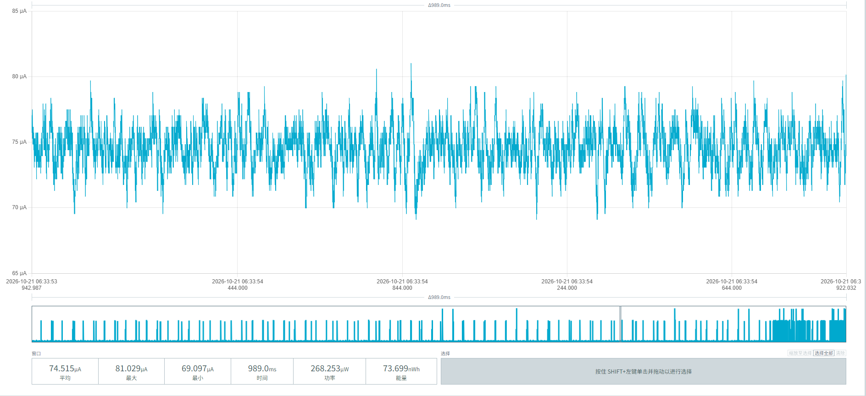
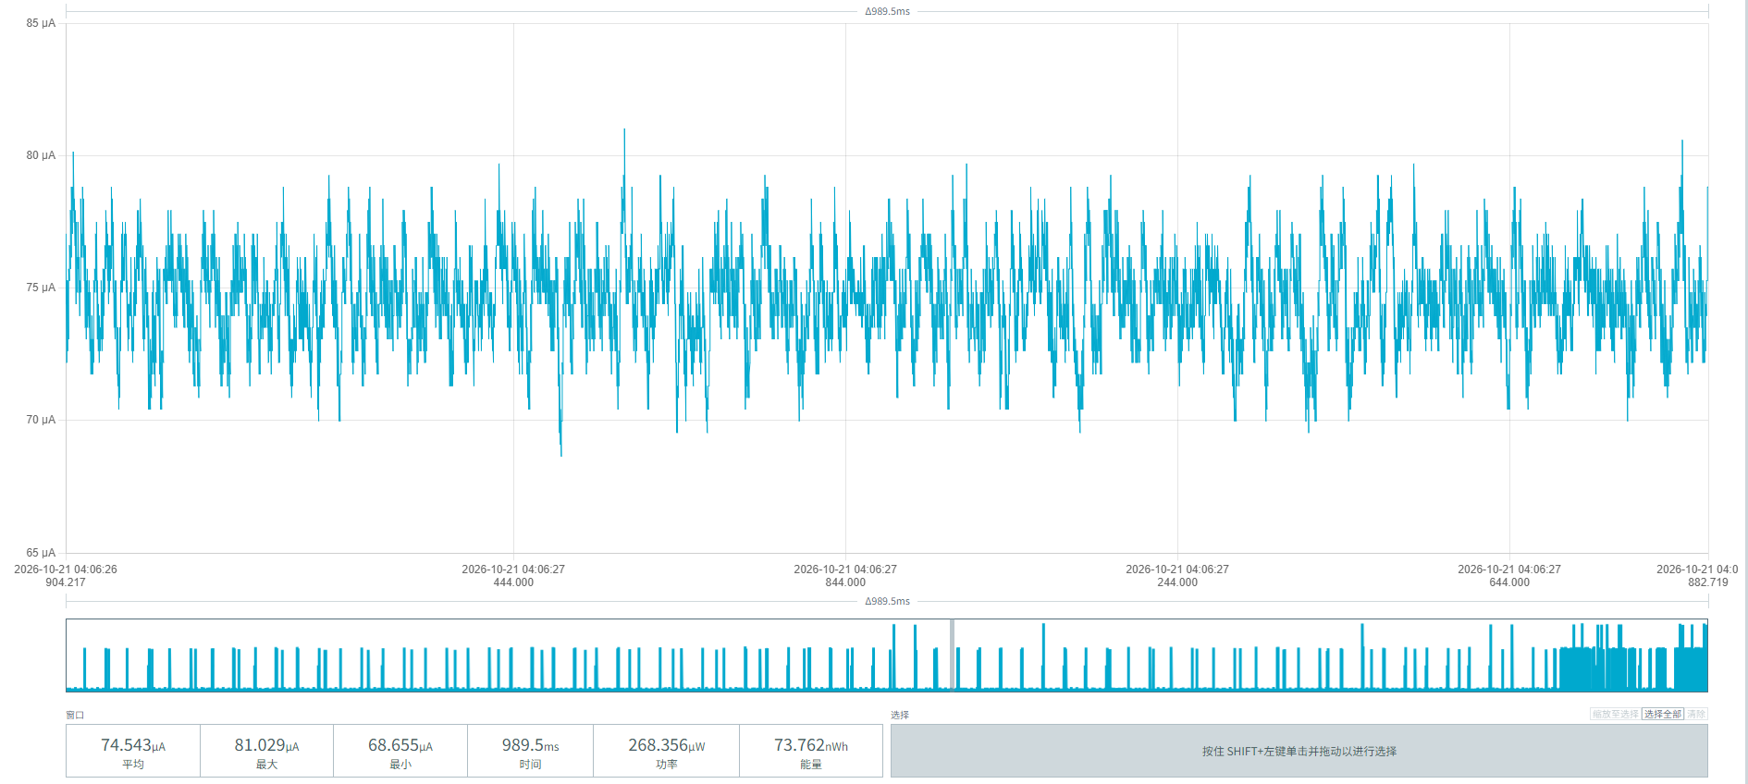
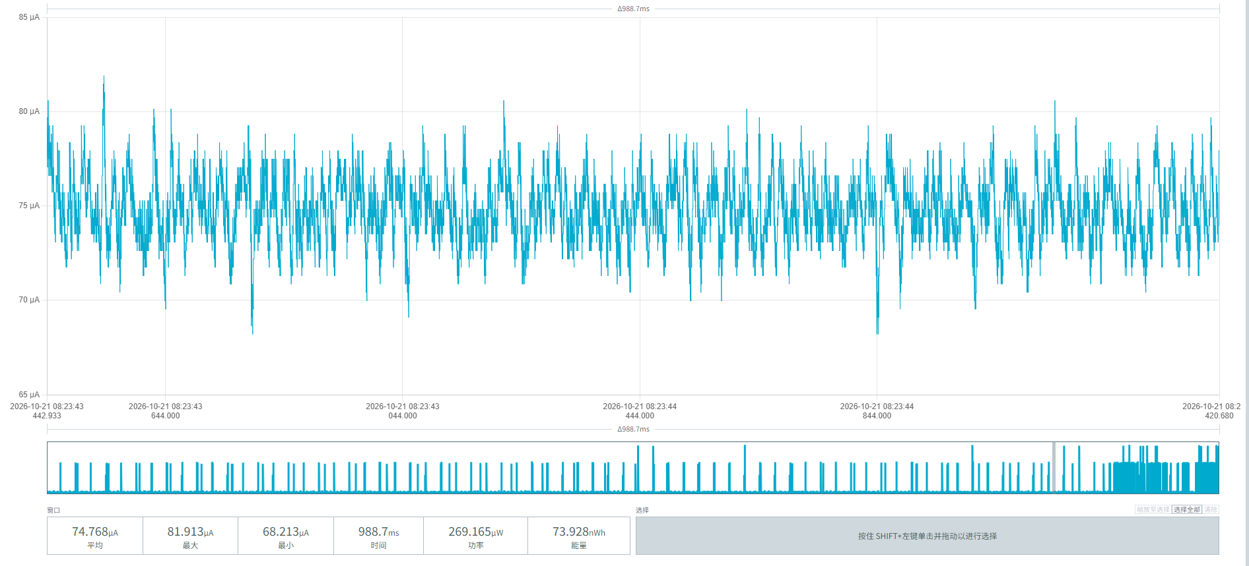
Figure 17 Noise-floor power consumption

After power-on, the radar module of the MPS-100 parking sensor runs automatically with one pulse per second. Figure 18 shows the radar module's baseline operating power:
Average current: (755.756 + 792.872 + 770.825) / 3 = 2319.453 / 3 ≈ 773.151 µA
Mean duration: (17.25 + 17.03 + 17.54) / 3 = 51.82 / 3 ≈ 17.27 ms
Mean energy: (13.038 + 13.503 + 13.527) / 3 = 40.068 / 3 = 13.356 nWh
Consumption per event: 13.356 nWh / 3.6V = 3.71 nAh = 0.00371 µAh/event
The radar baseline operating power can be calculated:
At a frequency of 1 pulse/second, one day has 24 h × 3600 s = 86,400 s, so the number of pulses per day = 86,400
Daily radar baseline operating power: 0.00371 µAh × 86,400 = 320.544 µAh = 0.321 mAh/day
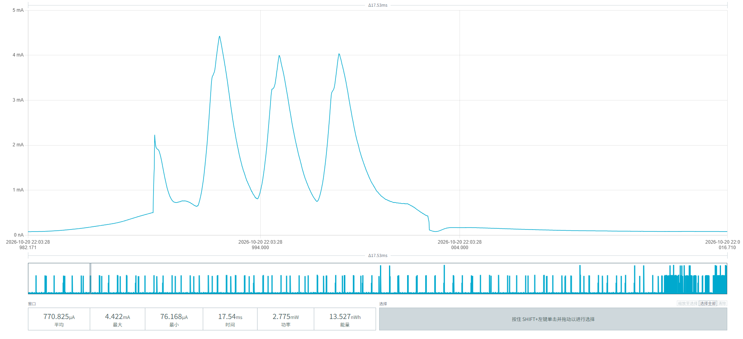
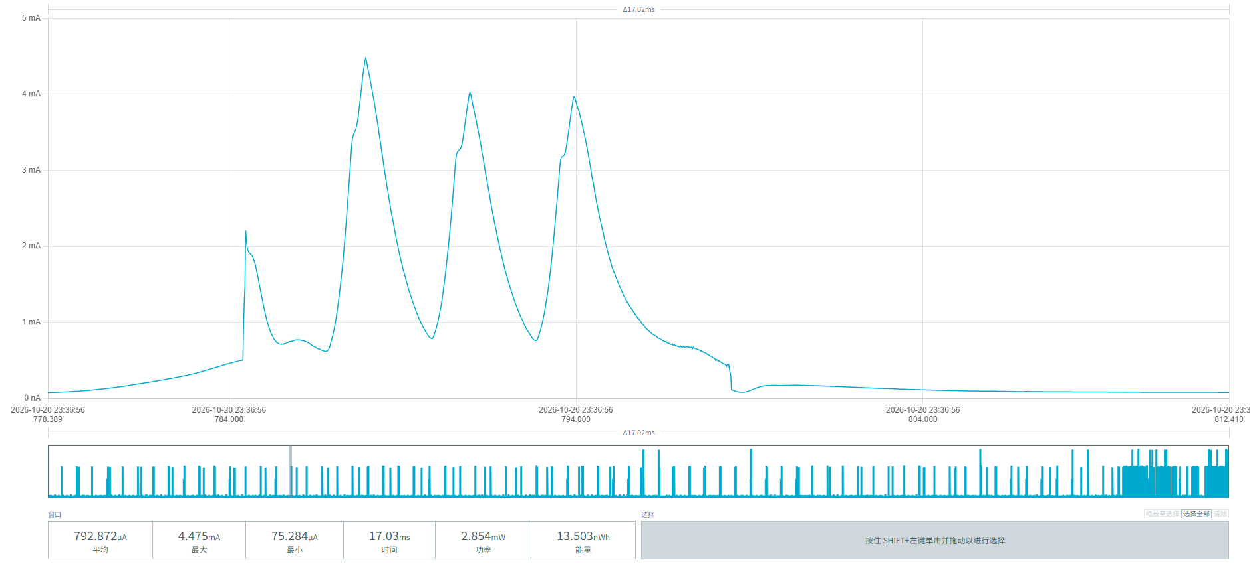
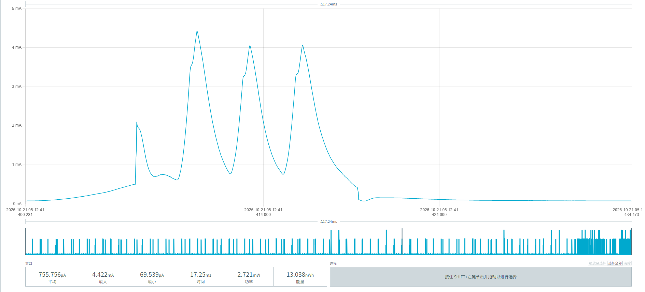
Figure 18 Radar module baseline operating power

After power-on, the MPS-100 parking sensor initiates one magnetometer detection every 8 seconds; Figure 19 shows the magnetometer detection power:
Average current: (3.275 + 3.245 + 3.211) / 3 ≈ 3.244 mA
Average duration: (60.80 + 60.36 + 59.89) / 3 = 60.35 ms
Average energy: (0.196 + 0.196 + 0.195) / 3 ≈ 0.1957 µWh
Average consumption per event: 0.19567 µWh / 3.6V = 0.05435 µAh/event
Cycles per day: 86,400 s ÷ 8 s = 10,800
Daily magnetometer detection power: 0.05435 µAh × 10800 = 586.98 µAh = 0.587 mAh/day
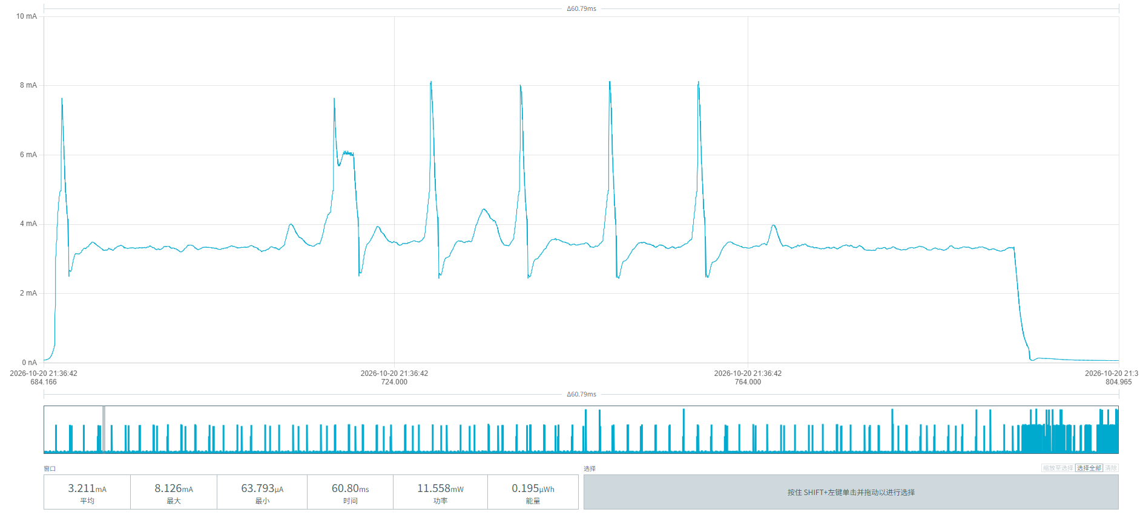
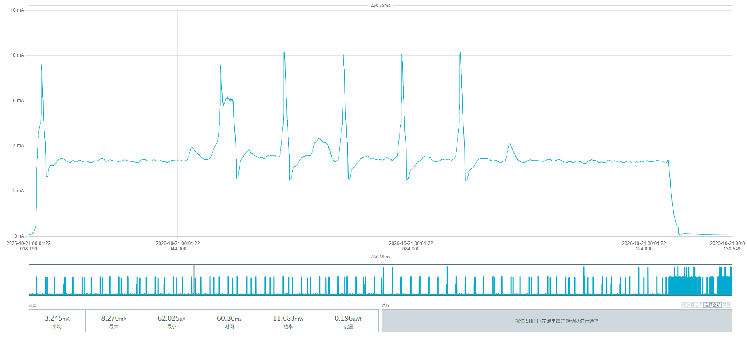
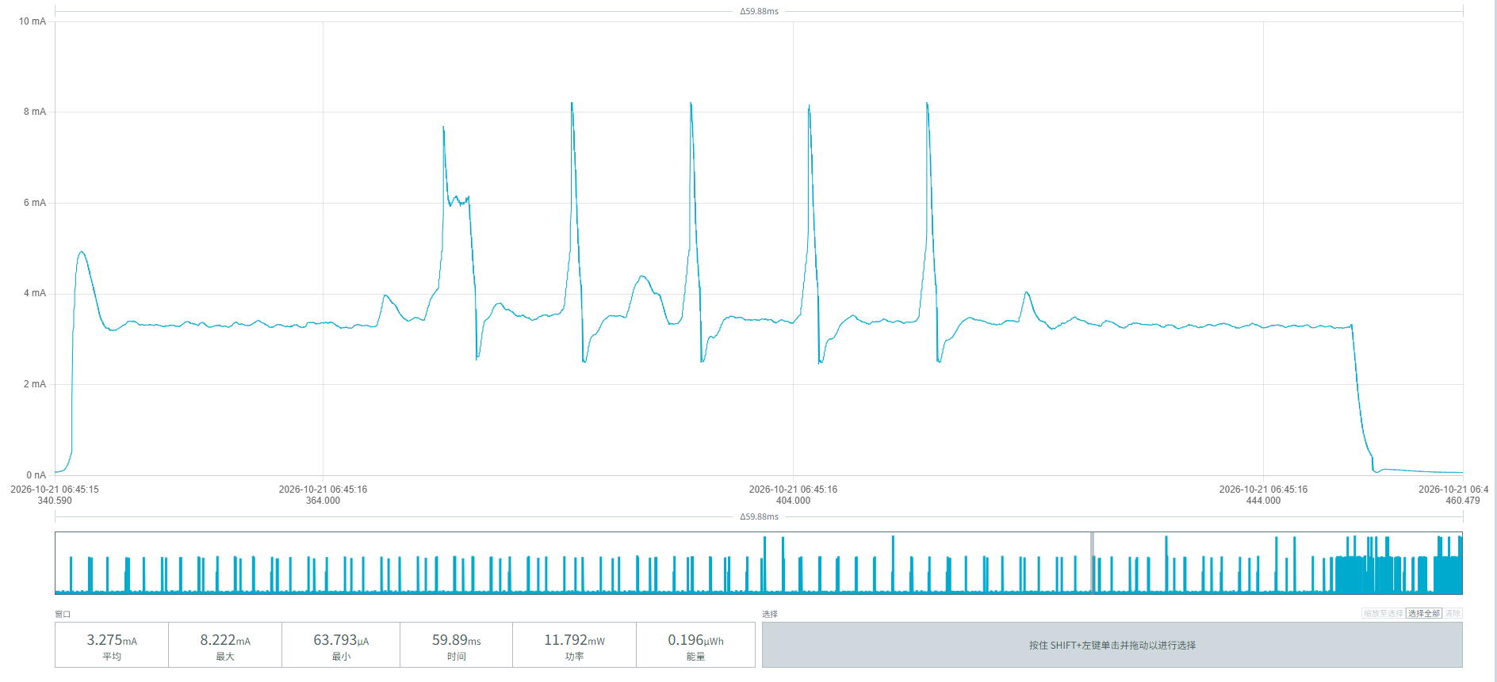
Figure 19 Power consumption of magnetometer detection initiated once every 8 seconds

The MPS-100 parking sensor periodically wakes up to poll the radar module once every 20 minutes. The three screenshots in Figure 20 show the power consumption of this process:
Average current: (4.859 + 4.824 + 4.879) / 3 ≈ 4.854 mA
Average duration: (4.240 + 4.509 + 4.165) / 3 ≈ 4.305 s
Average energy: (20.607 + 21.754 + 20.320) / 3 ≈ 20.894 µWh
Average consumption per event: 20.894 µWh / 3.6V ≈ 5.804 µAh/event
Events per day = 24 h × 60 min / 20 min = 72 times/day
Daily consumption: 5.804 µAh × 72 ≈ 0.418 mAh/day
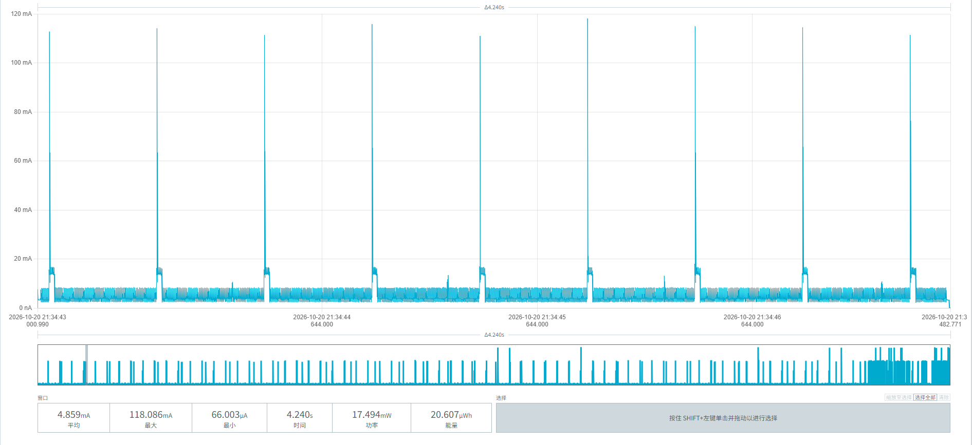
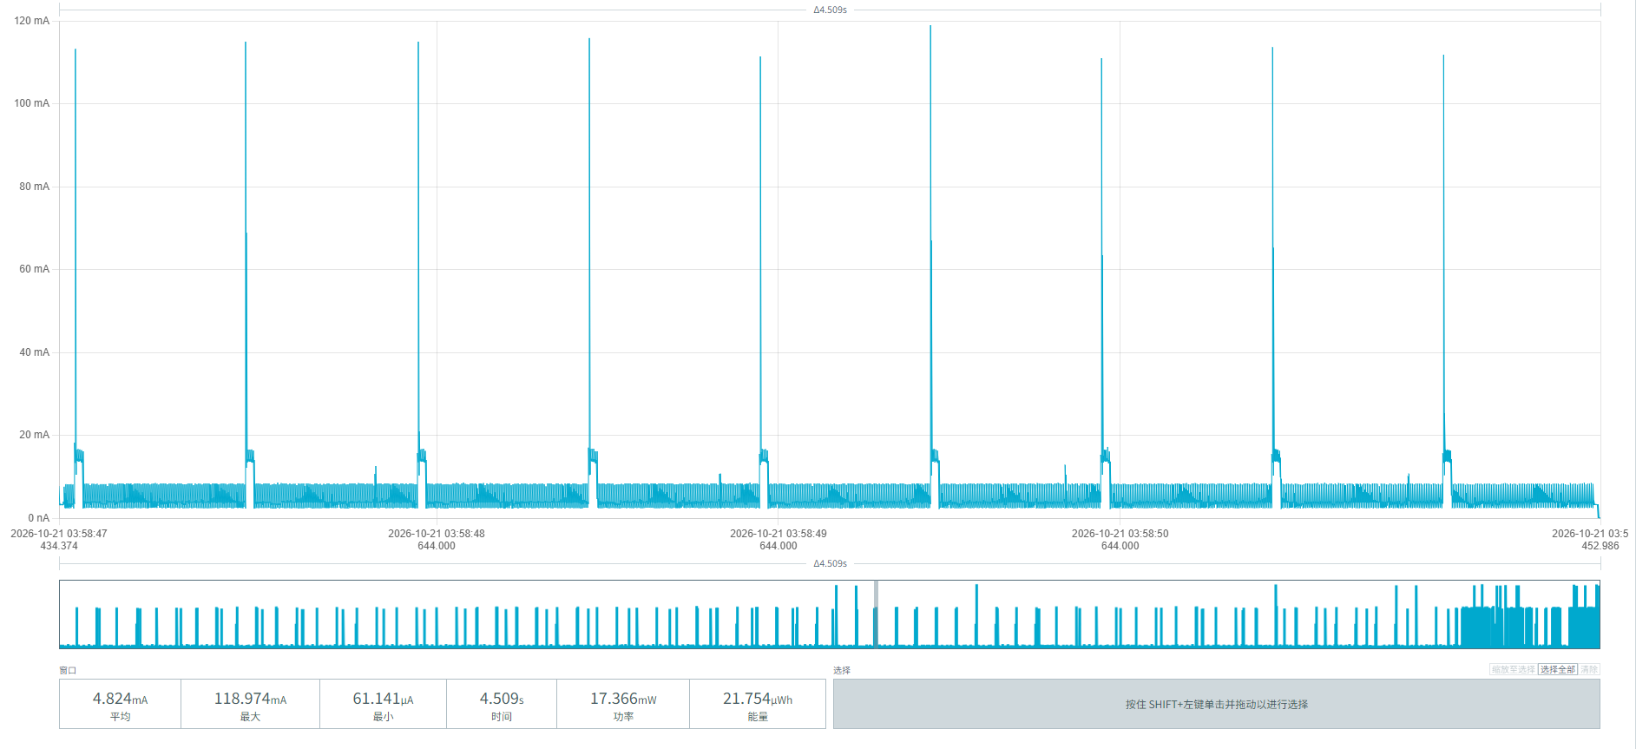
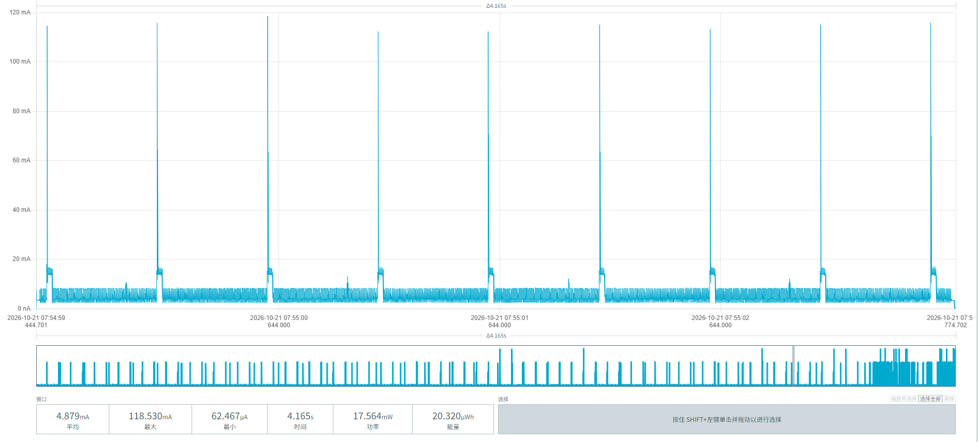
Figure 20 Power consumption of scanning initiated once every 20 minutes

After a vehicle parks above the MPS-100 parking sensor, detection and reporting are triggered. The three screenshots in Figure 21 show the power parameters of the vehicle-arrival process:
Average current: (7.957 + 7.938 + 7.941) / 3 = 7.945 mA
Average duration: (14.84 + 14.89 + 14.99) / 3 = 14.91 s
Total energy per event: (118.119 + 118.233 + 118.273) / 3 = 118.208 µWh
Average consumption per event = 118.208 µWh / 3.6V = 32.84 µAh
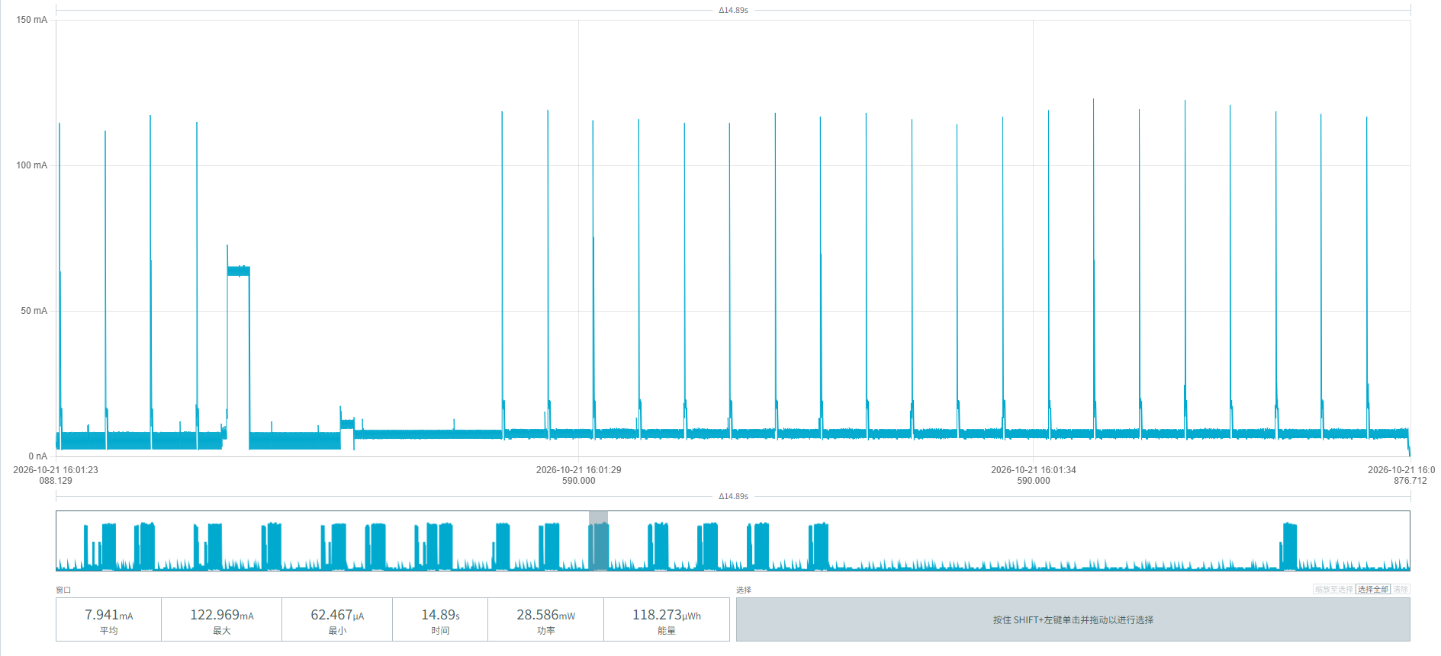
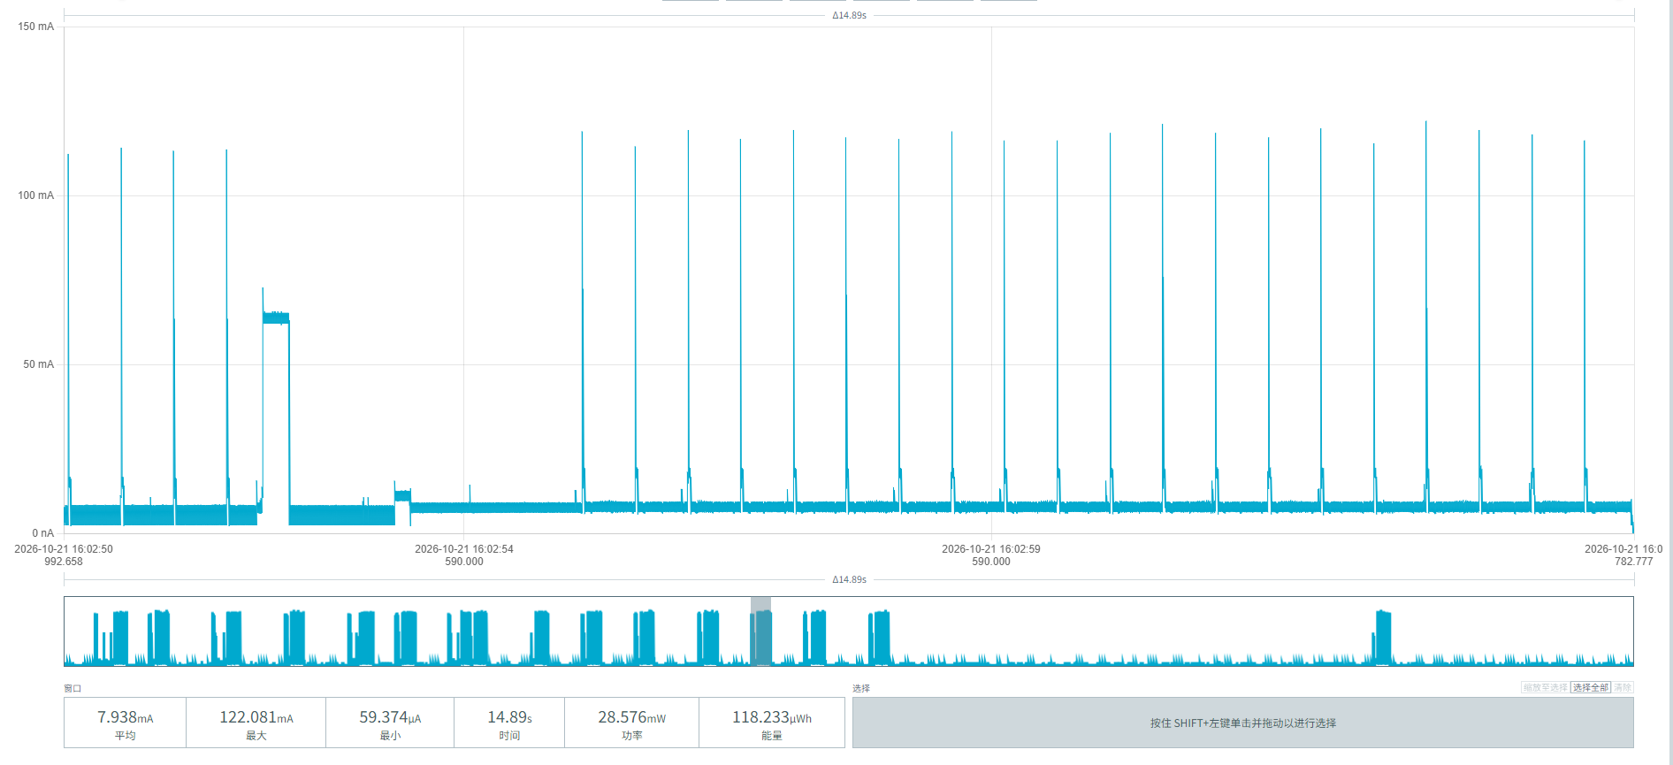
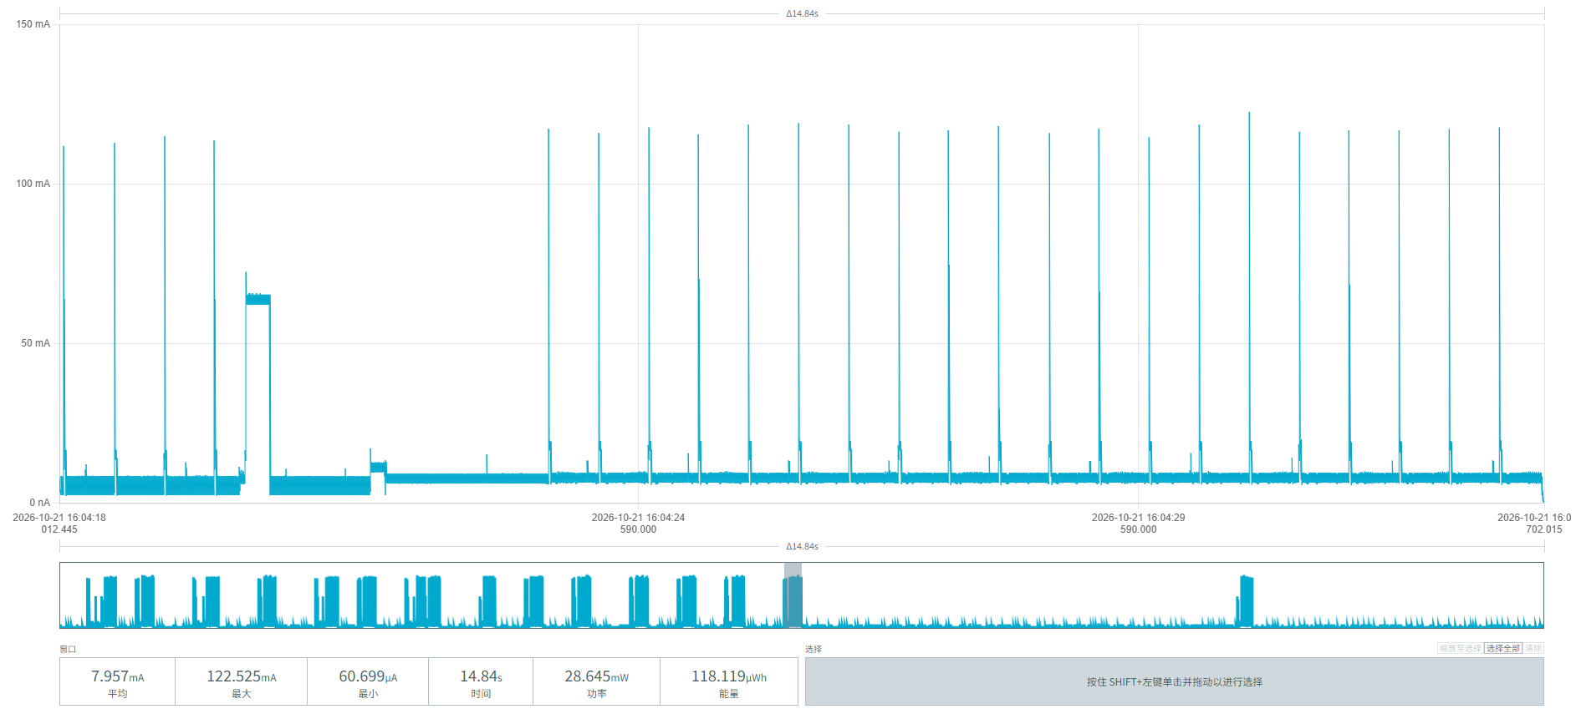
Figure 21 Vehicle arrival power screenshots

When the vehicle leaves the area above the MPS-100 parking sensor, detection and reporting are triggered. The three screenshots in Figure 22 show the power parameters of the vehicle-departure process:
Average current: (7.951 + 7.962 + 7.686) / 3 ≈ 7.866 mA
Duration: (14.89 + 14.85 + 15.89) / 3 ≈ 15.21 s
Energy per event: (118.446 + 118.253 + 122.179) / 3 = 119.626 µWh
Average consumption per event: 119.626 / 3.6 = 33.229 µAh
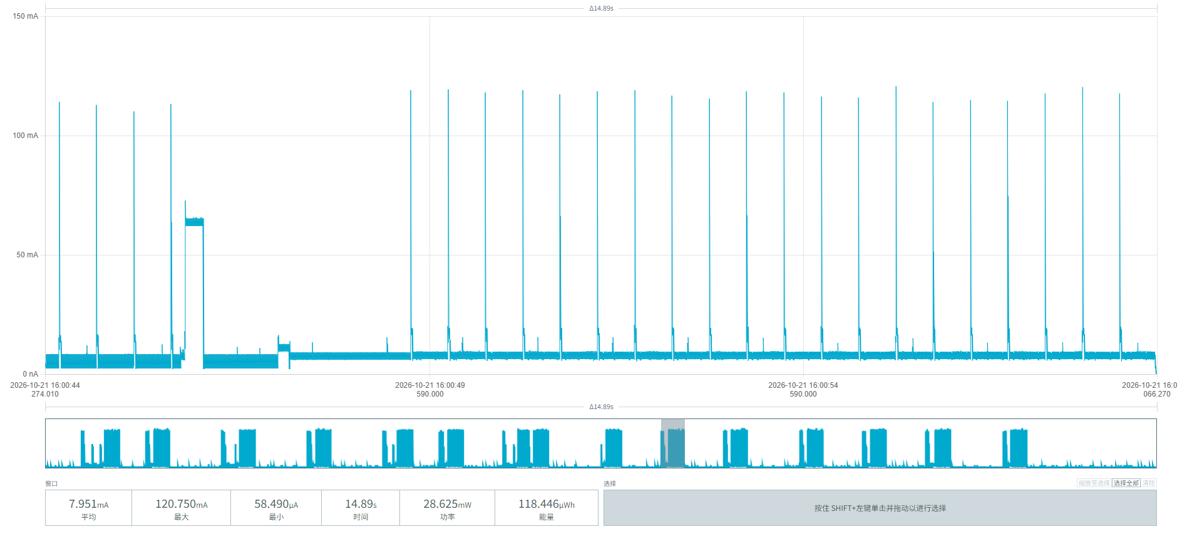
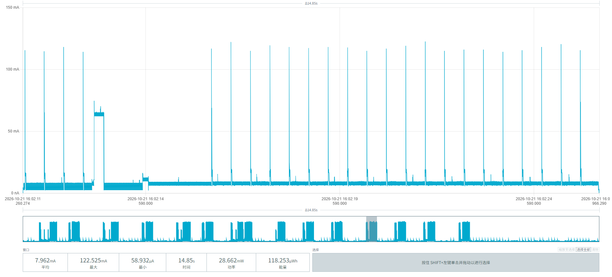
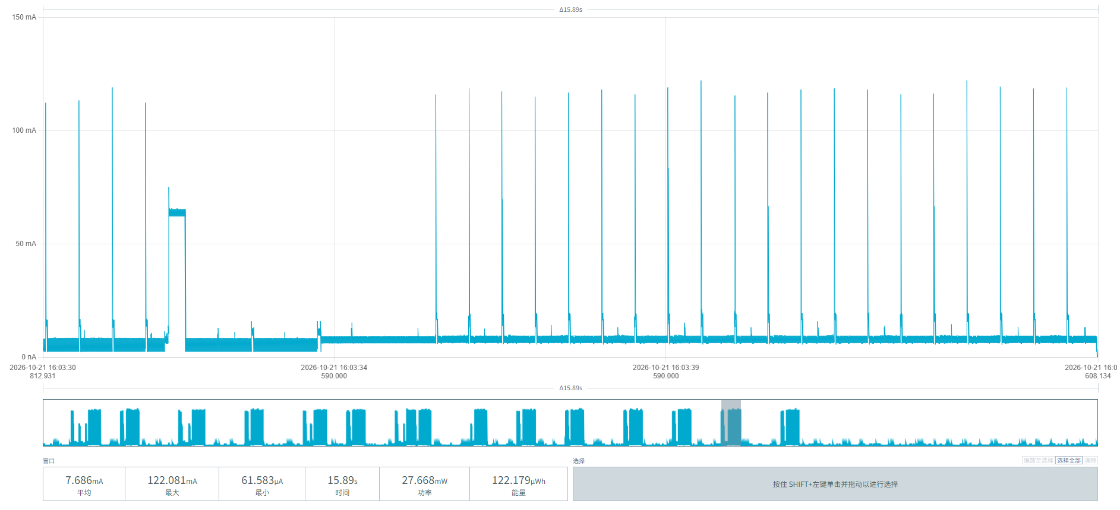
Figure 22 Vehicle departure power screenshots

Figure 23 shows the power parameters of a single periodic report of the MPS-100 parking sensor:
Average current: (7.585 + 7.868 + 7.886) / 3 ≈ 7.780 mA
Average duration per event: (12.43 + 12.84 + 12.76) / 3 ≈ 12.68 s
Average energy per event: (94.303 + 101.030 + 100.640) / 3 ≈ 98.658 µWh
Average consumption per event: 98.658 µWh / 3.6V = 27.405 µAh
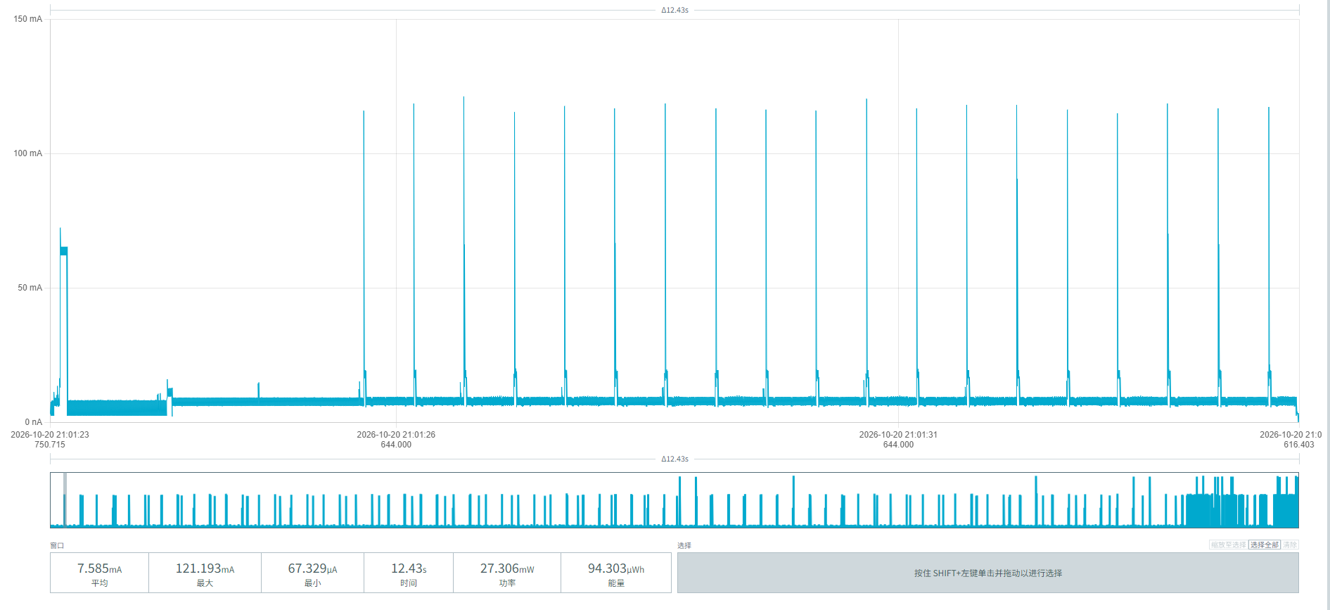
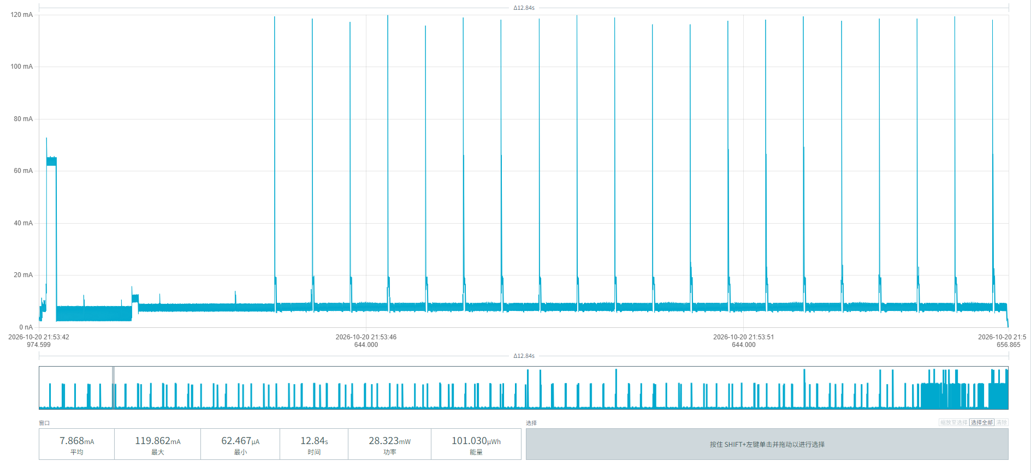
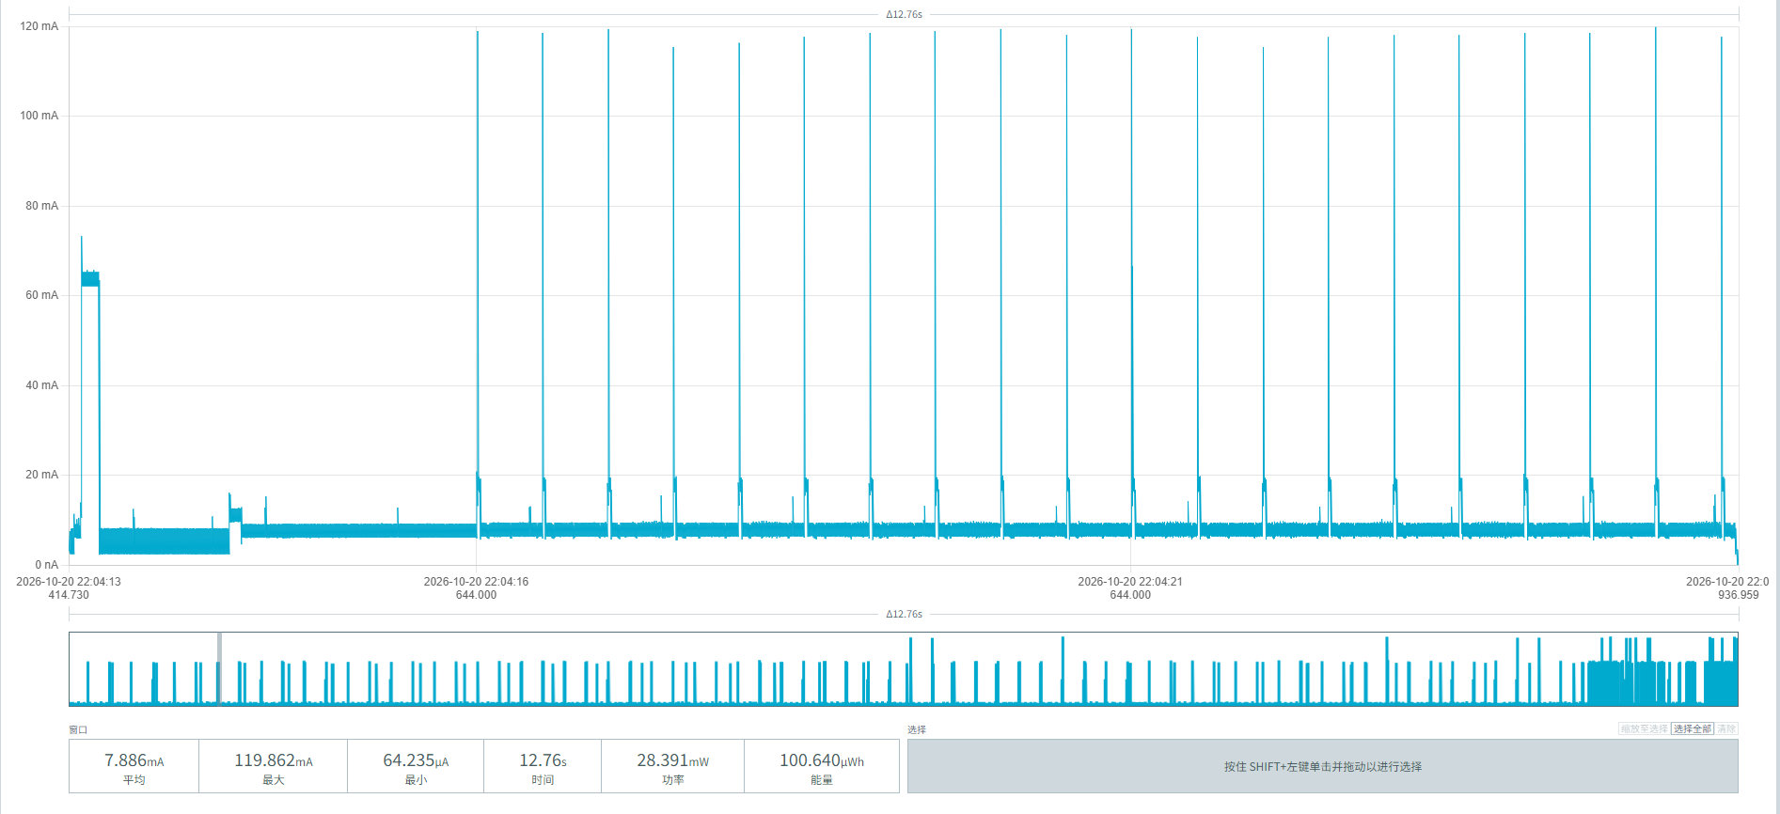
Figure 23 Periodic reporting power screenshots

From the segmented power consumption data of device 00956906000B06CD in this chapter, the battery service life under different demand scenarios with an unobstructed network can be calculated:
Baseline parameters:
Initial effective battery capacity: 17000mAh
Idle baseline consumption: 3.117 mAh/day (noise floor 1.791 + radar 0.321 + magnetometer 0.587 + 20-minute watchdog wake-up 0.418)
Single complete parking event: (arrival 32.84 µAh + departure 33.229 µAh, incl. 20% margin) 79.27 µAh
Single periodic report: 27.405 µAh
Parking frequency | Reporting interval | Daily / Annual consumption (mAh) | Estimated lifetime (iterative)
10 times/day | 1 per hour | 4.568 / 1,667.3 | 9.20 years
 | 1 per 4 hours | 4.074 / 1,487.0 | 10.36 years
 | 1 per 24 hours | 3.937 / 1,437.0 | 10.73 years
30 times/day | 1 per hour | 6.153 / 2,245.8 | 6.68 years
 | 1 per 4 hours | 5.659 / 2,065.5 | 7.31 years
 | 1 per 24 hours | 5.522 / 2,015.5 | 7.50 years

5.3 Device Power Consumption Data under Poor Communication Conditions
The MPS-100 parking sensor firmware disables ADR adaptation and sets SF=12. When the device is more than 500 meters from the gateway with obstructions in between, the communication signal is weak (RSSI < -100dBm and SNR < 0), and data reports are retransmitted multiple times — this affects the vehicle arrival, vehicle departure, and periodic reporting power. Other power consumption is unaffected.

5.3.1 Device 00956906000AF026
After a vehicle parks above the MPS-100 parking sensor, detection and reporting are triggered. Figure 24 shows the power parameters:
Average current: (5.963 + 6.239 + 6.004) / 3 ≈ 6.069 mA
Average duration: (28.22 + 25.75 + 27.21) / 3 ≈ 27.06 s
Average energy per event: (168.287 + 160.918 + 164.553) / 3 = 493.758 / 3 ≈ 164.586 µWh
Average consumption per event = 164.586 µWh / 3.6V ≈ 45.72 µAh
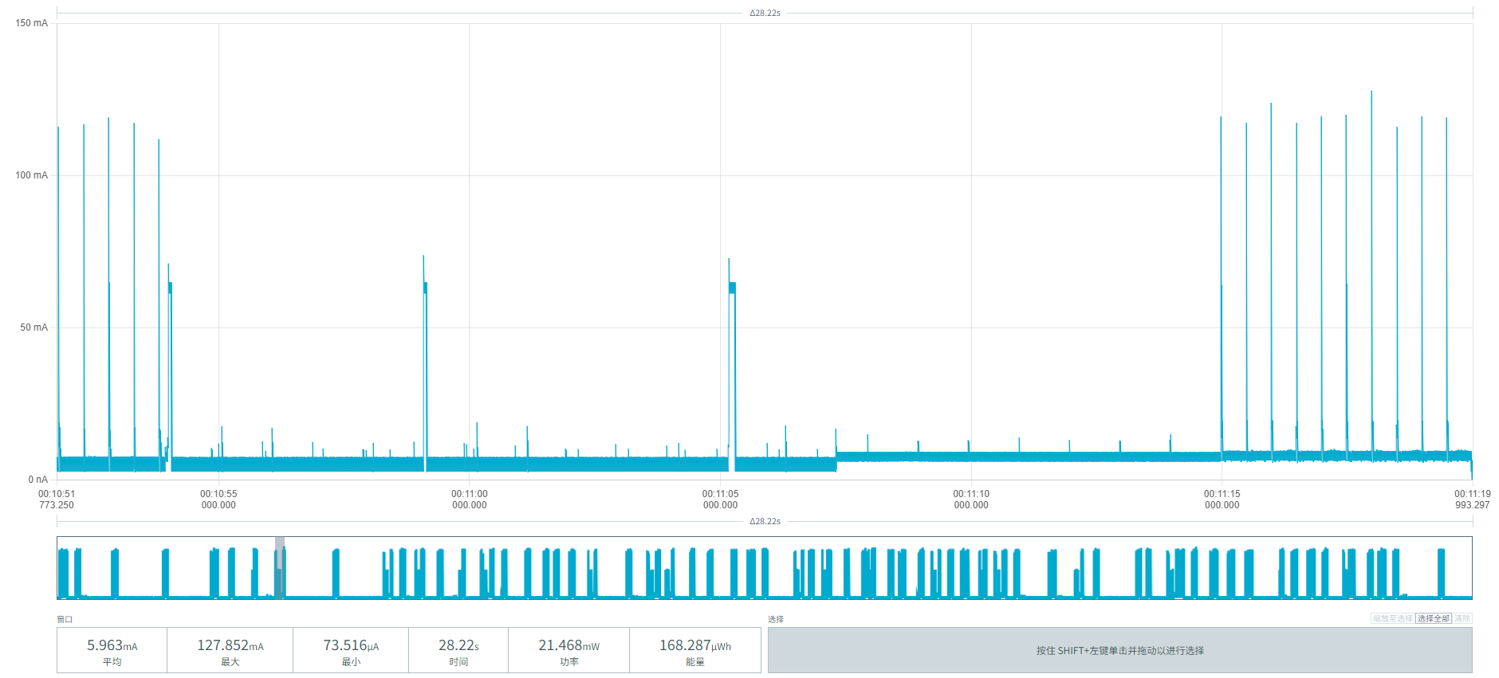
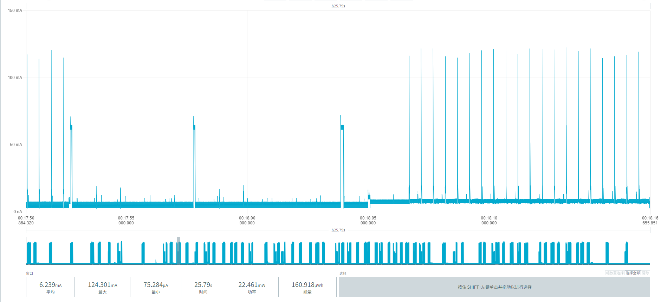
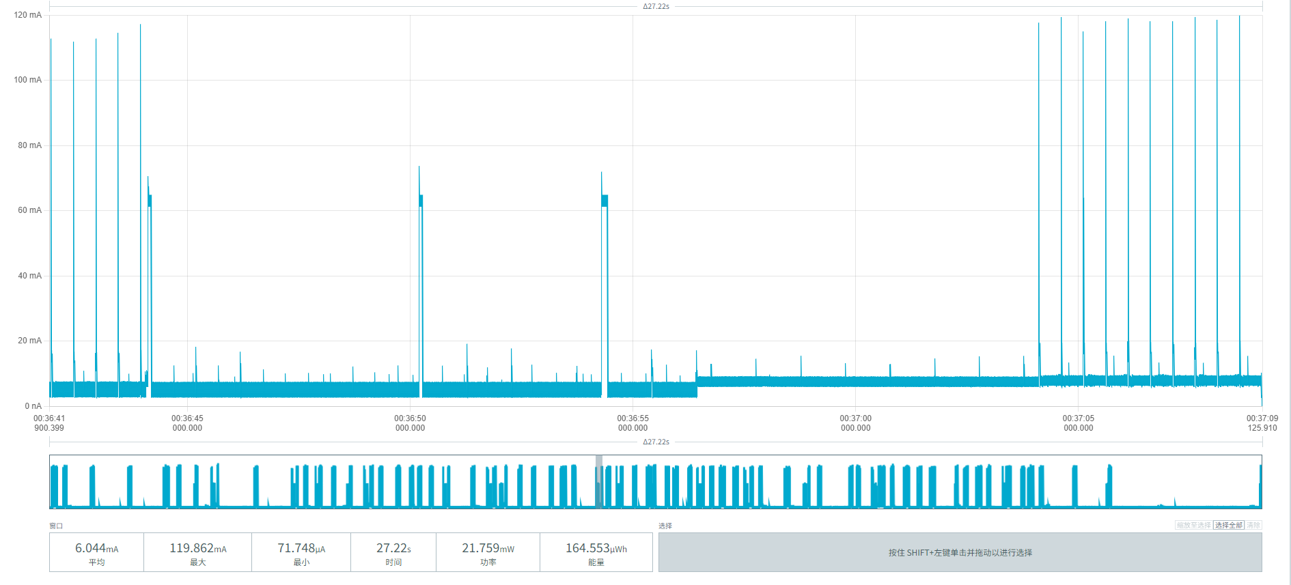
Figure 24 Vehicle arrival power screenshots

When the vehicle leaves the MPS-100 parking sensor, detection and reporting are triggered. Figure 25 shows the power parameters:
Average current: (6.222+6.131+6.137)/3 = 6.163mA
Average duration per event: (25.22 + 26.22 + 26.54) / 3 = 77.98 / 3 ≈ 25.99 s
Average energy per event: (156.948 + 160.757 + 164.759) / 3 = 482.464 / 3 = 160.821 µWh
Average consumption per event: 160.821 / 3.6 ≈ 44.672 µAh
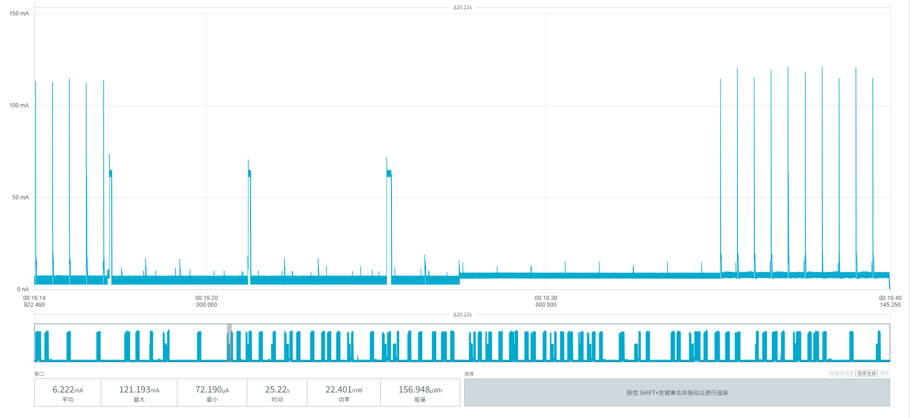
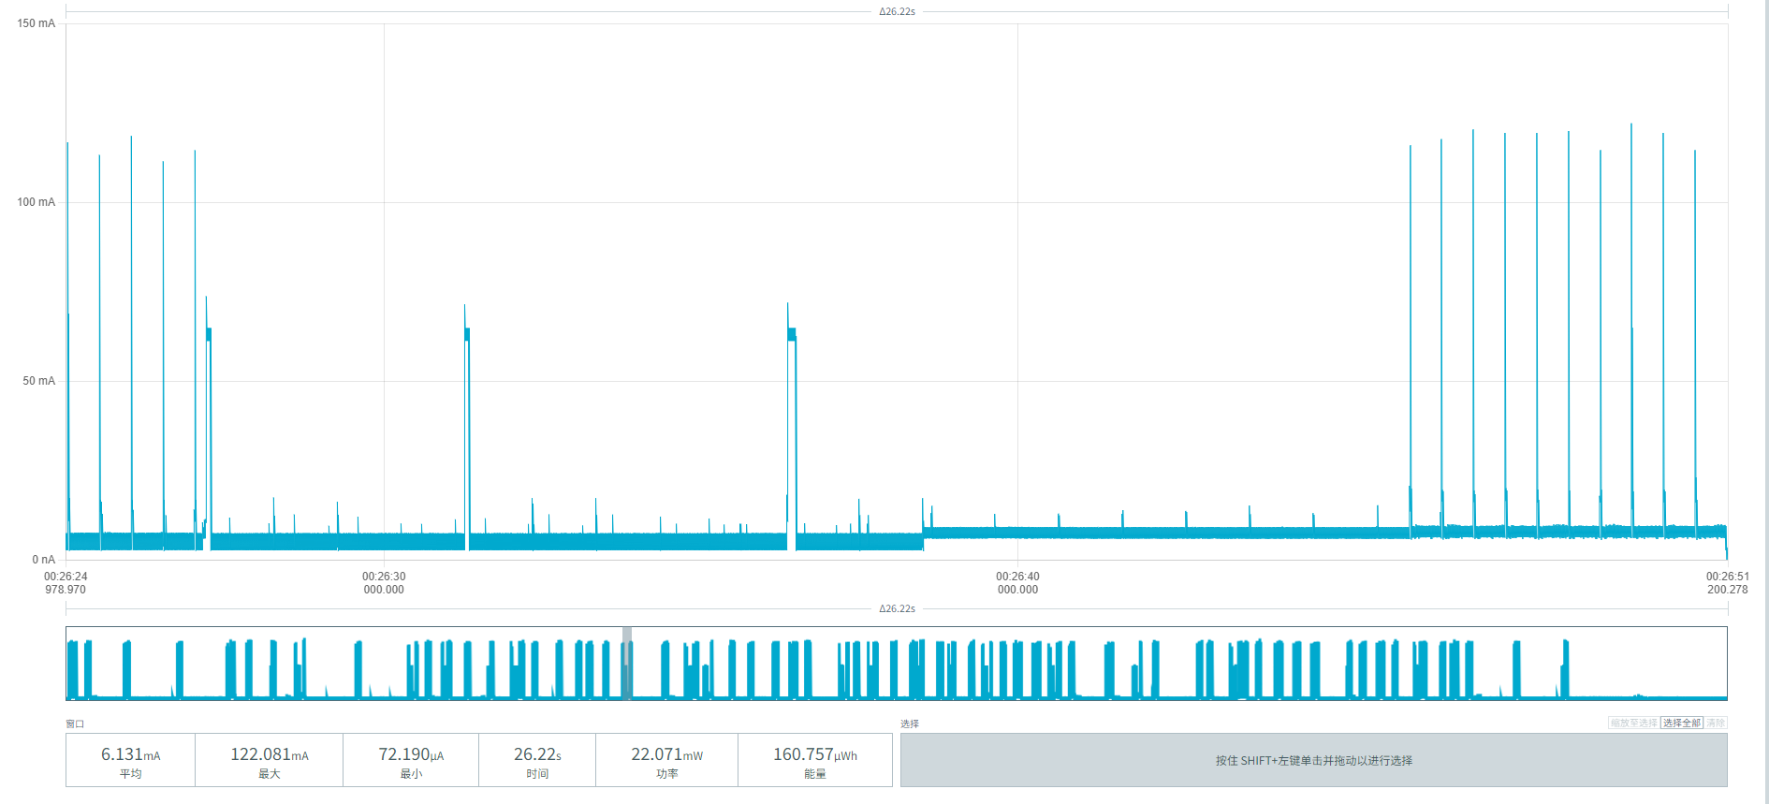
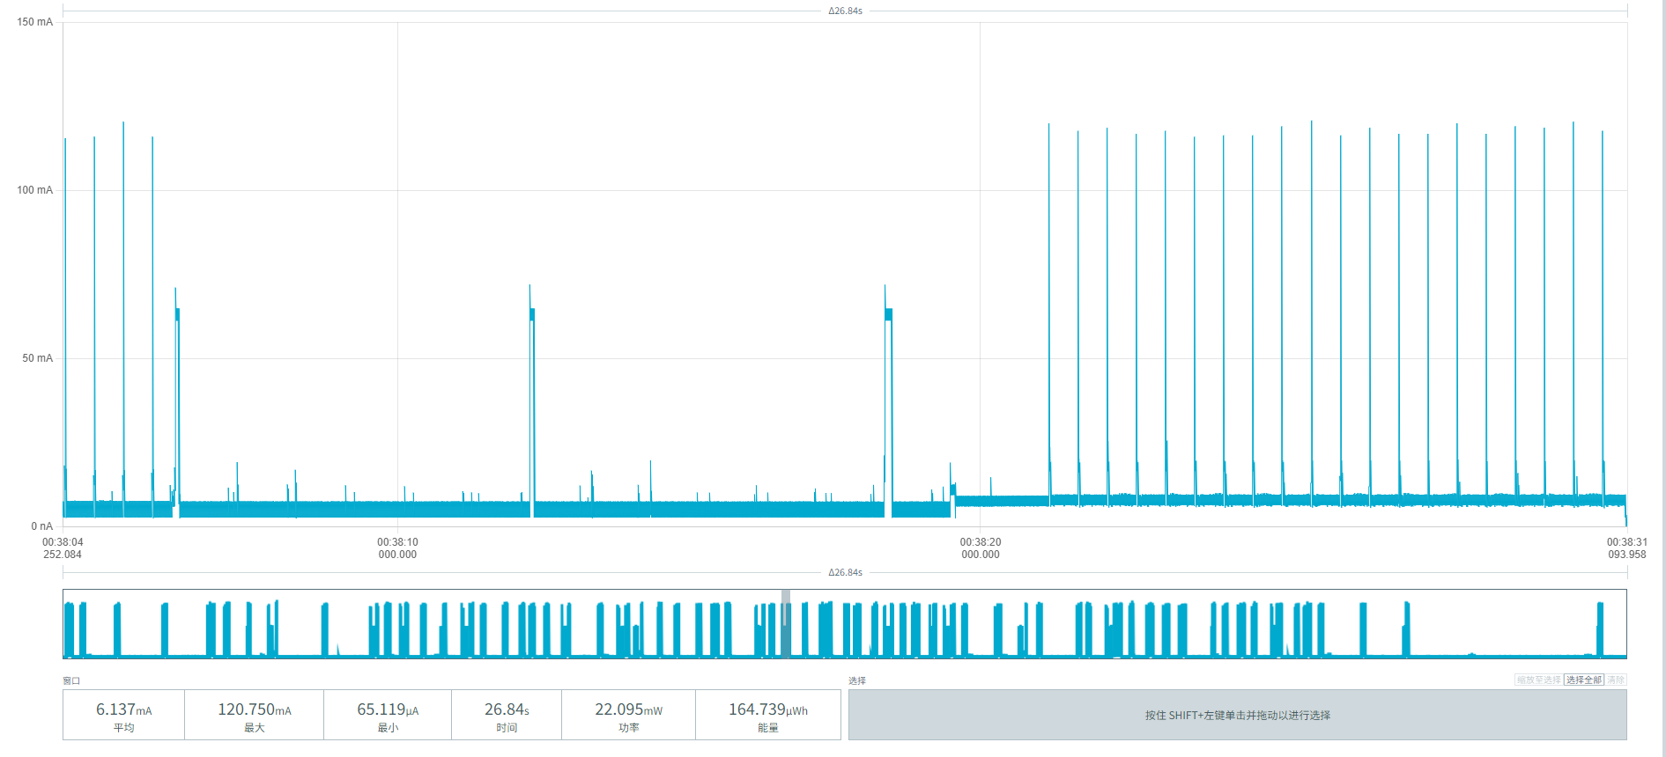
Figure 25 Vehicle departure power screenshots

Figure 26 shows the periodic reporting power of the MPS-100 parking sensor:
Average current: (6.042+6.134+6.713)/3=18.889/3≈6.296 mA
Average duration per event: (26.00+25.10+17.21)/3=68.31/3=22.77 s
Average energy per event: (157.676+153.999+115.596)/3=427.271/3=142.4237 µWh
Average consumption per event: 142.4237 µWh/3.6 V=39.562 µAh
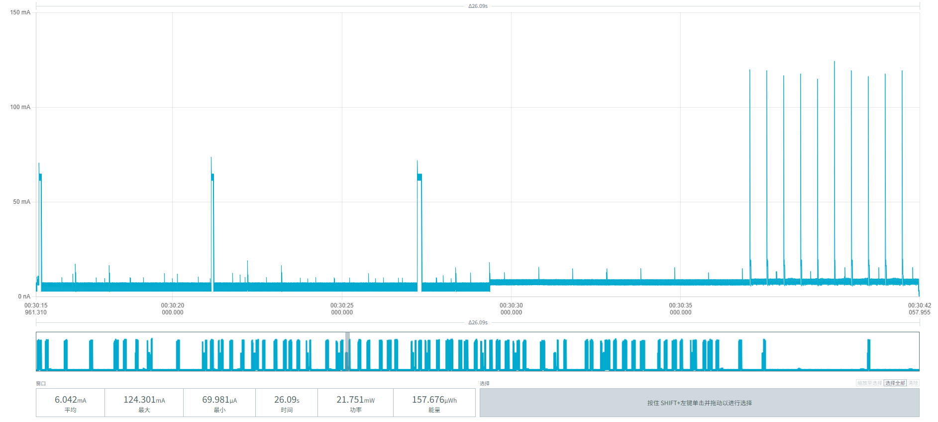
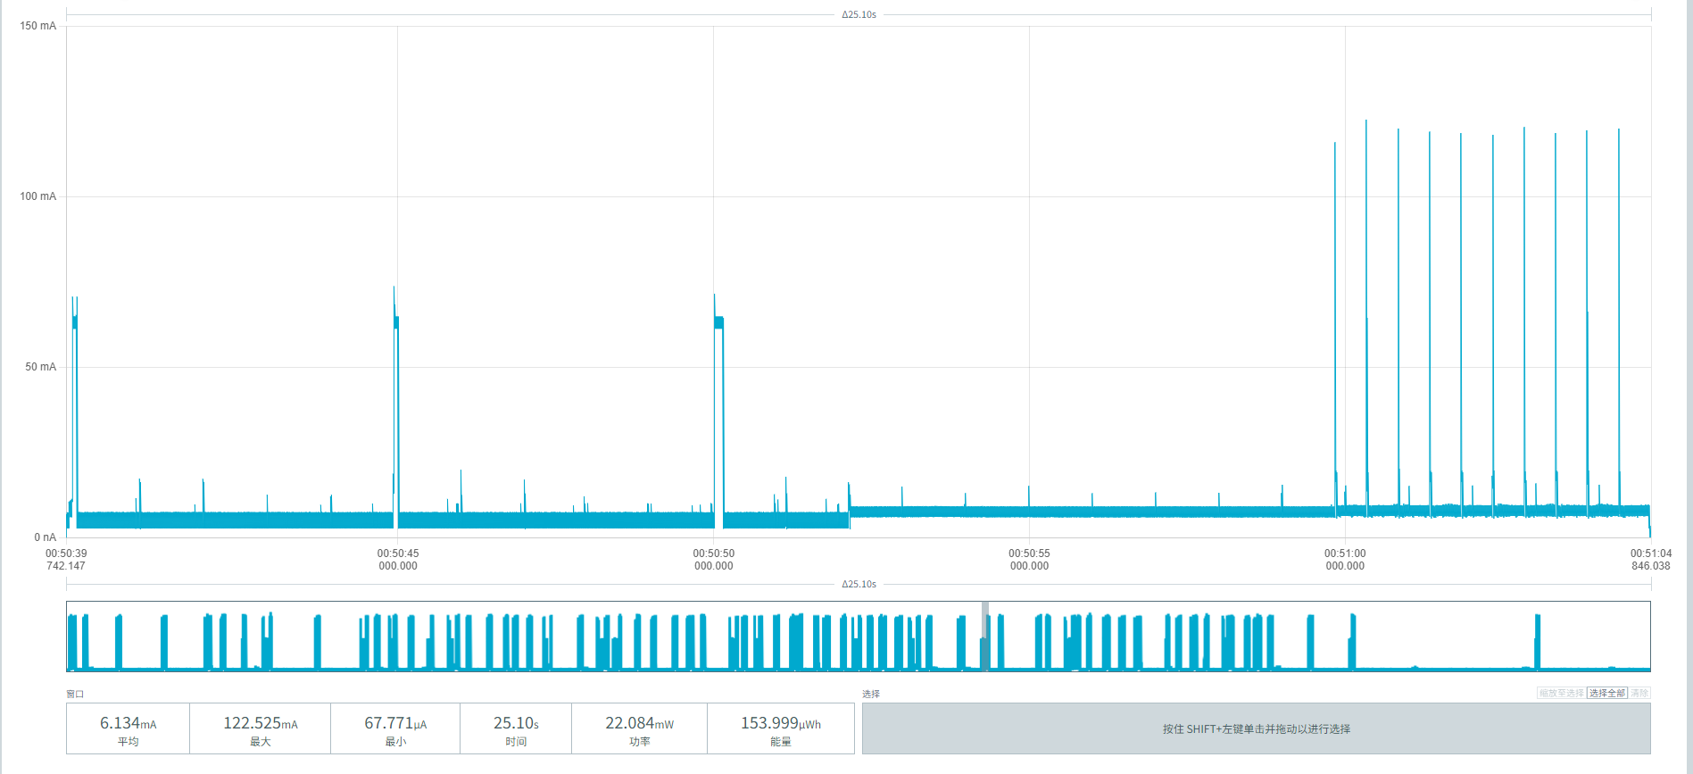
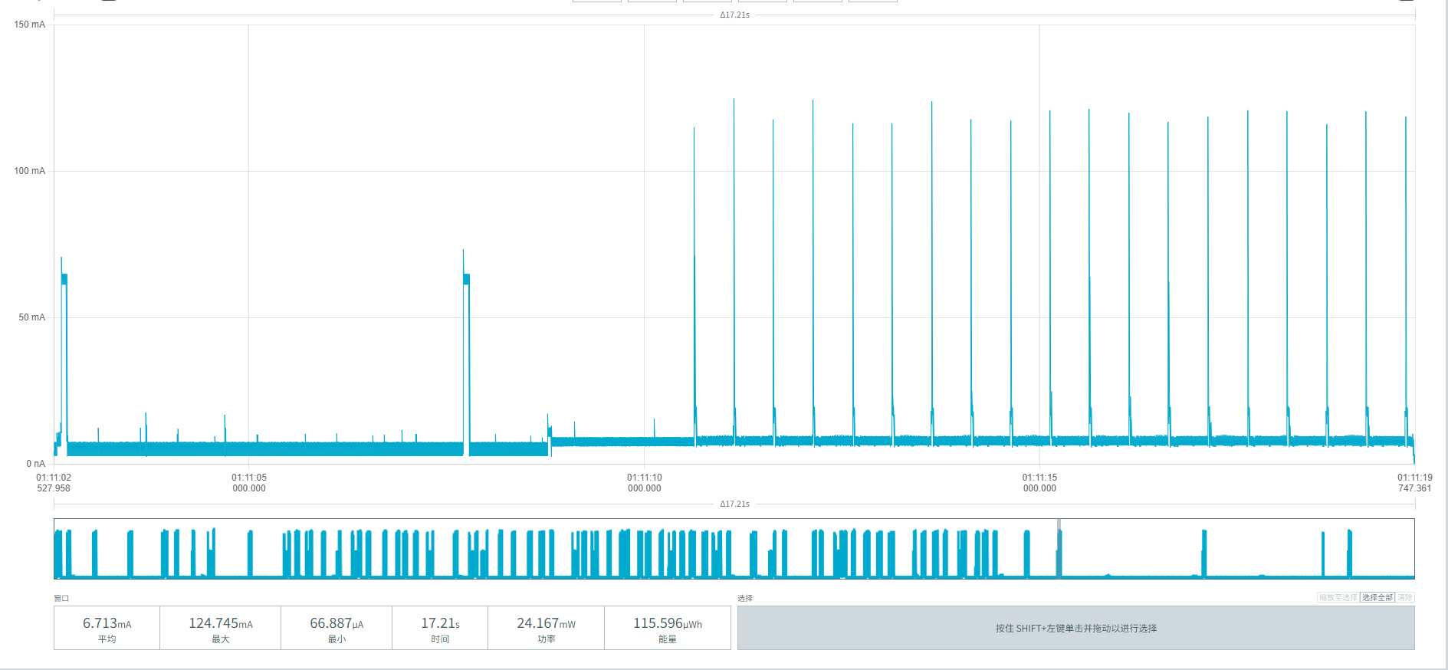
Figure 26 Periodic reporting power screenshots
From the extreme weak-network environment (SF12) results in this chapter: based on device 00956906000AF026's vehicle arrival and departure data under continuous retransmission, we fully superimpose them with the fixed consumption items (idle baseline, retransmission periodic reporting) to calculate the extreme power consumption and lifetime data for the worst-case network environment:
Baseline parameters:
Initial effective battery capacity: 17000mAh
Idle baseline consumption: 3.211 mAh/day (noise floor 1.842 + radar 0.326 + magnetometer 0.588 + 20-minute wake-up 0.455)
Single complete event (incl. 20% margin): (45.72 + 44.67) × 1.2 = 108.47 µAh
Single periodic report (weak network): 39.56 µAh
Parking frequency | Reporting interval | Daily / Annual consumption (mAh) | Estimated lifetime (iterative)
10 times/day | 1 per hour | 5.245 / 1,914.4 | 7.94 years
 | 1 per 4 hours | 4.533 / 1,654.5 | 9.27 years
 | 1 per 24 hours | 4.336 / 1,582.6 | 9.71 years
30 times/day | 1 per hour | 7.414 / 2,706.1 | 5.49 years
 | 1 per 4 hours | 6.702 / 2,446.2 | 6.10 years
 | 1 per 24 hours | 6.505 / 2,374.3 | 6.29 years

5.3.2 Device 00956906000AF03E
After a vehicle parks above the MPS-100 parking sensor, detection and reporting are triggered. Figure 27 shows the power parameters:
Average current: (6.414 + 6.152 + 6.060) / 3 ≈ 6.21 mA
Average duration: (23.55 + 25.94 + 27.21) / 3 ≈ 25.57 s
Average energy per event: (151.272 + 159.620 + 164.961) / 3 ≈ 158.618 µWh
Average consumption per event: 158.618 µWh / 3.6V ≈ 44.06 µAh
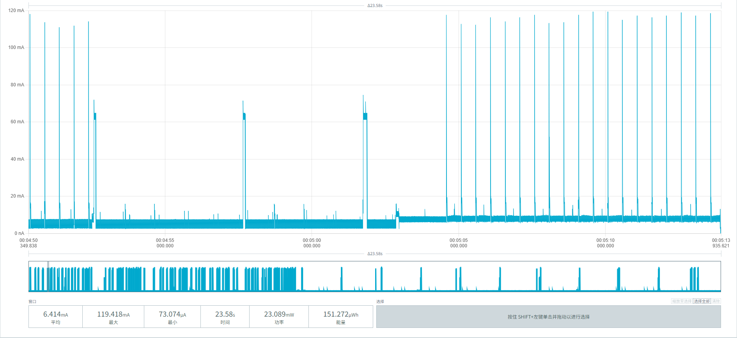
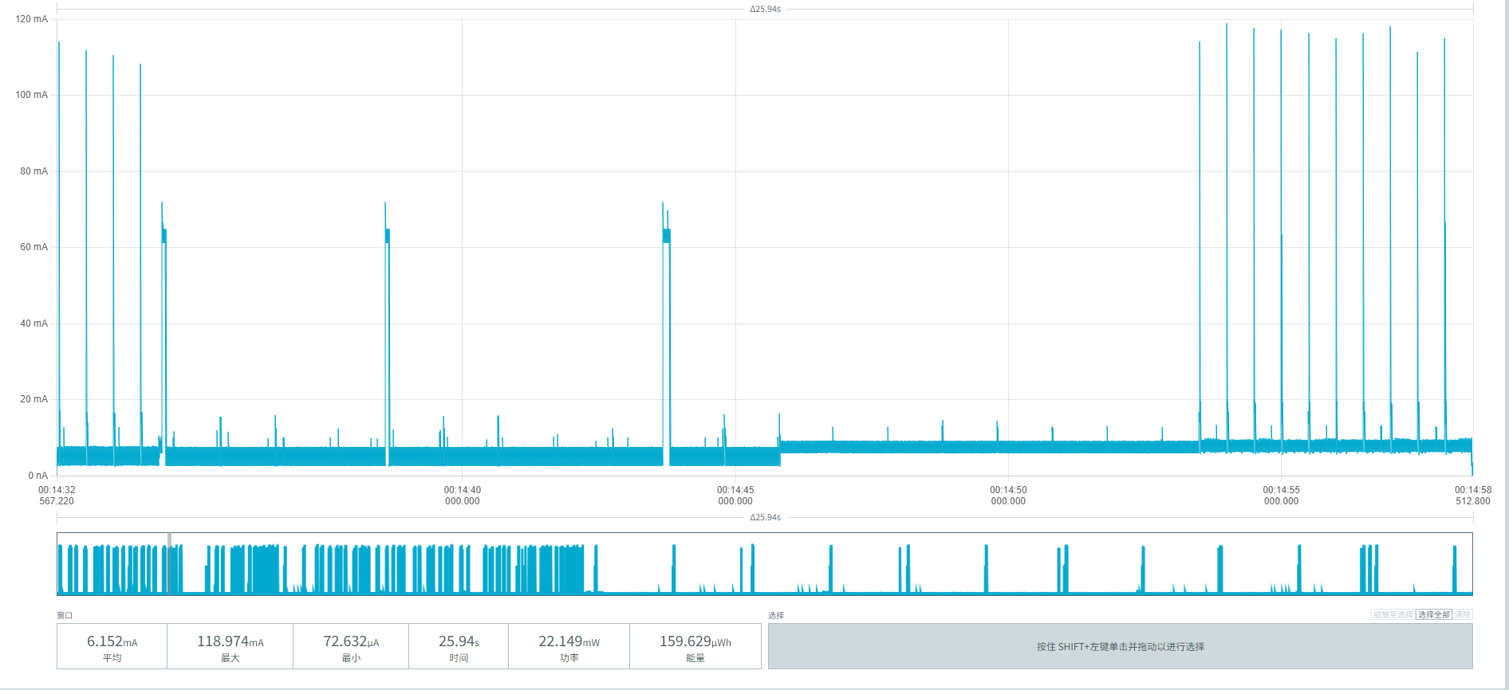
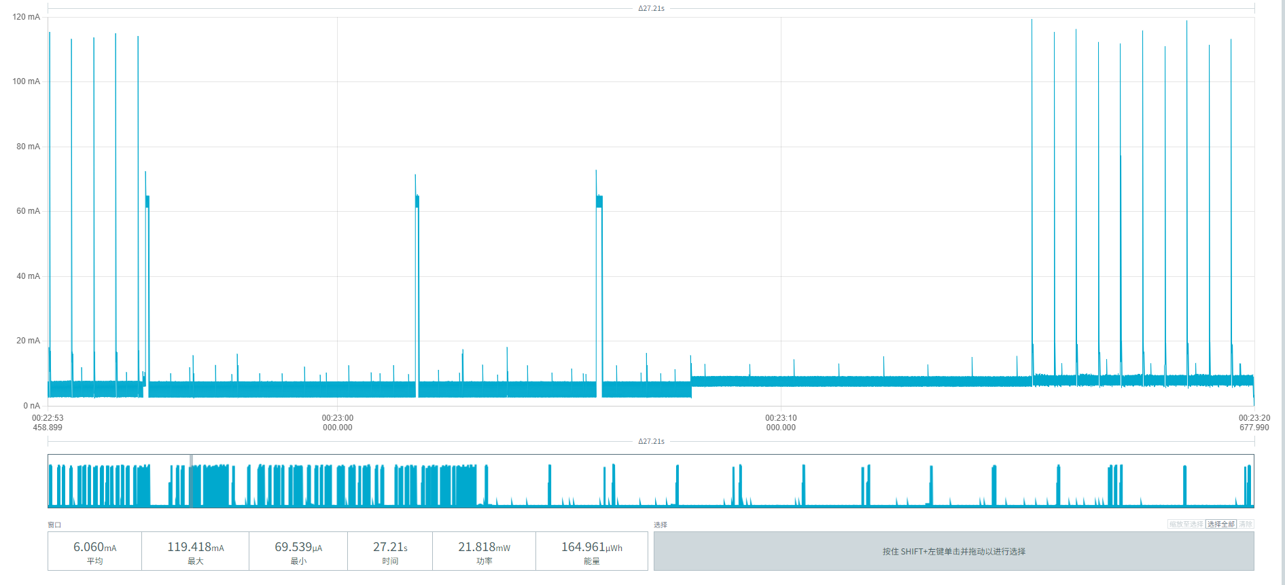
Figure 27 Vehicle arrival power screenshots

When the vehicle leaves the MPS-100 parking sensor, detection and reporting are triggered. Figure 28 shows the power parameters:
Average current: (6.083+6.148+6.349)/3 = 6.193mA
Average duration per event: (26.54 + 26.22 + 24.91) / 3 = 25.89 s
Average energy per event: (163.267 + 161.229 + 158.198) / 3 = 160.898 µWh
Average consumption per event: 160.898 µWh / 3.6V ≈ 44.69 µAh
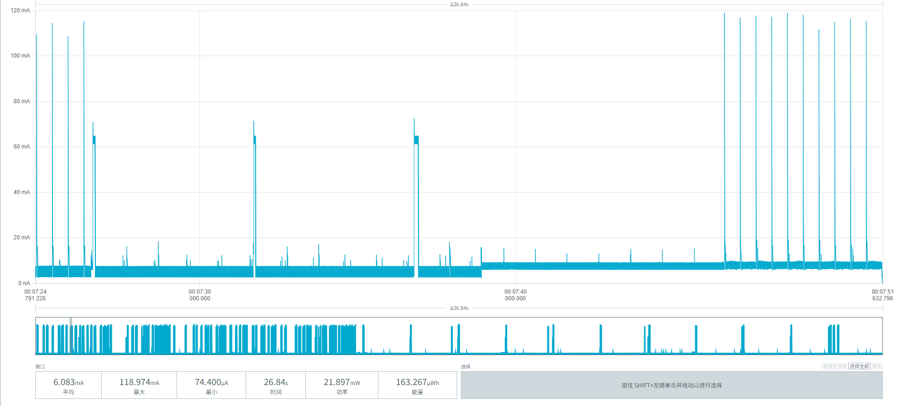
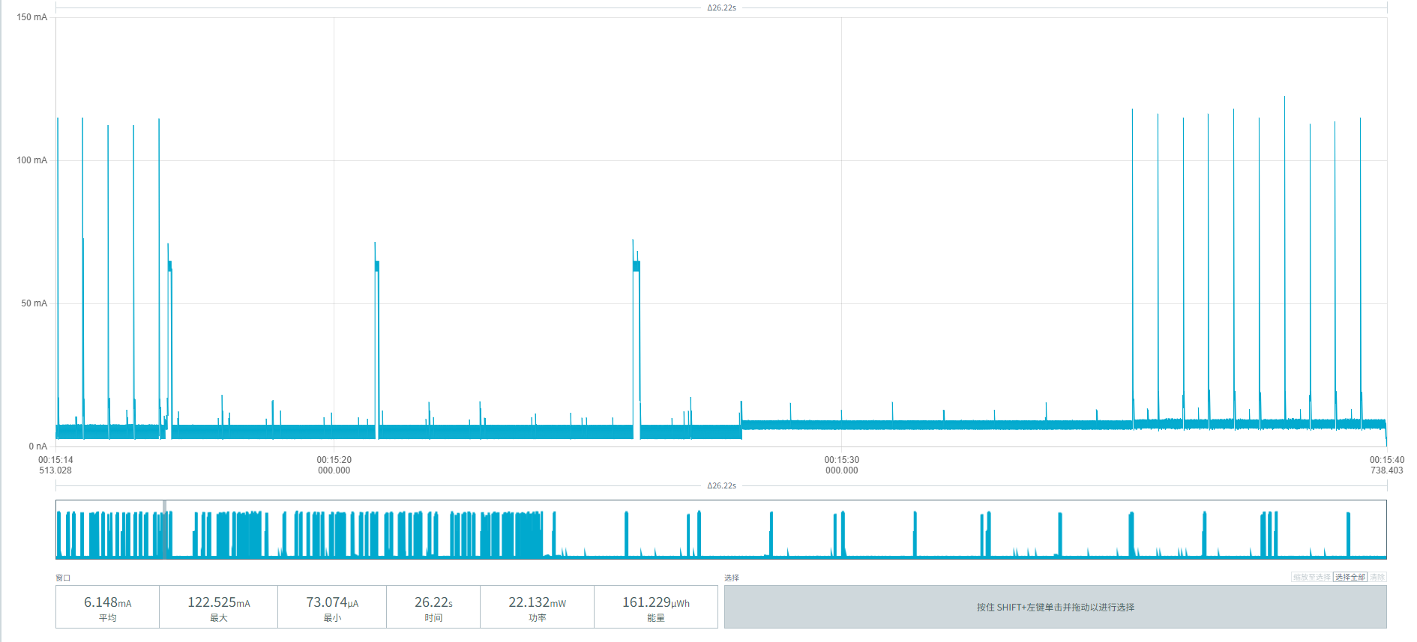
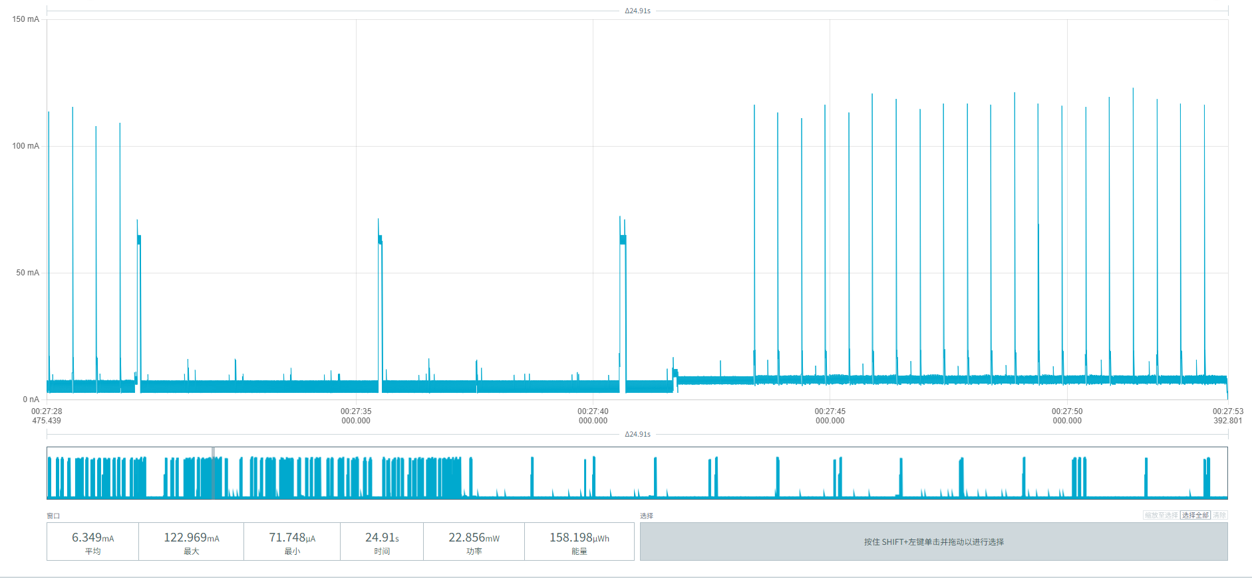
Figure 28 Vehicle departure power screenshots

Figure 29 shows the periodic reporting power of the MPS-100 parking sensor:
Average current: (6.574 + 6.252 + 6.457) / 3 ≈ 6.427 mA
Average duration per event: (21.80 + 24.10 + 22.75) / 3 ≈ 22.88 s
Average energy per event: (143.369 + 150.706 + 146.941)/3 = 147.005 µWh
Average consumption per event: 147.005 µWh / 3.6V = 40.835 µAh
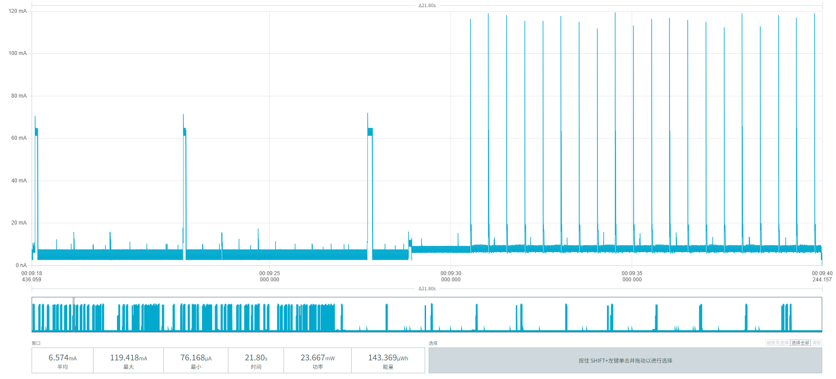
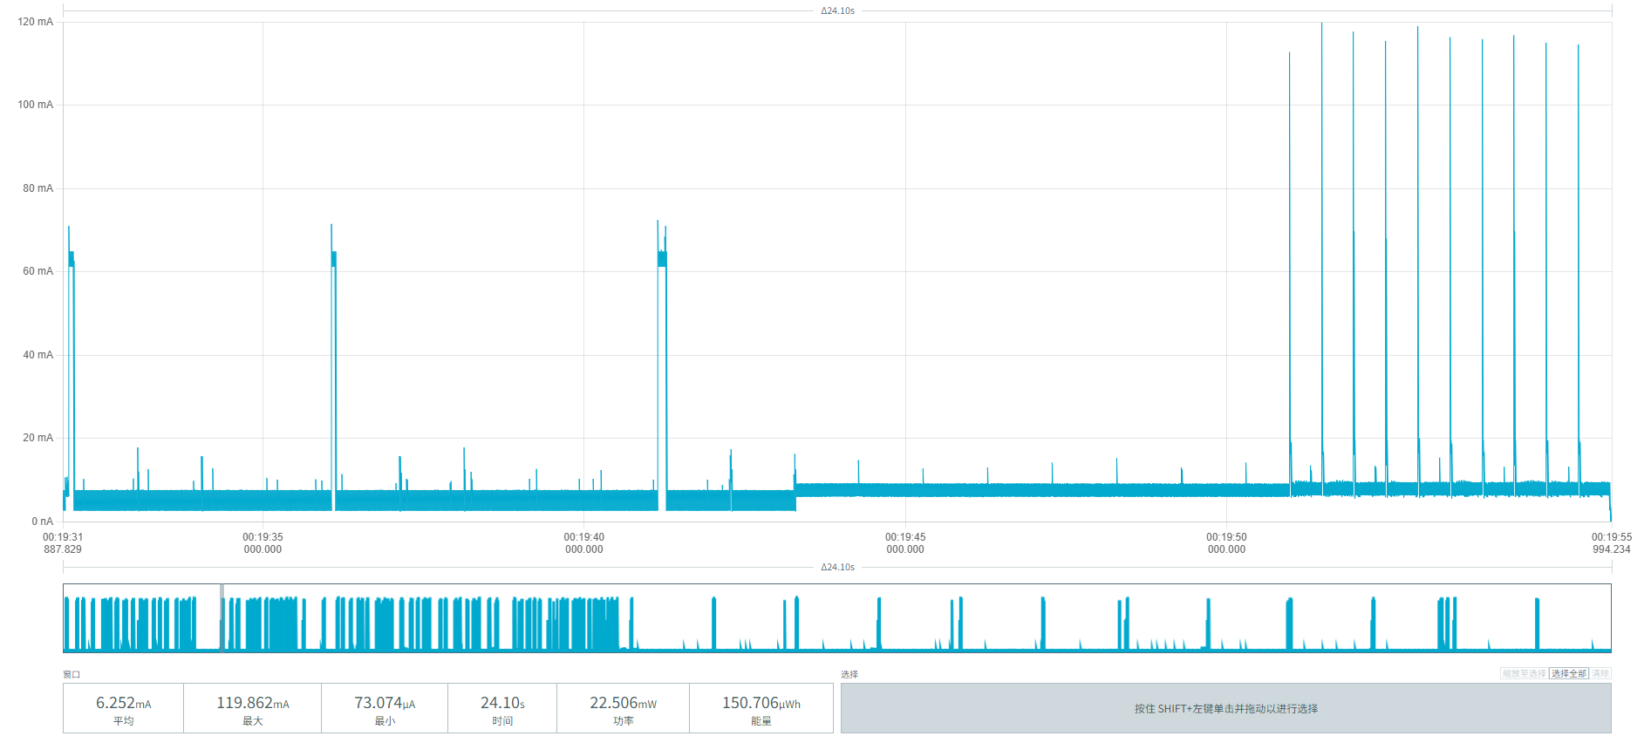
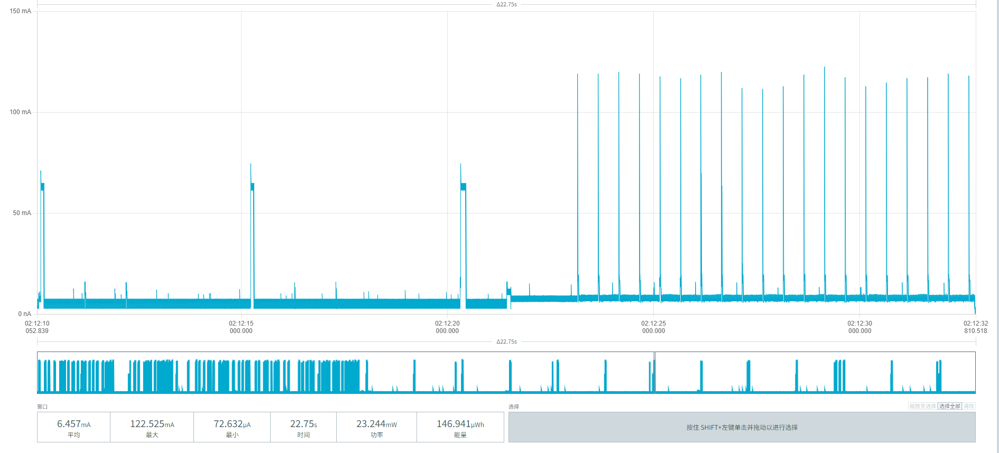
Figure 29 Periodic reporting power screenshots
From the extreme weak-network environment (SF12) results in this chapter: based on device 00956906000AF03E's vehicle arrival and departure data under continuous retransmission, we fully superimpose them with the fixed consumption items (idle baseline, retransmission periodic reporting) to calculate the extreme power consumption and lifetime data for the worst-case network environment:
Baseline parameters:
Initial effective battery capacity: 17000mAh
Idle baseline consumption: 3.202 mAh/day
Single complete parking event: 106.50 µAh (weak-network arrival 44.06 + weak-network departure 44.69, incl. 20% repeated-parking margin)
Single periodic report (weak network): 40.83 µAh
Parking frequency | Reporting interval | Daily / Annual consumption (mAh) | Estimated lifetime (iterative)
10 times/day | 1 per hour | 5.247 / 1,915.2 | 7.94 years
 | 1 per 4 hours | 4.512 / 1,646.9 | 9.31 years
 | 1 per 24 hours | 4.308 / 1,572.4 | 9.78 years
30 times/day | 1 per hour | 7.377 / 2,692.6 | 5.52 years
 | 1 per 4 hours | 6.642 / 2,424.3 | 6.16 years
 | 1 per 24 hours | 6.438 / 2,349.9 | 6.36 years

5.3.3 Device 00956906000B06CD
After a vehicle parks above the MPS-100 parking sensor, detection and reporting are triggered. Figure 30 shows the power parameters:
Average current: (19.696 + 14.743 + 19.599) / 3 ≈ 18.013 mA
Average duration: (21.71 + 32.85 + 21.95) / 3 ≈ 25.50 s
Average energy per event: (357.359 + 403.663 + 358.519) / 3 ≈ 373.180 µWh
Average consumption per event = 373.180 µWh / 3.6V ≈ 103.66 µAh
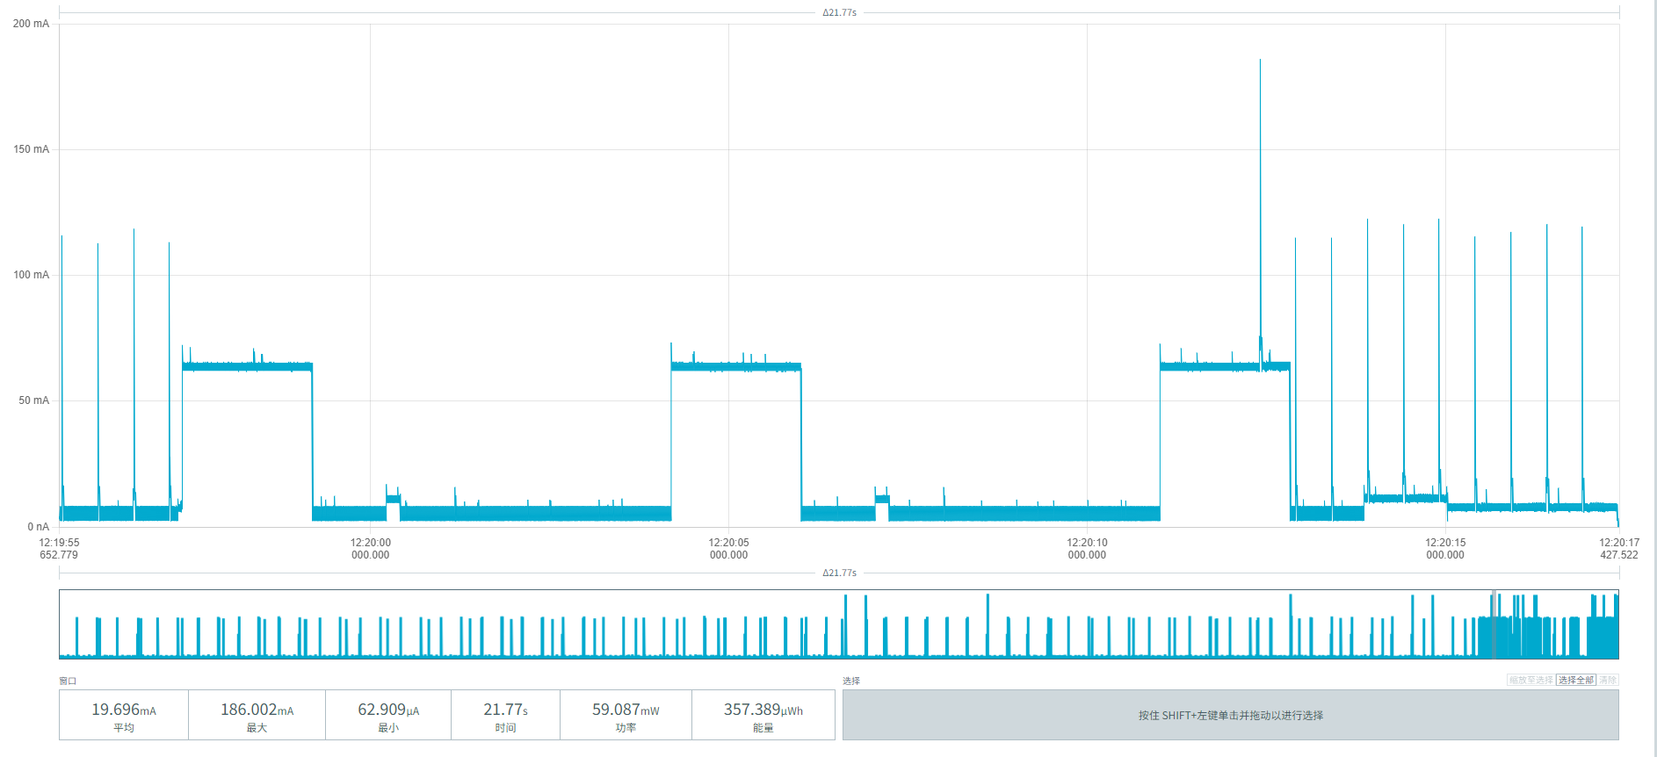
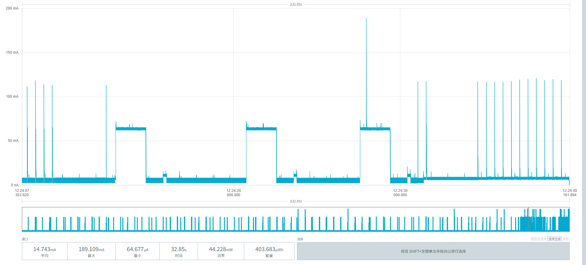
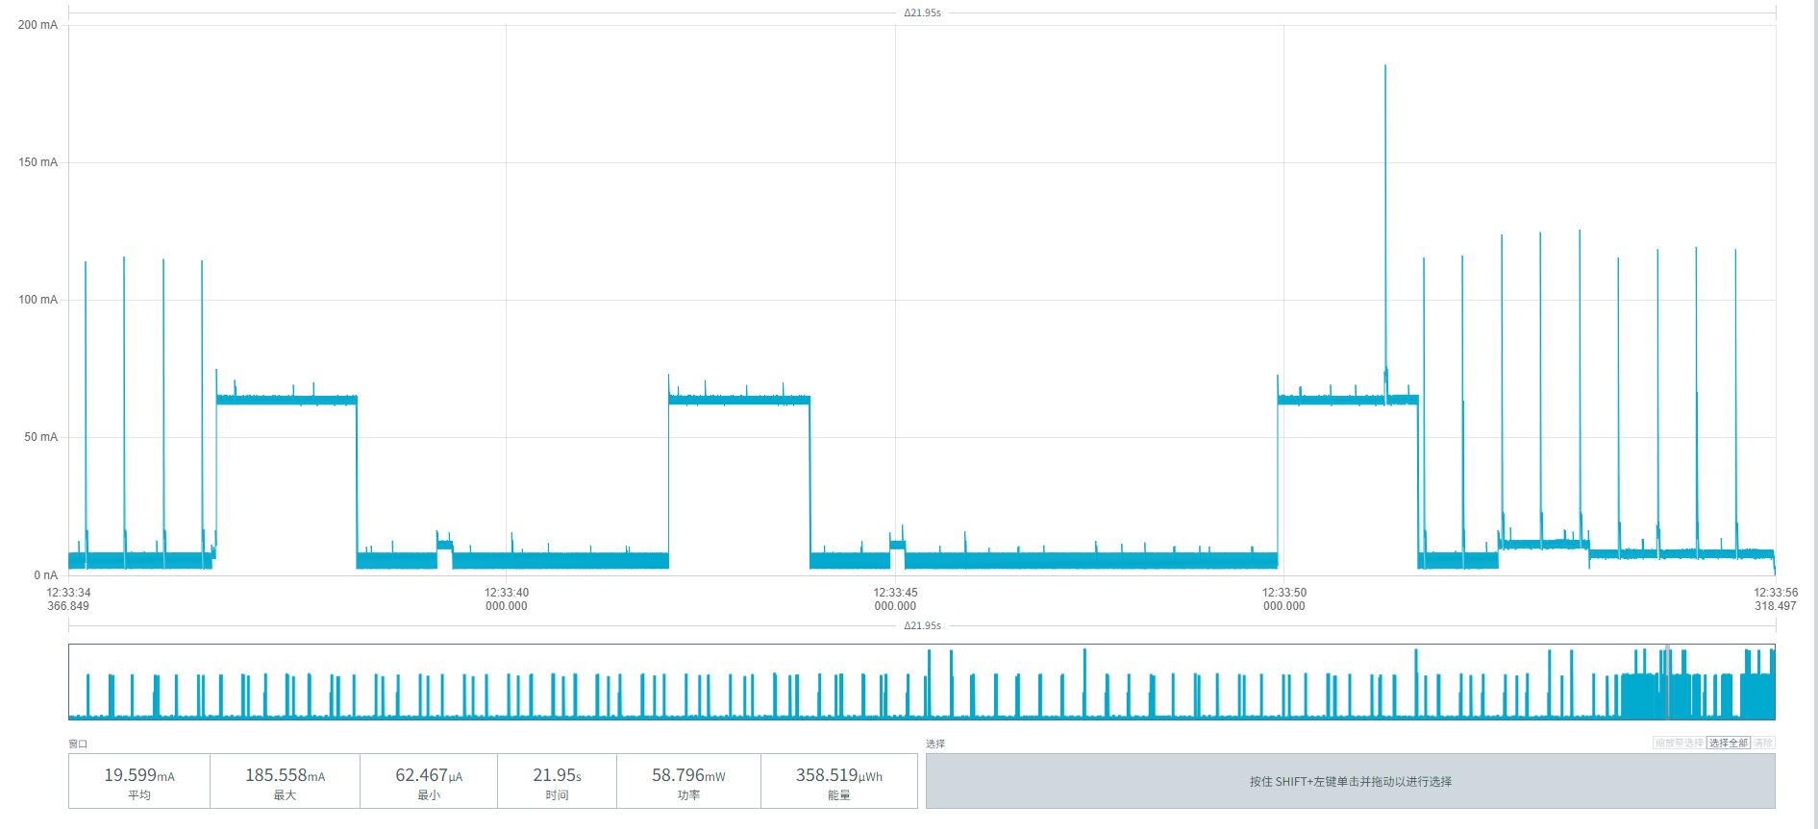
Figure 30 Vehicle arrival power screenshots

When the vehicle leaves the MPS-100 parking sensor, detection and reporting are triggered. Figure 31 shows the power parameters:
Average current: (15.473+19.684+19.374)/3 = 18.177mA
Average duration per event: (34.97+21.99+22.27)/3=79.23/3 = 26.41s
Average energy per event: (450.922+360.707+359.651)/3 = 390.4267 µWh
Average consumption per event: 390.4267 µWh/3.6V ≈ 108.45 µAh
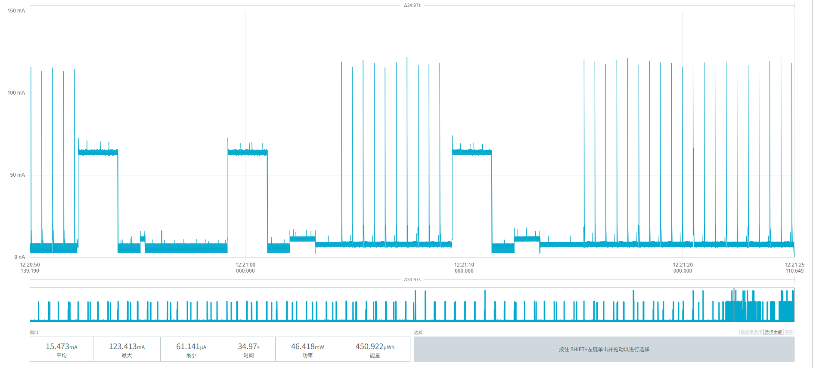
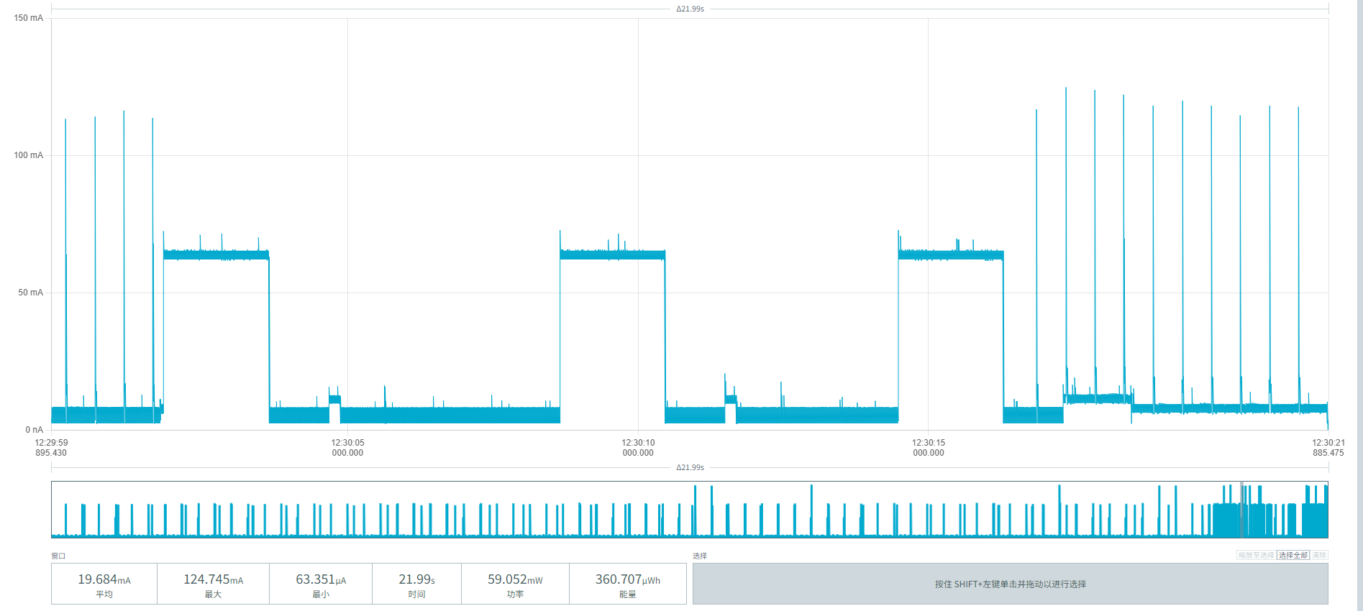
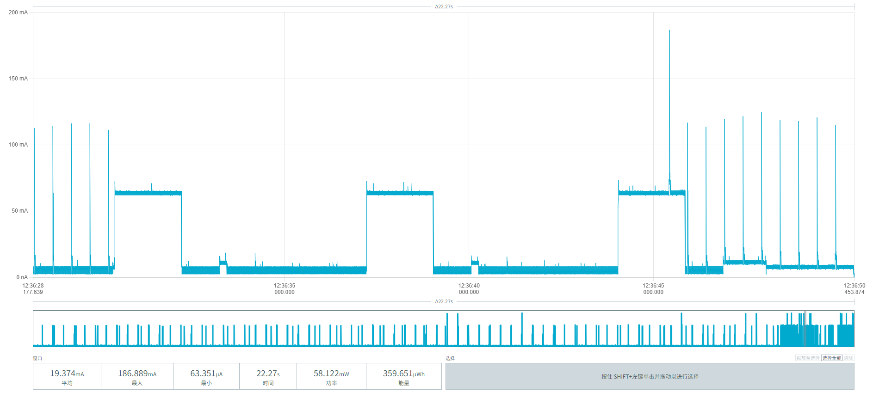
Figure 31 Vehicle departure power screenshots
Figure 32 shows the periodic reporting power of MPS-100 parking sensor B06CD:
Average current: (7.242 + 6.194 + 9.980) / 3 ≈ 7.805 mA
Average duration per event: (21.75 + 25.14 + 25.13) / 3 ≈ 24.01 s
Average energy per event: (131.295 + 129.785 + 209.080)/3 = 156.720 µWh
Average consumption per event: 156.720 µWh / 3.6V = 43.533 µAh
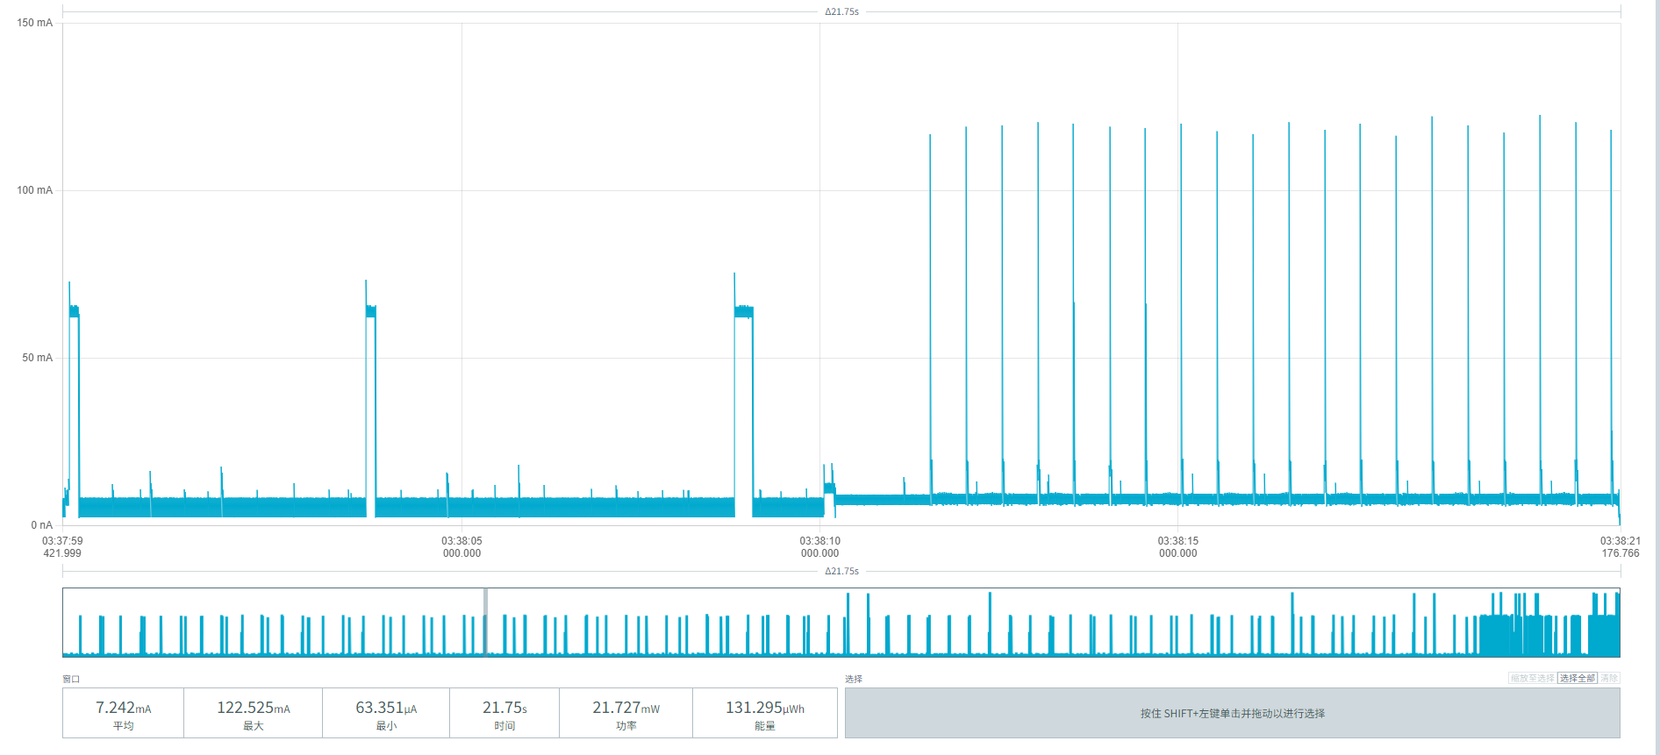
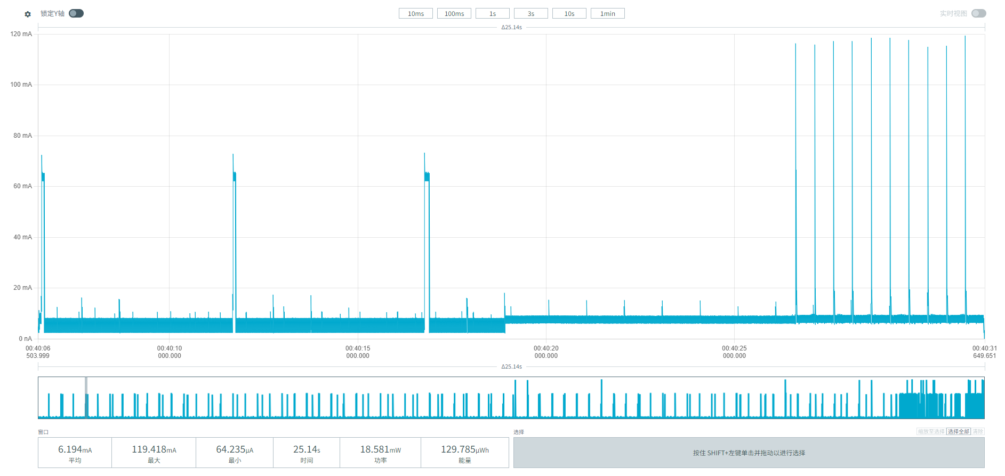
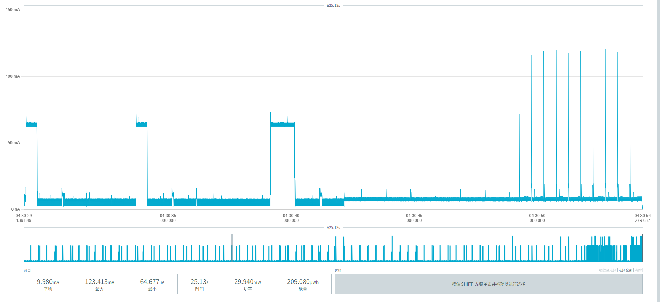
Figure 32 Periodic reporting power screenshots
From the extreme weak-network environment (SF12) results in this chapter: based on device 00956906000B06CD's vehicle arrival and departure data under continuous retransmission, we fully superimpose them with the fixed consumption items (idle baseline, retransmission periodic reporting) to calculate the extreme power consumption and lifetime data for the worst-case network environment:
Baseline parameters:
Initial effective battery capacity: 17000mAh
Daily idle baseline consumption: 3.117 mAh/day (noise floor + radar + magnetometer + 20-minute wake-up)
Single complete parking event: 254.53 µAh (weak-network arrival 103.66 + weak-network departure 108.45, incl. 20% repeated-parking margin)
Single periodic report (weak network): 43.533 µAh/event
Parking frequency | Reporting interval | Daily / Annual consumption (mAh) | Estimated lifetime (iterative)
10 times/day | 1 per hour | 6.707 / 2,448.1 | 6.09 years
 | 1 per 4 hours | 5.923 / 2,161.9 | 6.95 years
 | 1 per 24 hours | 5.706 / 2,082.7 | 7.23 years
30 times/day | 1 per hour | 11.798 / 4,306.3 | 3.71 years
 | 1 per 4 hours | 11.014 / 4,020.1 | 3.98 years
 | 1 per 24 hours | 10.797 / 3,940.9 | 4.06 years

6. Test Results

6.1 Summary of Measured Power Consumption by Phase
Based on the BLU939 measurements in a room-temperature environment (18~26°C), the key power consumption figures of the three prototypes under normal-network and extreme weak-network conditions are summarized below:
Operating scenario | AF026 device | AF03E device | B06CD device | Remarks
Baseline power | 3.211 mAh/day | 3.202 mAh/day | 3.117 mAh/day | Incl. noise floor, radar, magnetometer, and 20-minute wake-up
Single complete event (normal) | 73.32 μAh | 71.64 μAh | 79.27 μAh | Incl. TX peak and 20% repeated-parking margin
Single complete event (weak network) | 108.47 μAh | 106.50 μAh | 254.53 μAh | Incl. multiple retransmissions and extra-long RX windows
Single report (normal) | 27.28 μAh | 27.70 μAh | 27.41 μAh | 1 per 24 hours (normal handshake)
Single report (weak network) | 39.56 μAh | 40.83 μAh | 43.53 μAh | Incl. multiple retransmission confirmations

6.2 Battery Lifetime Projection at Room-Temperature Baseline
Baseline parameters and calculation formula:
Initial effective capacity: for the room-temperature environment, the nominal total battery capacity of 17,000 mAh is used
Year-by-year iteration formula: remaining capacity of the current year = remaining capacity of the previous year - consumption of the current year - (remaining capacity of the previous year × 2%)

Table 6.2.1 Lifetime projection under normal network conditions
Device model | Parking frequency | Reporting interval | Daily (mAh/day) | Annual (mAh/year) | Estimated lifetime (iterative)
AF026 | 10 times/day | 1 per hour | 4.599 | 1,678.6 | 9.14 years
 |  | 1 per 4 hours | 4.108 | 1,499.4 | 10.28 years
 |  | 1 per 24 hours | 3.971 | 1,449.4 | 10.65 years
 | 30 times/day | 1 per hour | 6.066 | 2,214.1 | 6.78 years
 |  | 1 per 4 hours | 5.575 | 2,034.9 | 7.43 years
 |  | 1 per 24 hours | 5.438 | 1,984.9 | 7.63 years
AF03E | 10 times/day | 1 per hour | 4.583 | 1,672.8 | 9.17 years
 |  | 1 per 4 hours | 4.084 | 1,490.7 | 10.33 years
 |  | 1 per 24 hours | 3.946 | 1,440.3 | 10.71 years
 | 30 times/day | 1 per hour | 6.016 | 2,195.8 | 6.84 years
 |  | 1 per 4 hours | 5.517 | 2,013.7 | 7.51 years
 |  | 1 per 24 hours | 5.379 | 1,963.3 | 7.71 years
B06CD | 10 times/day | 1 per hour | 4.568 | 1,667.3 | 9.20 years
 |  | 1 per 4 hours | 4.074 | 1,487.0 | 10.36 years
 |  | 1 per 24 hours | 3.937 | 1,437.0 | 10.73 years
 | 30 times/day | 1 per hour | 6.153 | 2,245.8 | 6.68 years
 |  | 1 per 4 hours | 5.659 | 2,065.5 | 7.31 years
 |  | 1 per 24 hours | 5.522 | 2,015.5 | 7.50 years

Table 6.2.2 Lifetime projection under weak-network conditions (frequent retransmissions)
Device model | Parking frequency | Reporting interval | Daily (mAh/day) | Annual (mAh/year) | Estimated lifetime (iterative)
AF026 | 10 times/day | 1 per hour | 5.245 | 1,914.4 | 7.94 years
 |  | 1 per 4 hours | 4.533 | 1,654.5 | 9.27 years
 |  | 1 per 24 hours | 4.336 | 1,582.6 | 9.71 years
 | 30 times/day | 1 per hour | 7.414 | 2,706.1 | 5.49 years
 |  | 1 per 4 hours | 6.702 | 2,446.2 | 6.10 years
 |  | 1 per 24 hours | 6.505 | 2,374.3 | 6.29 years
AF03E | 10 times/day | 1 per hour | 5.247 | 1,915.2 | 7.94 years
 |  | 1 per 4 hours | 4.512 | 1,646.9 | 9.31 years
 |  | 1 per 24 hours | 4.308 | 1,572.4 | 9.78 years
 | 30 times/day | 1 per hour | 7.377 | 2,692.6 | 5.52 years
 |  | 1 per 4 hours | 6.642 | 2,424.3 | 6.16 years
 |  | 1 per 24 hours | 6.438 | 2,349.9 | 6.36 years
B06CD | 10 times/day | 1 per hour | 6.707 | 2,448.1 | 6.09 years
 |  | 1 per 4 hours | 5.923 | 2,161.9 | 6.95 years
 |  | 1 per 24 hours | 5.706 | 2,082.7 | 7.23 years
 | 30 times/day | 1 per hour | 11.798 | 4,306.3 | 3.71 years
 |  | 1 per 4 hours | 11.014 | 4,020.1 | 3.98 years
 |  | 1 per 24 hours | 10.797 | 3,940.9 | 4.06 years

6.3 Croatia Extreme-Environment Projection
The projections above are all based on the room-temperature baseline. For Croatia's extreme summer asphalt-surface temperatures (60~70°C) and winter low temperatures, battery activity declines and SEI film growth causes capacity loss. To keep the warranty commitment safe, 85% of nominal capacity (i.e., 14,450 mAh) is conservatively adopted as the initial capacity for extreme environments. Substituting into the iteration model above:
Under the most demanding scenario (weak network + 30 times/day + 1 per hour): AF026 lifetime is about 4.67 years and AF03E about 4.70 years.
Under the recommended scenario (normal network + 30 times/day + 1 per 4 hours): all devices (including B06CD) reliably exceed 5.5 years of lifetime.
Note: the 85% initial effective capacity derating is an overall engineering assessment based on factors including the typical capacity fade of the ER26500 cell at high temperature (60–70°C, about 10%–15%) and the unusable capacity caused by voltage cut-off (about 5%–10%). This value covers the main risks of Croatia's outdoor environment and retains a reasonable safety margin to ensure the reliability of the 5-year service life.

6.4 Final Test Conclusions and Warranty Condition Recommendations
Excellent performance on normal networks: at room temperature with good network conditions, even with 30 parking events per day and high-frequency reporting, all three devices exceed 6 years of lifetime; with the recommended 4-hour reporting, all exceed 7 years.
Weak-network extremes expose hardware weaknesses: under extreme weak-network conditions (frequent retransmissions), AF026 and AF03E hold up well, with lifetime still above 5 years in the worst scenario; B06CD, however, shows an abnormal surge in weak-network power consumption due to anomalous individual RF performance (root cause under investigation, suspected to be related to RF matching), and its worst-scenario lifetime drops sharply to 3.71 years.
Extreme-climate safety margin: after accounting for the 85% high-temperature derating, devices using the recommended configuration still reliably exceed 5 years.
Deployment recommendations:
Based on rigorous physical projection, the following conditions are recommended for deployment and use:
Usage frequency: no more than 30 parking events per day.
Reporting interval: no less than 1 hour (strongly recommended: 1 per 4 hours or 1 per 24 hours).
Network and environment: ensure the site has basic LoRaWAN gateway coverage, and rule out areas with prolonged extreme heat (>45°C) or weak signal causing constant retransmissions.

